VIDEO COLOR PROCESSING

Draft version: 2.0

Sakinder Ali

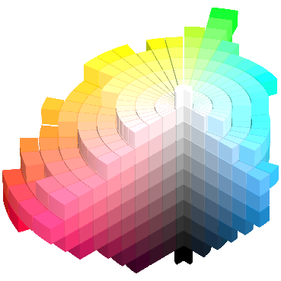

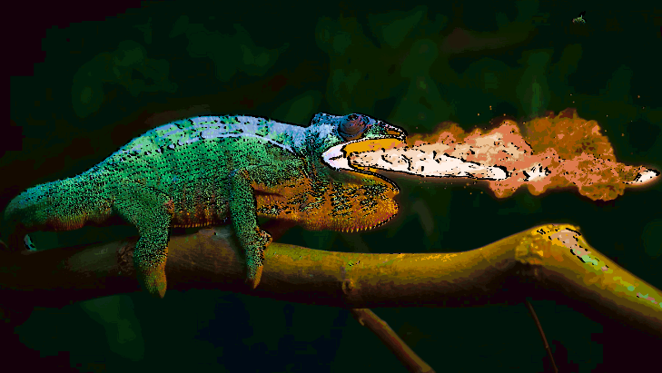

Contents

VIDEO COLOR PROCESSING 1

INTRODUCTION 9

VIVADO BLOCK DIAGRAM IP CUSTOMIZATION 11

ARCHITECTURE 15

BANDWIDTH AND DATA RATE CALCULATION 17

CMOS PIXEL CAPTURE 18

VCP 20

HSL COLOR SPACE 21

RGB TO HSV 22

HSV TO RGB 26

HSV COLOR SPACE 28

HSL COLOR RANGE SPACE 31

CMYK COLOR SPACE 35

YDBDR COLOR SPACE 37

CIEXYZ COLOR SPACE 38

CIEYUV COLOR SPACE 39

YIQ COLOR SPACE 40

YPBPR COLOR SPACE 41

I1I2I3 OHTA COLOR INTENSITIES 42

LMS COLOR SPACE 43

ICTCP COLOR SPACE 44

HED COLOR SPACE 45

YC1C2 COLOR SPACE 46

SHARP FILTER 47

BLUR FILTER 48

EMBOSS FILTER 50

SOBEL FILTER 51

YCBCR COLOR SPACE 53

COLOR ADJUST MATRIX 55

AN FPGA IMPLEMENTATION OF K-MEANS CLUSTERING 75

VIDEO CONTROLLER INTERFACE 85

LOCAL DYNAMIC THRESHOLD SEGMENTATION 86

IMAGE CONTRAST AND BRIGHTNESS 87

CAMERA RAW DATA 88

THREE TAPS DATA 89

FOUR TAPS DATA 89

PIXEL COORDINATES 89

CAMERA RAW DATA 91

HISTOGRAM 94

ETHERNET UDP VIDEO STREAMING 96

VIDEO STREAM DATA AND FORMAT 97

SONY IMX477/IMX682/IMX519/IMX219 AND ONSEMI AR1335 CAMERAS VIDEO STREAMING 98

LWIP ETHERNET INTERFACE 98

5MP OV5640 SENSOR INTERFACE 98

5MP OV5647 SENSOR INTERFACE 98

8MP IMX219 SENSOR INTERFACE 98

SONY 12.5MP IMX477 SENSOR 100

SPECIFICATIONS 100

DRIVE MODE 100

FEATURES 100

INTERFACE 101

16MP IMX519 SENSOR INTERFACE 104

64MP IMX682 SENSOR INTERFACE 104

TESTBENCH 105

TESTBENCH COMPONENTS/OBJECTS 106

DUT CONNECTIONS 110

SEQUENCE ITEM 111

SEQUENCE 112

SEQUENCER 113

DRIVER 114

MONITOR 122

AGENT 124

SCOREBOARD 124

ENVIRONMENT/ENV 125

TEST 125

D5M TRANSECTION 126

TESTBENCH_TOP 127

Figure 1 The overall structure of implemented design, which shows video RX and TX video data flow. 10

Figure 2 15

Figure 3 20

Figure 4 22

Figure 5 22

Figure 6: Hue Numerator Logic 23

Figure 7: Hue Denominator Logic 23

Figure 8: Hue Degree Logic 24

Figure 9 : HSL Filter Wave Diagram 24

Figure 10 24

Figure 11 24

Figure 12: RGB image 24

Figure 13: HSL converted image 24

Figure 14: RGB image 24

Figure 15: HSL converted image 24

Figure 16: HSL Image 25

Figure 17: Hue channel 25

Figure 18: Saturate channel 25

Figure 19: Luminosity channel 25

Figure 20: HSL Image 25

Figure 21: Hue channel 25

Figure 22: Saturate channel 25

Figure 23: Luminosity channel 25

Figure 24 25

Figure 25 26

Figure 26 26

Figure 27 26

Figure 28 26

Figure 29 26

Figure 30 27

Figure 31 27

Figure 32 28

Figure 33 28

Figure 34 28

Figure 35 28

Figure 36 29

Figure 37 29

Figure 38 29

Figure 39 29

Figure 40 29

Figure 41 29

Figure 42 29

Figure 43 29

Figure 44 29

Figure 45 29

Figure 46 29

Figure 47 29

Figure 48 30

Figure 49 30

Figure 50 30

Figure 51 30

Figure 52 31

Figure 53 31

Figure 54 31

Figure 55 31

Figure 56 31

Figure 57 31

Figure 58 31

Figure 59 31

Figure 60 32

Figure 61 32

Figure 62 32

Figure 63 32

Figure 64 32

Figure 65 32

Figure 66 32

Figure 67 32

Figure 68 33

Figure 69 33

Figure 70 33

Figure 71 33

Figure 72 33

Figure 73 33

Figure 74 33

Figure 75 33

Figure 76 33

Figure 77 33

Figure 78 33

Figure 79 33

Figure 80 34

Figure 81 34

Figure 82 34

Figure 83 34

Figure 84 34

Figure 85 34

Figure 86 34

Figure 87 34

Figure 88 35

Figure 89 35

Figure 90 35

Figure 91 35

Figure 92 36

Figure 93 36

Figure 94 RGB Image 37

Figure 95 YDBDR Image 37

Figure 96 RGB Image 37

Figure 97 YDBDR Image 37

Figure 98 38

Figure 99 38

Figure 100 38

Figure 101 38

Figure 102 39

Figure 103 39

Figure 104 39

Figure 105 39

Figure 106 40

Figure 107 40

Figure 108 40

Figure 109 40

Figure 110 41

Figure 111 41

Figure 112 41

Figure 113 41

Figure 114 42

Figure 115 42

Figure 116 42

Figure 117 42

Figure 118 42

Figure 119 43

Figure 120 43

Figure 121 43

Figure 122 43

Figure 123 43

Figure 124 44

Figure 125 44

Figure 126 44

Figure 127 44

Figure 128 44

Figure 129 45

Figure 130 45

Figure 131 45

Figure 132 45

Figure 133 45

Figure 134 46

Figure 135 46

Figure 136 46

Figure 137 46

Figure 138 46

Figure 139 47

Figure 140 48

Figure 141 52

Figure 142 53

Figure 143 54

Figure 144 55

Figure 145 75

Figure 146 76

Figure 147 76

Figure 148 : camera raw data module 88

Figure 149 : General view of camera raw data flow 88

Figure 150 89

Figure 151 89

Figure 152 90

Figure 153 91

Figure 154 91

Figure 155 94

Figure 156 94

Figure 157 95

Figure 158 109

Figure 159 110

Figure 160 115

INTRODUCTION

Video color processing based upon implementation of raspberry pi camera link running on a Kria KV260 board. This design capture rgb video data via MIPI interface and process video data into axi4 stream and output to ethernet /display port.

This design takes 10-bit RGB format video stream and apply various filters and color space conversions. At high level, the design comprises of three pipelines: Capture, Process and Output pipelines. During process pipeline each rgb pixel either filtered or converted into color space which is implemented video color processing (VCP) module.

VCP module contains a collection of control registers and maintain a local small buffers to store video frame lines. A VCP module takes input video pixel stream, performs computation, or adds new contents to the stream through filters, and then outputs the processed pixel stream. VCP module can be either a pixel transformation or a pixel generation.

VCP have following filters and color space conversion which can enabled before build:

* Color Correction Matrix
* K-Mean Color Clustering
* Test-Pattern
* Filters
  + SHARP
  + BLUR
  + EMBOSS
  + SOBEL EDGE DETECTION
  + CONTRAST
* Color Space Conversions
  + RGB TO HSL
  + HSL TO RGB
  + RGB TO YCBCR
  + YCBCR TO RGB
  + RGB TO CMYK
  + RGB TO YDBDR
  + RGB TO CIEXYZ
  + RGB TO CIEYUV
  + RGB TO YIQ
  + RGB TO YPBPR
  + RGB TO LMS
  + RGB TO ICTCP
  + RGB TO HED
  + RGB TO YC1C2
  + RGB TO YCBCR

Image frame resolution is set to 3840x2160 at 30 frames per second and maximum full resolution of 4056x3040 is also supported but limited to 15 frames per second.

The simplified block diagram for implemented end-to-end pipeline design is shown in Figure 1. The design is appliable to process video from both connected cameras AR1335 and IMX477 and transmit video stream to output components display and ethernet ports.



Figure The overall structure of implemented design, which shows video RX and TX video data flow.

The Sony IMX477 12.5MP sensor is a 1/2.3-inch CMOS digital image sensor with an active imaging pixel array of 4056H x 3040V 30fps@max resolution. This sensor is configured by I2C interface and has MIPI output interface that is connected to the MIPI CSI-2 RX subsystem inside.

The AR 1335 13.0MP sensor is a 1/3.2-inch CMOS digital image sensor with an active imaging pixel array of 4208H x 3120V 30fps@max resolution. This sensor is configured by I2C interface and has MIPI output interface that is connected to the MIPI CSI-2 RX subsystem inside.

The MIPI CSI-2 receiver subsystem includes a MIPI D-PHY core and that connects 2 data lanes for imx477 camera device and 4 lanes for AR1335 camera device. The subsystem captures video stream frames from the AR1335 camera and IMX477 camera in RAW10 format.

The Demosaic module converts bayer pattern input frame to RGB color frame.

The VCP custom module apply various filters, color space conversion and K-Mean color clusters. It also applies image enhancement control to improve image quality which include contrast, brightness, saturation, white/black balance and rgb gain through axi4 lite configuration registers.

VDMA (Video Direct Memory Access) transfer video streaming to and from external memory and operate under software control.

The DP (display port) in PS source (live input) video data from PL.

VIVADO BLOCK DIAGRAM IP CUSTOMIZATION

|  |  |  |
| --- | --- | --- |
| **ZYNQ ULTRASCALE+ MPSoC** | | **SETTINGS** |
| **I/O CONFIGURATION** | | |
|  | DPAUX | **MIO 27 TO MIO 30** |
|  | DisplayPort Lane Selection | **Dual Lower** |
| **CLOCK CONFIGURATION** | | |
|  | PL Fabric Output Clock PL0 | IOP 100 MHz |
|  | DisplayPort Reference Frequency | 27 |
| **PS-PL CONFIGURATION** | | |
|  | PS-PL Interface: AXI HPM0 FPD | **Select** |
| PS-PL Interface: AXI HPM0 FPD Data Width | **128** |
| PS-PL Interface: AXI HPM1 FPD | **Select** |
| PS-PL Interface: AXI HPM1 FPD Data Width | **128** |
| PS-PL Interface: Slave Interface AXI HPC0 FPD | **Select** |
| PS-PL Interface: Slave Interface AXI HPC0 FPD Data Width | **128** |

|  |  |
| --- | --- |
| **MIPI CSI2 RX SUBSYSTEM 1** | **SETTINGS** |
| Pixel Format | RAW10 |
| Serial Data Lanes | 2 |
| Line Rate | 2500 Mbps |
| CSI2 Controller Register Interface | Select |
| Filter User Defines Data Types | Select |
| Line Buffer Defined Data Types | 4096 |
| Allowed VC | All |
| Pixel Per Clock | 1 |
| TUSER Width | 1 |
| Enable CRC | Select |

|  |  |
| --- | --- |
| **MIPI CSI2 RX SUBSYSTEM 2** | **SETTINGS** |
| Pixel Format | RAW10 |
| Serial Data Lanes | 4 |
| Line Rate | 2000 Mbps |
| CSI2 Controller Register Interface | Select |
| Filter User Defines Data Types | Select |
| Line Buffer Defined Data Types | 4096 |
| Allowed VC | All |
| Pixel Per Clock | 1 |
| TUSER Width | 1 |
| Enable CRC | Select |

|  |  |  |  |  |  |  |  |  |  |
| --- | --- | --- | --- | --- | --- | --- | --- | --- | --- |
| **RESOLUTIONS** | | | | | | | | | **V_CLK** |
| **WIDTH** | **HEIGHT** | **MODE** | **HTOTAL** | **HBLANK** | **VTOTAL** | **VBLANK** | **HFREQ** | **VFREQ** | **CLOCK** |
| 640 | 480 | PROGRESSIVE | 800 | 160 | 525 | 45.0 | 31.469 | 59.940 | 25.175 |
| 720 | 480 | PROGRESSIVE | 858 | 138 | 525 | 45.0 | 31.469 | 59.940 | 27.000 |
| 720 | 480 | PROGRESSIVE | 858 | 138 | 525 | 45.0 | 31.469 | 59.940 | 27.000 |
| 1280 | 720 | PROGRESSIVE | 1650 | 370 | 750 | 30.0 | 45.000 | 60.000 | 74.250 |
| 1920 | 1080 | INTERLACED | 2200 | 280 | 1125 | 22.5 | 33.750 | 60.000 | 72.250 |
| 1440 | 480 | INTERLACED | 1716 | 276 | 525 | 22.5 | 15.734 | 59.940 | 27.000 |
| 1440 | 480 | INTERLACED | 1716 | 276 | 525 | 22.5 | 15.734 | 59.940 | 27.000 |
| 1440 | 240 | PROGRESSIVE | 1716 | 276 | 262 | 22.0 | 15.734 | 60.054 | 27.000 |
| 1440 | 240 | PROGRESSIVE | 1716 | 276 | 262 | 22.0 | 15.734 | 59.826 | 27.000 |
| 2880 | 480 | INTERLACED | 3432 | 552 | 525 | 22.5 | 15.734 | 59.940 | 54.000 |
| 2880 | 480 | INTERLACED | 3432 | 552 | 525 | 22.5 | 15.734 | 59.940 | 54.000 |
| 2880 | 240 | PROGRESSIVE | 3432 | 552 | 262 | 22.0 | 15.734 | 60.054 | 54.000 |
| 2880 | 240 | PROGRESSIVE | 3432 | 552 | 262 | 22.0 | 15.734 | 59.826 | 54.000 |
| 1440 | 480 | PROGRESSIVE | 1716 | 276 | 525 | 45.0 | 31.469 | 59.940 | 54.000 |
| 1440 | 480 | PROGRESSIVE | 1716 | 276 | 525 | 45.0 | 31.469 | 59.940 | 54.000 |
| 1920 | 1080 | PROGRESSIVE | 2200 | 280 | 1125 | 45.0 | 67.500 | 60.000 | 148.500 |
| 720 | 576 | PROGRESSIVE | 864 | 144 | 625 | 49.0 | 31.250 | 50.000 | 27.000 |
| 720 | 576 | PROGRESSIVE | 864 | 144 | 625 | 49.0 | 31.250 | 50.000 | 27.000 |
| 1280 | 720 | PROGRESSIVE | 1980 | 700 | 750 | 30.0 | 37.500 | 50.000 | 74.250 |
| 1920 | 1080 | INTERLACED | 2640 | 720 | 1125 | 22.5 | 28.125 | 50.000 | 74.250 |
| 1440 | 576 | INTERLACED | 1728 | 288 | 625 | 24.5 | 15.625 | 50.000 | 27.000 |
| 1440 | 576 | INTERLACED | 1728 | 288 | 625 | 24.5 | 15.625 | 50.000 | 27.000 |
| 1440 | 288 | PROGRESSIVE | 1728 | 288 | 312 | 24.0 | 15.625 | 50.080 | 27.000 |
| 1440 | 288 | PROGRESSIVE | 1728 | 288 | 313 | 25.0 | 15.625 | 49.920 | 27.000 |
| 2880 | 576 | INTERLACED | 3456 | 576 | 625 | 24.5 | 15.625 | 50.000 | 54.000 |
| 2880 | 576 | INTERLACED | 3456 | 576 | 625 | 24.5 | 15.625 | 50.000 | 54.000 |
| 2880 | 288 | PROGRESSIVE | 3456 | 576 | 312 | 24.0 | 15.625 | 50.080 | 54.000 |
| 2880 | 288 | PROGRESSIVE | 3456 | 576 | 313 | 25.0 | 15.625 | 49.920 | 54.000 |
| 1440 | 576 | PROGRESSIVE | 1728 | 288 | 625 | 49.0 | 31.250 | 50.000 | 54.000 |
| 1440 | 576 | PROGRESSIVE | 1728 | 288 | 625 | 49.0 | 31.250 | 50.000 | 54.000 |
| 1920 | 1080 | PROGRESSIVE | 2640 | 720 | 1125 | 45.0 | 56.250 | 50.000 | 148.500 |
| 1920 | 1080 | PROGRESSIVE | 2750 | 830 | 1125 | 45.0 | 27.000 | 24.000 | 74.250 |
| 1920 | 1080 | PROGRESSIVE | 2640 | 720 | 1125 | 45.0 | 28.125 | 25.000 | 74.250 |
| 1920 | 1080 | PROGRESSIVE | 2200 | 280 | 1125 | 45.0 | 33.750 | 30.000 | 74.250 |
| 2880 | 480 | PROGRESSIVE | 3432 | 552 | 525 | 45.0 | 31.469 | 59.940 | 108.500 |
| 2880 | 480 | PROGRESSIVE | 3432 | 552 | 525 | 45.0 | 31.469 | 59.940 | 108.500 |
| 2880 | 576 | PROGRESSIVE | 3456 | 576 | 625 | 49.0 | 31.250 | 50.000 | 108.000 |
| 2880 | 576 | PROGRESSIVE | 3456 | 576 | 625 | 49.0 | 31.250 | 50.000 | 108.000 |
| 1920 | 1080 | INTERLACED | 2304 | 384 | 1250 | 85.0 | 31.250 | 50.000 | 72.000 |
| 1920 | 1080 | INTERLACED | 2640 | 720 | 1125 | 22.5 | 56.250 | 100.000 | 148.500 |
| 1280 | 720 | PROGRESSIVE | 1980 | 700 | 750 | 30.0 | 75.000 | 100.000 | 148.500 |
| 720 | 576 | PROGRESSIVE | 864 | 144 | 625 | 49.0 | 62.500 | 100.000 | 54.000 |
| 720 | 576 | PROGRESSIVE | 864 | 144 | 625 | 49.0 | 62.500 | 100.000 | 54.000 |
| 1440 | 576 | INTERLACED | 1728 | 288 | 625 | 24.5 | 31.250 | 100.000 | 54.000 |
| 1440 | 576 | INTERLACED | 1728 | 288 | 625 | 24.5 | 31.250 | 100.000 | 54.000 |
| 1920 | 1080 | INTERLACED | 2200 | 280 | 1125 | 22.5 | 67.500 | 120.000 | 148.500 |
| 1280 | 720 | PROGRESSIVE | 1650 | 370 | 750 | 30.0 | 90.000 | 120.000 | 148.500 |
| 720 | 480 | PROGRESSIVE | 858 | 138 | 525 | 45.0 | 62.937 | 119.880 | 54.000 |
| 720 | 480 | PROGRESSIVE | 858 | 138 | 525 | 45.0 | 62.937 | 119.880 | 54.000 |
| 1440 | 480 | INTERLACED | 1716 | 276 | 525 | 22.5 | 31.469 | 119.880 | 54.000 |
| 1440 | 480 | INTERLACED | 1716 | 276 | 525 | 22.5 | 31.469 | 119.880 | 54.000 |
| 720 | 576 | PROGRESSIVE | 864 | 144 | 625 | 49.0 | 125.000 | 200.000 | 108.000 |
| 720 | 576 | PROGRESSIVE | 864 | 144 | 625 | 49.0 | 125.000 | 200.000 | 108.000 |
| 1440 | 576 | INTERLACED | 1728 | 288 | 625 | 24.5 | 62.500 | 200.000 | 108.000 |
| 1440 | 576 | INTERLACED | 1728 | 288 | 625 | 24.5 | 62.500 | 200.000 | 108.000 |
| 720 | 480 | PROGRESSIVE | 858 | 138 | 525 | 45.0 | 125.874 | 239.760 | 108.000 |
| 720 | 480 | PROGRESSIVE | 858 | 138 | 525 | 45.0 | 125.874 | 239.760 | 108.000 |
| 1440 | 480 | INTERLACED | 1716 | 276 | 525 | 22.5 | 62.937 | 239.760 | 108.000 |
| 1440 | 480 | INTERLACED | 1716 | 276 | 525 | 22.5 | 62.937 | 239.760 | 108.000 |
| 1280 | 720 | PROGRESSIVE | 3300 | 2020 | 750 | 30 | 18 | 24.0003 | 59.4 |
| 1280 | 720 | PROGRESSIVE | 3960 | 2680 | 750 | 30 | 18.75 | 25 | 74.25 |
| 1280 | 720 | PROGRESSIVE | 3300 | 2020 | 750 | 30 | 22.5 | 30.0003 | 74.25 |
| 1920 | 1080 | PROGRESSIVE | 2200 | 280 | 1125 | 45 | 135 | 120.003 | 297 |
| 1920 | 1080 | PROGRESSIVE | 2640 | 720 | 1125 | 45 | 112.5 | 100 | 297 |
| 1280 | 720 | PROGRESSIVE | 3300 | 2020 | 750 | 30 | 18 | 24.0003 | 59.4 |
| 1280 | 720 | PROGRESSIVE | 3960 | 2680 | 750 | 30 | 18.75 | 25 | 74.25 |
| 1280 | 720 | PROGRESSIVE | 3300 | 2020 | 750 | 30 | 22.5 | 30.0003 | 74.25 |
| 1280 | 720 | PROGRESSIVE | 1980 | 700 | 750 | 30 | 37.5 | 50 | 74.25 |
| 1280 | 720 | PROGRESSIVE | 1650 | 370 | 750 | 30 | 45 | 60.0003 | 74.25 |
| 1280 | 720 | PROGRESSIVE | 1980 | 700 | 750 | 30 | 75 | 100 | 148.5 |
| 1280 | 720 | PROGRESSIVE | 1650 | 370 | 750 | 30 | 90 | 120.003 | 148.5 |
| 1920 | 1080 | PROGRESSIVE | 2750 | 830 | 1125 | 45 | 27 | 24.0003 | 74.25 |
| 1920 | 1080 | PROGRESSIVE | 2640 | 720 | 1125 | 45 | 28.125 | 25 | 74.25 |
| 1920 | 1080 | PROGRESSIVE | 2200 | 280 | 1125 | 45 | 33.75 | 30.0003 | 74.25 |
| 1920 | 1080 | PROGRESSIVE | 2640 | 720 | 1125 | 45 | 56.25 | 50 | 148.5 |
| 1920 | 1080 | PROGRESSIVE | 2200 | 280 | 1125 | 45 | 67.5 | 60.0003 | 148.5 |
| **1920** | **1080** | **PROGRESSIVE** | **2640** | **720** | **1125** | **45** | **112.5** | **100** | **297** |
| **1920** | **1080** | **PROGRESSIVE** | **2200** | **280** | **1125** | **45** | **135** | **120.003** | **297** |
| 1680 | 720 | PROGRESSIVE | 3300 | 1620 | 750 | 30 | 18 | 24.0003 | 59.4 |
| 1680 | 720 | PROGRESSIVE | 3168 | 1488 | 750 | 30 | 18.75 | 25 | 59.4 |
| 1680 | 720 | PROGRESSIVE | 2640 | 960 | 750 | 30 | 22.5 | 30.0003 | 59.4 |
| 1680 | 720 | PROGRESSIVE | 2200 | 520 | 750 | 30 | 37.5 | 50 | 82.5 |
| 1680 | 720 | PROGRESSIVE | 2200 | 520 | 750 | 30 | 45 | 60.0003 | 99 |
| 1680 | 720 | PROGRESSIVE | 2000 | 320 | 825 | 105 | 82.5 | 100 | 165 |
| 1680 | 720 | PROGRESSIVE | 2000 | 320 | 825 | 105 | 99 | 120.003 | 198 |
| 2560 | 1080 | PROGRESSIVE | 3750 | 1190 | 1100 | 20 | 26.4 | 24.0003 | 99 |
| 2560 | 1080 | PROGRESSIVE | 3200 | 640 | 1125 | 45 | 28.125 | 25 | 90 |
| 2560 | 1080 | PROGRESSIVE | 3520 | 960 | 1125 | 45 | 33.75 | 30.0003 | 118.8 |
| 2560 | 1080 | PROGRESSIVE | 3300 | 740 | 1125 | 45 | 56.25 | 50 | 185.625 |
| 2560 | 1080 | PROGRESSIVE | 3000 | 440 | 1100 | 20 | 66 | 60.0003 | 198 |
| 2560 | 1080 | PROGRESSIVE | 2970 | 410 | 1250 | 170 | 125 | 100 | 371.25 |
| 2560 | 1080 | PROGRESSIVE | 3300 | 740 | 1250 | 170 | 150 | 120.003 | 495 |
| **3840** | **2160** | **PROGRESSIVE** | **5500** | **1660** | **2250** | **90** | **54** | **24.0003** | **297** |
| **3840** | **2160** | **PROGRESSIVE** | **5280** | **1440** | **2250** | **90** | **56.25** | **25** | **297** |
| **3840** | **2160** | **PROGRESSIVE** | **4400** | **560** | **2250** | **90** | **67.5** | **30.0003** | **297** |
| 3840 | 2160 | PROGRESSIVE | 5280 | 1440 | 2250 | 90 | 112.5 | 50 | 594 |
| 3840 | 2160 | PROGRESSIVE | 4400 | 560 | 2250 | 90 | 135 | 60.0003 | 594 |
| **4096** | **2160** | **PROGRESSIVE** | **5500** | **1404** | **2250** | **90** | **54** | **24.0003** | **297** |
| **4096** | **2160** | **PROGRESSIVE** | **5280** | **1184** | **2250** | **90** | **56.25** | **25** | **297** |
| **4096** | **2160** | **PROGRESSIVE** | **4400** | **304** | **2250** | **90** | **67.5** | **30.0003** | **297** |
| 4096 | 2160 | PROGRESSIVE | 5280 | 1184 | 2250 | 90 | 112.5 | 50 | 594 |
| 4096 | 2160 | PROGRESSIVE | 4400 | 304 | 2250 | 90 | 135 | 60.0003 | 594 |
| **3840** | **2160** | **PROGRESSIVE** | **5500** | **1660** | **2250** | **90** | **54** | **24.0003** | **297** |
| **3840** | **2160** | **PROGRESSIVE** | **5280** | **1440** | **2250** | **90** | **56.25** | **25** | **297** |
| **3840** | **2160** | **PROGRESSIVE** | **4400** | **560** | **2250** | **90** | **67.5** | **30.0003** | **297** |
| 3840 | 2160 | PROGRESSIVE | 5280 | 1440 | 2250 | 90 | 112.5 | 50 | 594 |
| 3840 | 2160 | PROGRESSIVE | 4400 | 560 | 2250 | 90 | 135 | 60.0003 | 594 |
| 1280 | 720 | PROGRESSIVE | 2500 | 1220 | 750 | 30 | 36 | 48.0003 | 90 |
| 1280 | 720 | PROGRESSIVE | 2500 | 1220 | 750 | 30 | 36 | 48.0003 | 90 |
| 1680 | 720 | PROGRESSIVE | 2750 | 1070 | 750 | 30 | 36 | 48.0003 | 99 |
| 1920 | 1080 | PROGRESSIVE | 2750 | 830 | 1125 | 45 | 54 | 48.0003 | 148.5 |
| 1920 | 1080 | PROGRESSIVE | 2750 | 830 | 1125 | 45 | 54 | 48.0003 | 148.5 |
| 2560 | 1080 | PROGRESSIVE | 3750 | 1190 | 1100 | 20 | 52.8 | 48.0003 | 198 |
| 3840 | 2160 | PROGRESSIVE | 5500 | 1660 | 2250 | 90 | 108 | 48.0003 | 594 |
| 4096 | 2160 | PROGRESSIVE | 5500 | 1404 | 2250 | 90 | 108 | 48.0003 | 594 |
| 3840 | 2160 | PROGRESSIVE | 5500 | 1660 | 2250 | 90 | 108 | 48.0003 | 594 |
| 3840 | 2160 | PROGRESSIVE | 5280 | 1440 | 2250 | 90 | 225 | 100 | 1188 |
| 3840 | 2160 | PROGRESSIVE | 4400 | 560 | 2250 | 90 | 270 | 120.003 | 1188 |
| 3840 | 2160 | PROGRESSIVE | 5280 | 1440 | 2250 | 90 | 225 | 100 | 1188 |
| 3840 | 2160 | PROGRESSIVE | 4400 | 560 | 2250 | 90 | 270 | 120.003 | 1188 |
| 5120 | 2160 | PROGRESSIVE | 7500 | 2380 | 2200 | 40 | 52.8 | 24.0003 | 396 |
| 5120 | 2160 | PROGRESSIVE | 7200 | 2080 | 2200 | 40 | 55 | 25 | 396 |
| 5120 | 2160 | PROGRESSIVE | 6000 | 880 | 2200 | 40 | 66 | 30.0003 | 396 |
| 5120 | 2160 | PROGRESSIVE | 6250 | 1130 | 2475 | 315 | 118.8 | 48.0003 | 742.5 |
| 5120 | 2160 | PROGRESSIVE | 6600 | 1480 | 2250 | 90 | 112.5 | 50 | 742.5 |
| 5120 | 2160 | PROGRESSIVE | 5500 | 380 | 2250 | 90 | 135 | 60.0003 | 742.5 |
| 5120 | 2160 | PROGRESSIVE | 6600 | 1480 | 2250 | 90 | 225 | 100 | 1485 |
| 5120 | 2160 | PROGRESSIVE | 5500 | 380 | 2250 | 90 | 270 | 120.003 | 1485 |
| 7680 | 4320 | PROGRESSIVE | 11000 | 3320 | 4500 | 180 | 108 | 24.0003 | 1188 |
| 7680 | 4320 | PROGRESSIVE | 10800 | 3120 | 4400 | 80 | 110 | 25 | 1188 |
| 7680 | 4320 | PROGRESSIVE | 9000 | 1320 | 4400 | 80 | 132 | 30.0003 | 1188 |
| 7680 | 4320 | PROGRESSIVE | 11000 | 3320 | 4500 | 180 | 216 | 48.0003 | 2376 |
| 7680 | 4320 | PROGRESSIVE | 10800 | 3120 | 4400 | 80 | 220 | 50 | 2376 |
| 7680 | 4320 | PROGRESSIVE | 9000 | 1320 | 4400 | 80 | 264 | 60.0003 | 2376 |
| 7680 | 4320 | PROGRESSIVE | 10560 | 2880 | 4500 | 180 | 450 | 100 | 4752 |
| 7680 | 4320 | PROGRESSIVE | 8800 | 1120 | 4500 | 180 | 540 | 120.003 | 4752 |
| 7680 | 4320 | PROGRESSIVE | 11000 | 3320 | 4500 | 180 | 108 | 24.0003 | 1188 |
| 7680 | 4320 | PROGRESSIVE | 10800 | 3120 | 4400 | 80 | 110 | 25 | 1188 |
| 7680 | 4320 | PROGRESSIVE | 9000 | 1320 | 4400 | 80 | 132 | 30.0003 | 1188 |
| 7680 | 4320 | PROGRESSIVE | 11000 | 3320 | 4500 | 180 | 216 | 48.0003 | 2376 |
| 7680 | 4320 | PROGRESSIVE | 10800 | 3120 | 4400 | 80 | 220 | 50 | 2376 |
| 7680 | 4320 | PROGRESSIVE | 9000 | 1320 | 4400 | 80 | 264 | 60.0003 | 2376 |
| 7680 | 4320 | PROGRESSIVE | 10560 | 2880 | 4500 | 180 | 450 | 100 | 4752 |
| 7680 | 4320 | PROGRESSIVE | 8800 | 1120 | 4500 | 180 | 540 | 120.003 | 4752 |
| 10240 | 4320 | PROGRESSIVE | 12500 | 2260 | 4950 | 630 | 118.8 | 24.0003 | 1485 |
| 10240 | 4320 | PROGRESSIVE | 13500 | 3260 | 4400 | 80 | 110 | 25 | 1485 |
| 10240 | 4320 | PROGRESSIVE | 11000 | 760 | 4500 | 180 | 135 | 30.0003 | 1485 |
| 10240 | 4320 | PROGRESSIVE | 12500 | 2260 | 4950 | 630 | 237.6 | 48.0003 | 2970 |
| 10240 | 4320 | PROGRESSIVE | 13500 | 3260 | 4400 | 80 | 220 | 50 | 2970 |
| 10240 | 4320 | PROGRESSIVE | 11000 | 760 | 4500 | 180 | 270 | 60.0003 | 2970 |
| 10240 | 4320 | PROGRESSIVE | 13200 | 2960 | 4500 | 180 | 450 | 100 | 5940 |
| 10240 | 4320 | PROGRESSIVE | 11000 | 760 | 4500 | 180 | 540 | 120.003 | 5940 |
| 4096 | 2160 | PROGRESSIVE | 5280 | 1184 | 2250 | 90 | 225 | 100 | 1188 |
| 4096 | 2160 | PROGRESSIVE | 4400 | 304 | 2250 | 90 | 270 | 120.003 | 1188 |

ARCHITECTURE

The Video Color Processing module provides a modular expandable interface for video pipeline.

General architecture of VCP consists of axi4 lite for configuration and axi4 stream video input and output. It consists of filters, color space conversion, k-mean video color quantization and color gain matrix.



Figure : Video color processing architecture

The idea behind to use the D5M camera for the FPGA was to have the easy connection of 40 pins between these two devices. This 40 pins connection provide input/output communication using the pixel clock, pixel data (12 bits), power (3.3V), Serial clock, serial data(I2C), frame valid and line valid. A typical camera system is shown in figure 1. At the heart of every digital camera is an image sensor either CCD image senor or a CMOS sensor. Both types of sensors capture the light through the lens and convert into the electrical signal which is further processed by ADC. Nowadays, majority of sensors consist of high-performance ADC converters which are employed to produce the digital output. Most CMOS image sensors have ADC resolutions of 10 to 12 bits. In this project, D5M camera has 12 bits ADC resolution. The D5M pixel array consists of a 2752-coloumn by 2004-row matrix. The pixel array is addressed by column and row. The array consists of a 2592-column by 1944-row active region and a border region as shown below. The output images are divided into frames, which are further divided into lines. The output signals frame valid and lines valid are used to indicate the boundaries between the lines and frames [3]. Pixel clock is used as a clock to latch the data. For each pixel clock cycle, one 12-bit pixel data outputs on the data out pins [3]. When both frame valid and line valid are asserted, the pixel is valid. Pixel clock cycles that occur when frame valid is negated are called vertical blanking. Pixel clock cycles that occur when only line valid is negated are called horizontal blanking. The camera has an array of 255 register, a lot of them are configurable, and it is possible to set up the operation of the camera by writing to these registers. This communication is performed using a generic two wire serial interface commonly referred to as I2C[3]. There are two different communication modes, control / configuration mode which included read/write values to the register in the D5M card, and pixel data read out which consists of reading the pixel data from the camera card [3].

BANDWIDTH AND DATA RATE CALCULATION

The design is divided into three clock domains. The frequency of the output clock from ZYNQ UltraScale+ MPSoC is set to 100MHz, and it than fed to the clock generator that create all other clocks in the PL design. A 100Mhz input clock is fed to generator block which than generate three clock outputs 300MHz and 297MHz and 200MHz. Pixel clock is nominally the pixel clock rate set according to resolution and refresh rate.

Following are the clocks used in this design:

* Clock 300MHz for video Axi4 video configuration and process.
* Clock 200MHz for MIPI DPHY video input.
* Clock 297MHz for video output.

**PIXEL CLOCK FREQUENCY**

Pixel Clock Frequency = Total Horizontal Samples * Total Vertical Lines * Refresh Rate

**VIDEO CLOCK**

The following equation is used to calculate the minimum required Video Clock:

$$video_aclk (MHz)=\frac{Line Rate\left(\frac{Mb}{s}\right)*Data Lanes}{Pixels per Clock* Number of Bits Per Pixel}$$

**TOTAL DATA RATE**

The following equation is used to calculate the minimum required Total Data Rate:

$$Total Data Rate (Bandwidth)= Pixel Clock Frequency * Pixel Size (in bits)$$

**BANDWIDTH**

The bandwidth of a given video format is a product of the Pixel Clock Frequency and Pixel Size in bits.

Bandwidth = Pixel Clock Frequency * Pixel Size

**LINE RATE**

The Line Rate is the total data rate (bandwidth) divided by the number of lanes.

Line Rate = Total Data Rate (Bandwidth)/Number of Data Lane.

**1920x1080p@60Hz, RAW10, 2-lane**

Total Horizontal Samples = 2200,

Total Vertical Lines = 1125

Refresh Rate = 60

Number of Data Lanes = 2

Pixel per clock = 1

Video Clock = 2200 x 1125 x 60 = 148.5 MHz

Bandwidth (Total Data Rate) = 148.5 MHz * 10-bit = 1485 Mbps

Line Rate (Data Rate per Lane) = 1485 Mbps /2-lane = 742.5 Mbps

Video Clock = 742.5 Mbps * 2 / 1*10 = 148.5 MHz

**2560x1080p@30Hz, RAW10, 2-lane**

Total Horizontal Samples = 3520

Total Vertical Lines = 1125

Pixel Clock Frequency = 3520 x 1125 x 30 = 118.8 MHz

Bandwidth (Total Data Rate) = 118.8 MHz * 10-bit = 1188 Mbps

Line Rate (Data Rate per Lane) = 1188 Mbps /2-lane = 594.0 Mbps

**2560x1080p@60Hz, RAW10, 2-lane**

Total Horizontal Samples = 3520

Total Vertical Lines = 1125

Pixel Clock Frequency = 3520 x 1125 x 60 = 237.6 MHz

Bandwidth (Total Data Rate) = 237.6MHz * 10-bit = 2376 Mbps

Line Rate (Data Rate per Lane) = 2376 Mbps /2-lane = 1188.0 Mbps

**3840x2160@30Hz, RAW8, 4-lane**

Total Horizontal Samples = 4400,

Total Vertical Lines = 2250

Pixel Clock Frequency = 4400 x 2250 * 30 = 297 MHz

Bandwidth (Total Data Rate) = 297 MHz * 8-bit = 2376 Mbps

Line Rate (Data Rate per Lane) = 2376 Mbps /4-lane = 594 Mbps

In above calculation, resolution “p” signifies “progressive scan” which display both odd and even lines and where as “i” denotes the use of interlaced scanning, with quality being lower which displays odd and even scan lines as individual fields.

CMOS PIXEL CAPTURE

Pixel capture module is the first module inside the FPGA which communicate with camera. It receives the data of 12 bits per pixel at each clock cycle from the cmos camera when the frame valid and line valid are asserted high. Pixel clock (50MHz) is used to latch the data on the rising edge of the clock. In the case of when clear is set, then it captures on the falling edge of the pixel clock. Vertical blank occurs when frame valid is high. However, horizontal blank only occurs when both frames line valid and frame valid are high. To pause, restart, snapshot and change the exposure level of the video, certain registers need to be assigned the hex values. These hex values are given in the datasheet of this camera. Setting these values will enable the features and functionality of the camera. These features were enabled by using the I2C bus which has two wires SDA and SCL. SDA is the data line. SCL is the clock line which is used to synchronize all data transfers over the I2C bus. The SCL & SDA lines are connected to the FPGA and the camera on the I2C bus. Once the registers were assigned the values and valid signal are asserted, the camera output the 12 bits data at the maximum data rate of 96Mp/s. Input clock for the camera is 96MHz which gives the maximum data rate, but this data rate should be latched at the 50MHz clock. Active pixels: 2,592H x 1,944V Pixel size: 2.2μm x 2.2μm Color filter array RGB Bayer pattern Full resolution Programmable up to 15 fps Frame rate VGA (640 x 480) Programmable up to 70 fps ADC resolution: 12-bit Pixel dynamic range: 70.1dB SNRMAX: 38.1dB Supply Power Voltage: 3.3V I/O Voltage: 1.7V～3.1V

VCP

Prior to the overview of the various filters, it necessary to overview top module and io connections to internal modules. Generic defined in VCP give user option to select various filter, config axi4-lite address/data bus width and set revision number. The TDATA_WIDTH generic specifies the number of bits in a word and the ADDR_WIDTH specifies the number of address bits, which implies that there is 2^ADDR_WITH words. BMP_WIDTH AND BMP_HEIGHT specifies image frame width and height.

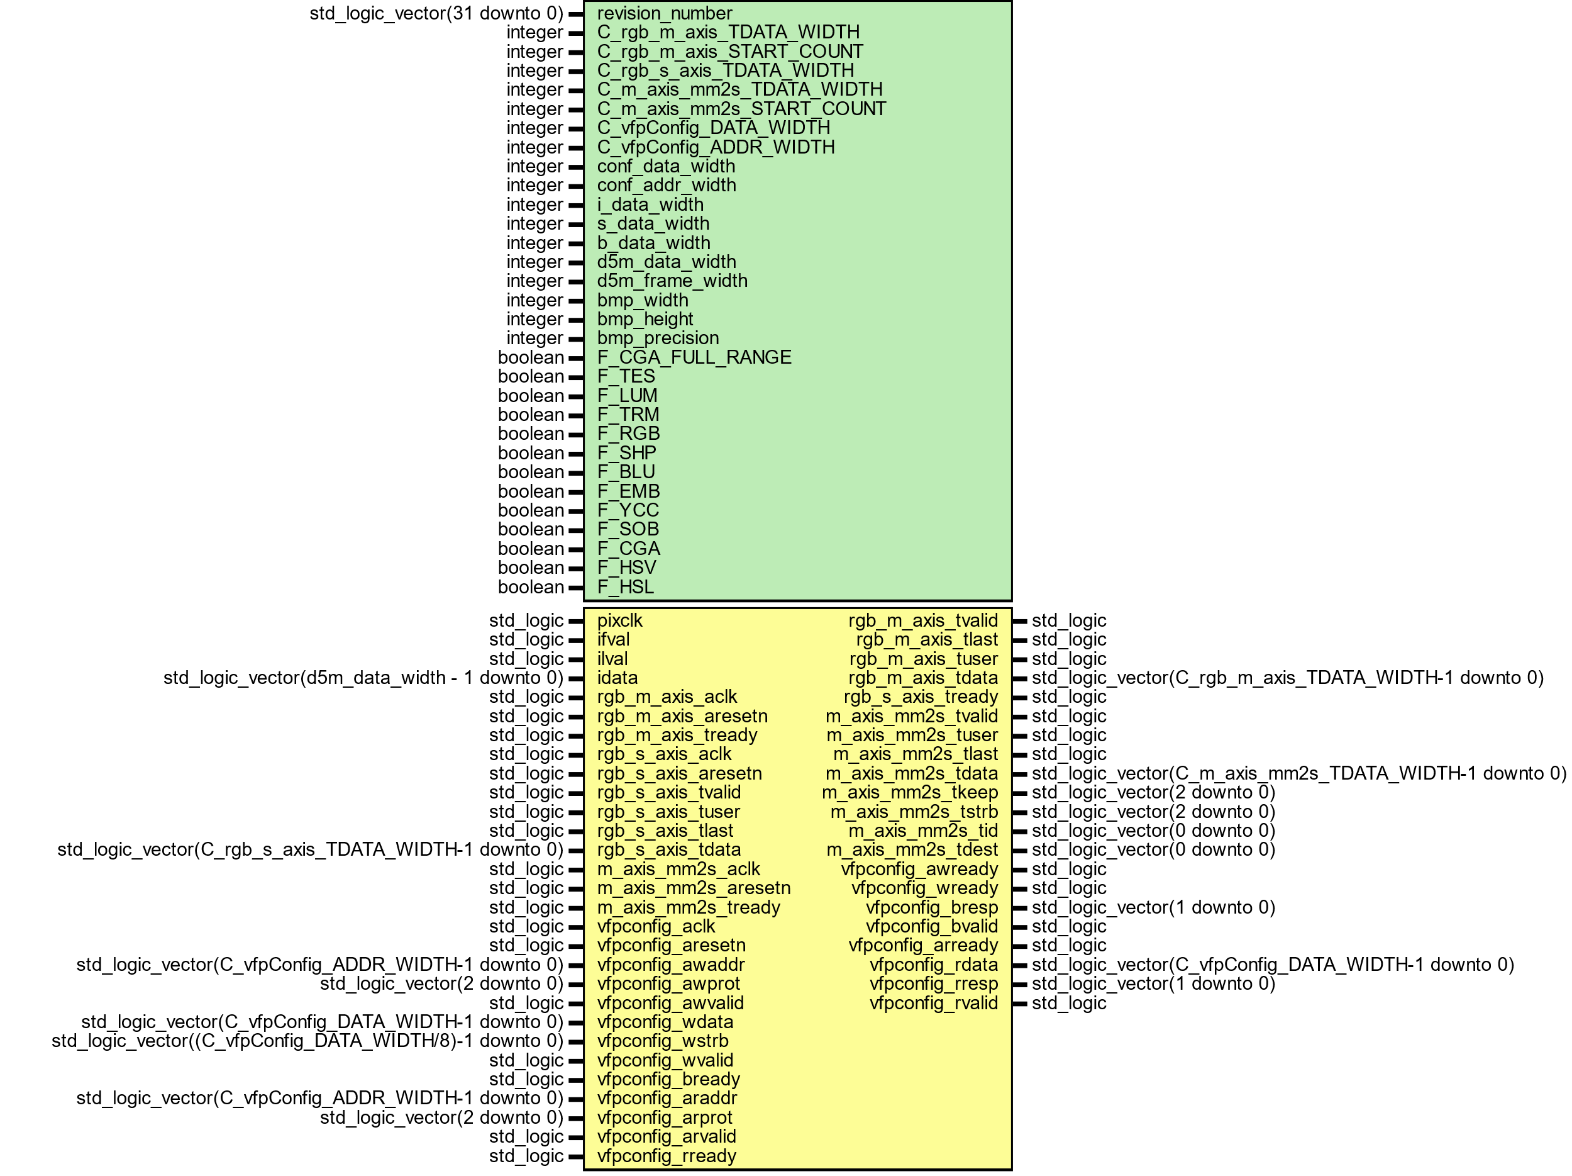

Figure

To configure video stream register, axi4-lite protocol is implemented which present a memory map register interface to the processor.

HSL COLOR SPACE

HSV, HSL and HSI: Hue is a color range degree from 0 degree to 360 degree which describe a pure color. Saturate is shade of gray to full color. Amount of saturation of color is known as chroma. Higher value of chroma is clear and bight. The strongest magnitude is value and its range correspond to brightness and balanced magnitude corresponds to the intensity. Hue color describe the pure color whereas saturate values determine pure color range strength and luminosity describe pure color range. A color with 100% **s**aturation yields purest color and 0% yields grayscale. A color with 0% luminosity is black and 100% luminosity yields bright color.

Value of angles below are hue values on the color wheel.

* 0 degree – Red
* 60 degree – Yellow
* 120 degree – Green
* 180 degree – Cyan
* 240 degree – Blue
* 300 degree – Magenta
* 360 degree – Red-Magenta



From RGB triplet saturation equation shown below where max and min is calculated of between red, green, and blue channel. It represents the strength of the color and the radius of the cone. RGB consist of equal amount of white light. When max rgb component is subtract with minimum rgb component and divided by max rgb component than grayscale intensity is eliminated. Thus, this new color has no white light and saturated and represent a single wavelength.

$$saturate=\frac{\left(max⁡(rgb)-min⁡(rgb)\right)}{max⁡(rgb)}$$

The rgb colors made stronger by increasing the saturation in hsv color space when converted from rgb to hsv and hsv to rgb. The hue, saturation, and intensity elements control wider color range for image enhancement.

RGB TO HSV

The implemented rgb to hsv color space in video color processing module uses hsv algorithm for FPGA devices, and it has been designed with a standard Xilinx AXI4 streaming interface, so that it can be inserted as module ip within any image processing pipeline.

This module converts rgb color space to hsl color space. First logic calculates maximum and minimum value of rgb values. Hue is calculated by determining the hue fraction from greatest rgb channel value. If current max channel is red than Hue numerator will be set to be green subtract blue only if green is greater than blue else blue is subtracted from green and Hue degree would be zero. If current max channel is green than Hue numerator will be set to be blue subtract red only if blue is greater than red else red is subtracted from blue and Hue degree would be 129. Similarly, if current channel is blue than Hue numerator will be set to be red subtract green only if red is greater than green else green subtracted from red and Hue degree would be 212. Hue denominator would be rgb delta. Once Hue fraction values are calculated than fraction values would be added to hue degree which would give final hue value as done logic. Saturate value is calculated from difference between rgb max and min over rgb max whereas Lightness value rgb max value.

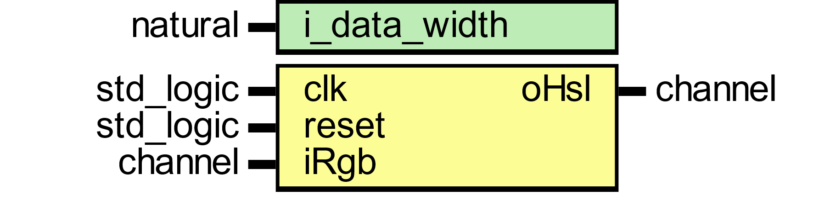

Figure

Rgb to hsl module convert input rgb to hsl color space. The module has clock and reset ports. Port iRGB consist of red, green, and blue rgb channels with valid signal, which is used to convert to rgb pixels to hsl pixels.

|  |  |
| --- | --- |
| **Ports** | **Description** |
| clk | Reference clock for input and output data stream. |
| reset | Specifies module asynchronous active low reset. |
| iRgb.red | 8-bit input data. Red value. |
| iRgb.green | 8-bit input data. Green value. |
| iRgb.blue | 8-bit input data. Blue value. |
| iRgb.valid | Input data valid. Specifies whether the next data point has arrived for processing. |
| oHsl.red | 8-bit output data. Hue value. |
| oHsl.green | 8-bit output data. Saturate value. |
| oHsl.blue | 8-bit output data. Luminosity value. |
| oHsl.valid | Output data valid. Control signal to indicate the validity of each pixel. |

The Functional block diagram of the implemented rgb to hsl color space conversion is shown in Figure 9-12.



The max and min rgb value is calculated according to logic implementation shown in figure above.



Figure : Hue Numerator Logic



Figure : Hue Denominator Logic



Figure : Hue Degree Logic

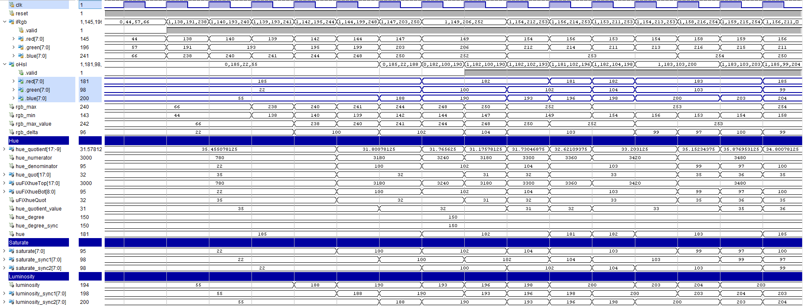

Figure : HSL Filter Wave Diagram

The simulation results of rgb channel conversion to hsl color space is presented in wave diagram figure 8.

|  |  |
| --- | --- |
| A picture containing shape  Description automatically generated  Figure | A picture containing background pattern  Description automatically generated  Figure |

Below figures shows rgb color space conversion implementation into six regions of the hexagon images. The representation of the RGB color space shown in 1st and 3rd figure.

|  |  |  |  |
| --- | --- | --- | --- |
| Figure : RGB image | Figure : HSL converted image | Figure : RGB image | Figure : HSL converted image |
| 1st and 3rd figure are rgb image and whereas 2nd and 4th are hsl simulated results. | | | |
| Figure : HSL Image | Figure : Hue channel | Figure : Saturate channel | Figure : Luminosity channel |
| Figure : HSL Image | Figure : Hue channel | Figure : Saturate channel | Figure : Luminosity channel |
| 1st image is hsl image, 2nd represent hue channel, 3rd saturate channel and 4th luminosity channel.   |  |  |  |  | | --- | --- | --- | --- | |  |  |  |  | | 1ST figure shows rgb image. 2nd figure shows red channel. 3rd figure shows green channel and 4th figure shows blue channel. | | | | | | | |
| |  |  | | --- | --- | | Figure |  | | Figure | Figure | | Figure | Figure | | A picture containing cup, indoor, pot, bin  Description automatically generated  Figure |  | | | | |
| 1st image is hsl image, 2nd represent hue channel, 3rd saturate channel and 4th luminosity channel.  HSL is cylindrical geometry with hue, angular dimension colors transition from red to orange, yellow, green, cyan, blue, magenta. | | | |

HSV TO RGB

The implemented hsv rgb color space in video color processing module uses hsv to rgb conversion algorithm for FPGA devices, and it has been designed with a standard Xilinx AXI4 streaming interface, so that it can be inserted as module ip within any image processing pipeline.



Figure

HSV to RGB module convert input hsv to hsl color space. The module has clock and reset ports. Port iRGB consist of red, green, and blue rgb channels with valid signal, which is used to convert to rgb pixels to hsl pixels.

|  |  |
| --- | --- |
| Ports | Description |
| clk | Reference clock for input and output data stream. |
| reset | Specifies module asynchronous active low reset. |
| iRgb.red | 8-bit input data. Red value. |
| iRgb.green | 8-bit input data. Green value. |
| iRgb.blue | 8-bit input data. Blue value. |
| iRgb.valid | Input data valid. Specifies whether the next data point has arrived for processing. |
| oHsl.red | 8-bit output data. Hue value. |
| oHsl.green | 8-bit output data. Saturate value. |
| oHsl.blue | 8-bit output data. Luminosity value. |
| oHsl.valid | Output data valid. Control signal to indicate the validity of each pixel. |



Figure

HSV COLOR SPACE

This module converts rgb color space to hsl color space. First logic calculates maximum and minimum value of rgb values. Hue is calculated first determining the hue fraction from greatest rgb channel value. If current max channel is red than Hue numerator will be set to be green subtract blue only if green is greater than blue else blue is subtracted from green and Hue degree would be zero. If current max channel is green than Hue numerator will be set to be blue subtract red only if blue is greater than red else red is subtracted from blue and Hue degree would be 129. Similarly, if current channel is blue than Hue numerator will be set to be red subtract green only if red is greater than green else green subtracted from red and Hue degree would be 212. Hue denominator would be rgb delta. Once Hue fraction values are calculated than fraction values would be added to hue degree which would give final hue value as done logic. Saturate value is calculated from difference between rgb max and min over rgb max whereas Intensity value rgb max value.

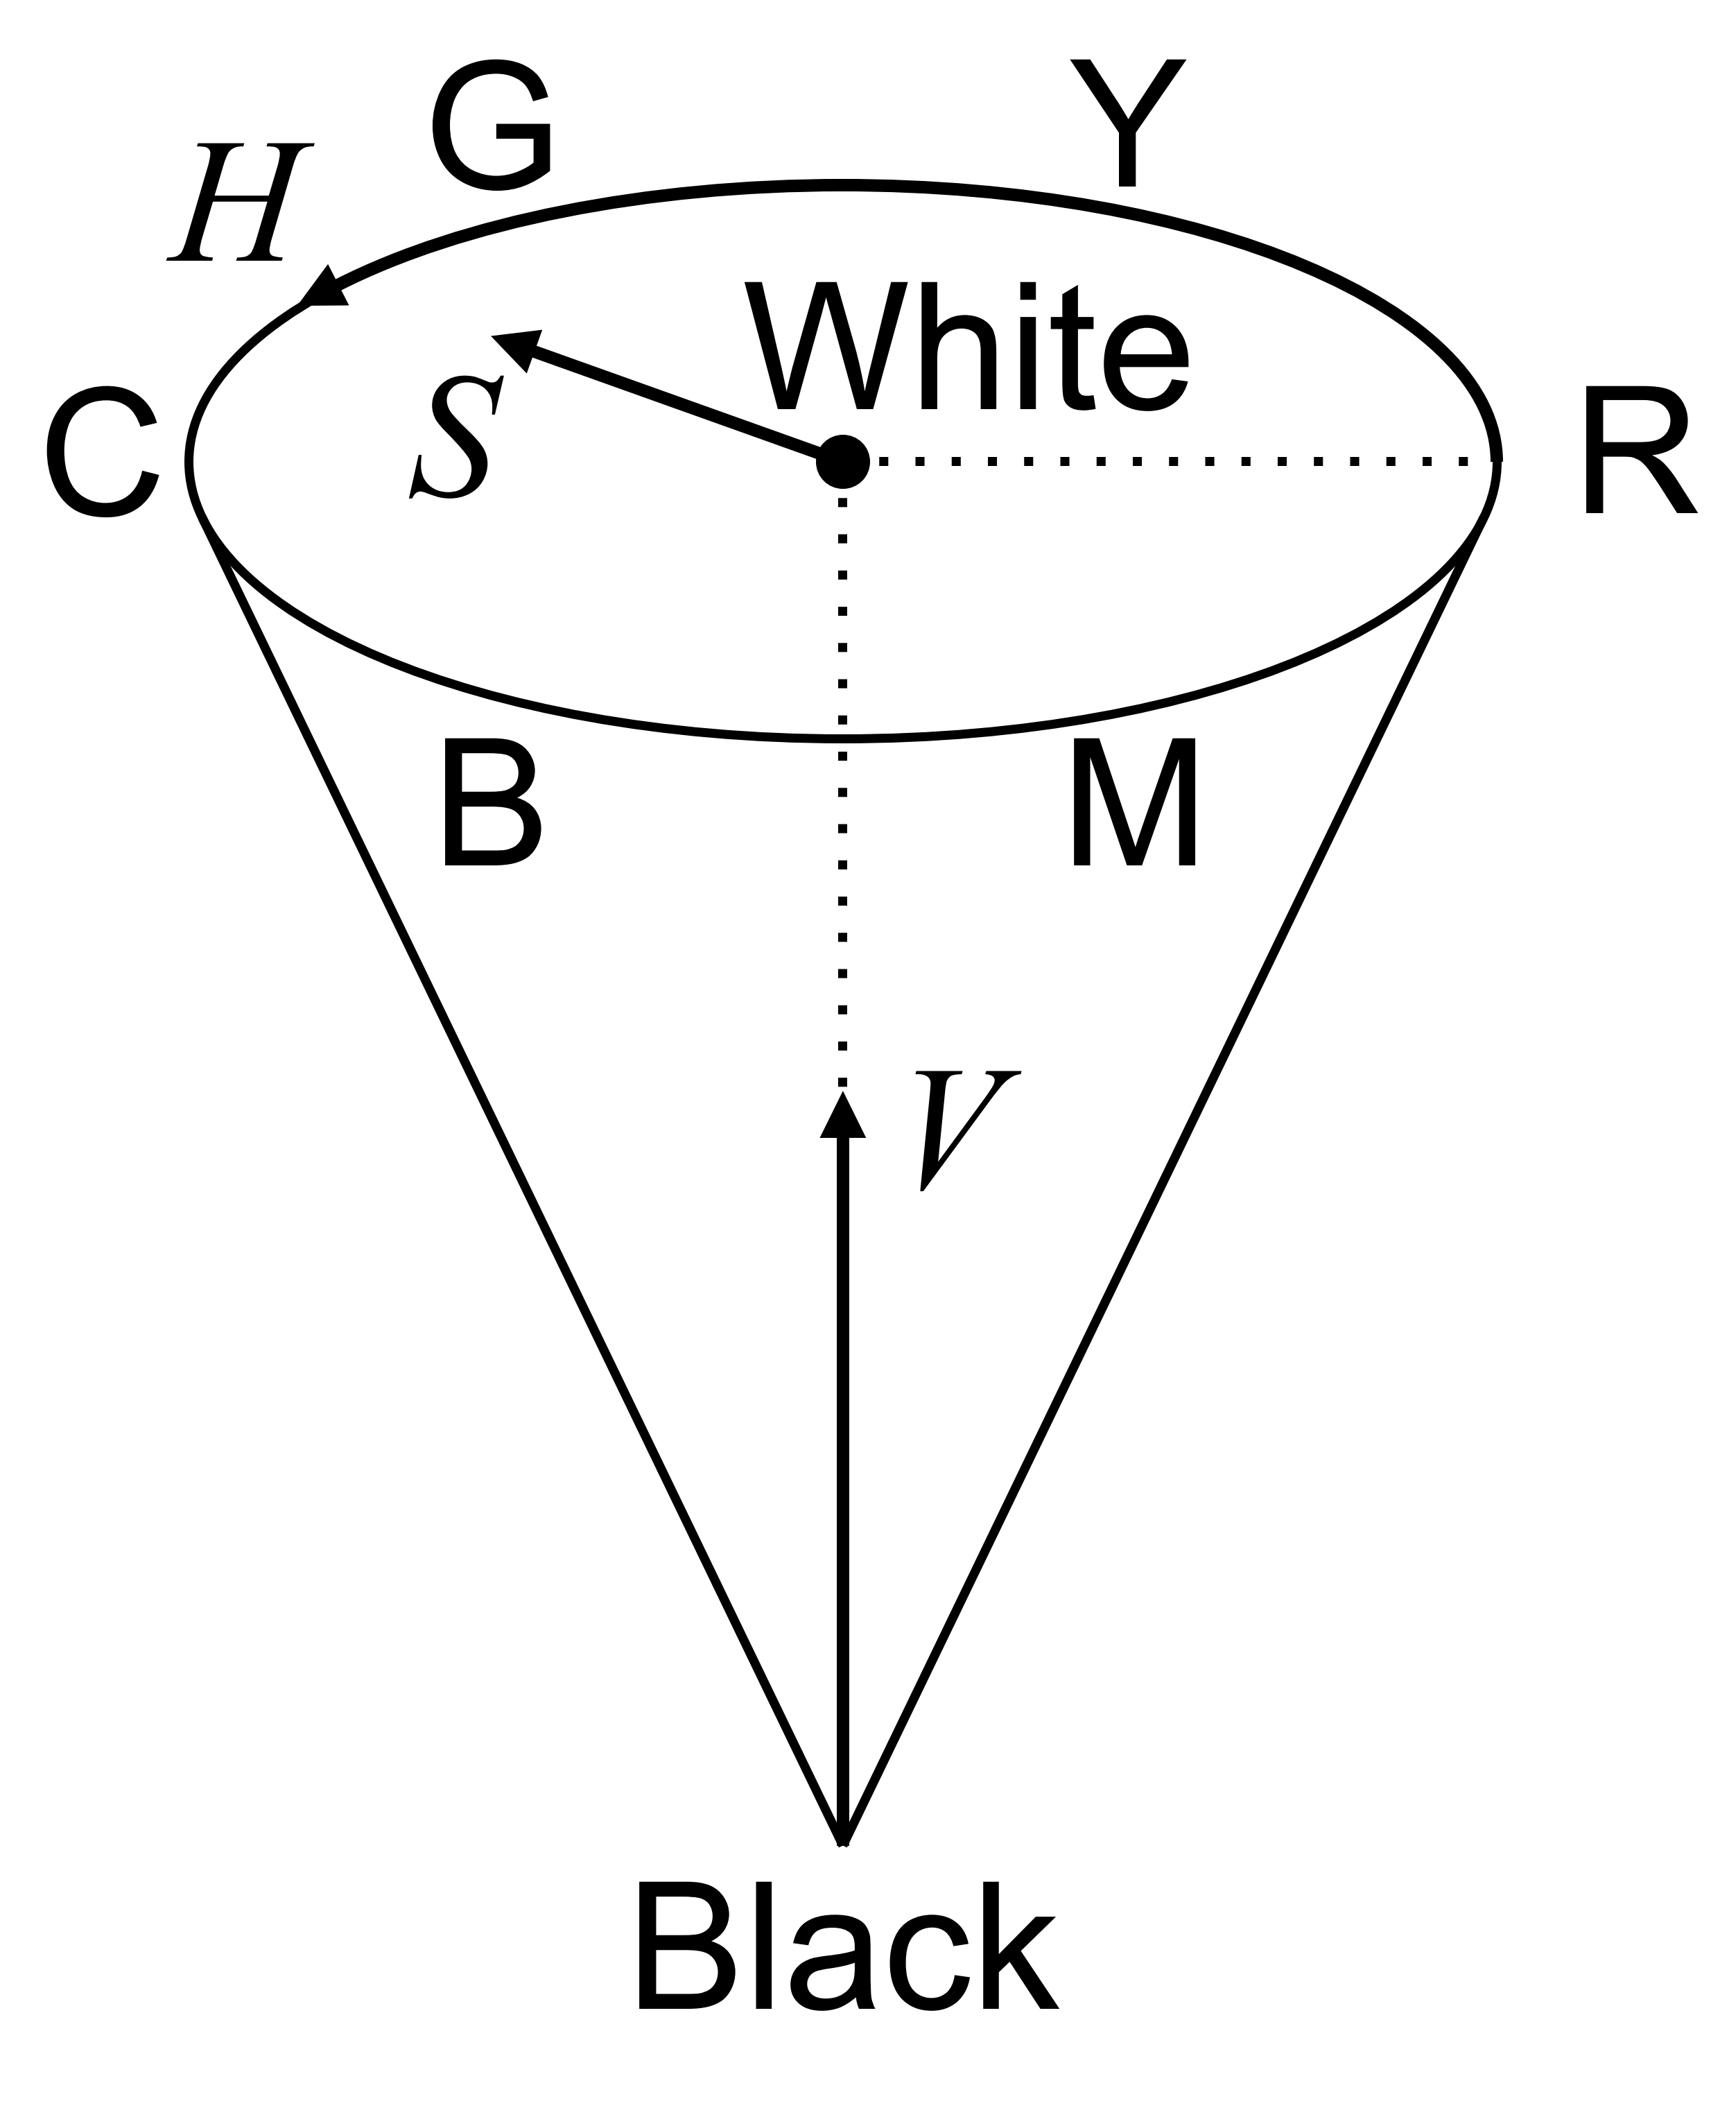

Figure

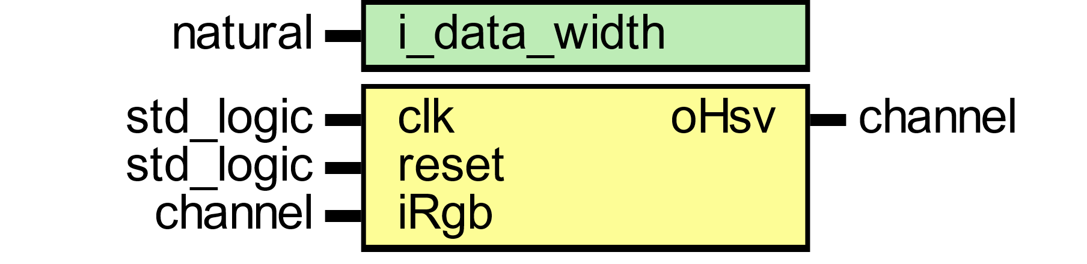

Figure

|  |  |
| --- | --- |
| A picture containing shape  Description automatically generated  Figure | A picture containing shape  Description automatically generated  Figure |

|  |  |  |  |
| --- | --- | --- | --- |
| Figure | Figure | Figure | Figure |
| 1st and 2nd figure are rgb image and whereas 3rd and 4th are hsl simulated results. | | | |
| Figure | Figure | Figure | Figure |
| 1st and 2nd figure are rgb image and whereas 3rd and 4th are hsl simulated results. | | | |
| Figure | A picture containing stationary  Description automatically generated  Figure | Shape  Description automatically generated  Figure | Figure |
| 1st and 2nd figure are rgb image and whereas 3rd and 4th are hsl simulated results. | | | |
| Figure | Figure | Figure | Figure |
| 1ST figure shows rgb image. 2nd figure shows red channel. 3rd figure shows green channel and 4th figure shows blue channel. | | | |

HSL COLOR RANGE SPACE

|  |  |  |  |
| --- | --- | --- | --- |
| Figure | Figure | Figure | Figure |
| 1ST figure shows rgb image. 2nd figure shows red channel. 3rd figure shows green channel and 4th figure shows blue channel.  COLORHSL | | | |
| Figure | Figure | Figure | Figure |
| 1ST figure shows rgb image. 2nd figure shows red channel. 3rd figure shows green channel and 4th figure shows blue channel.  HSL_1RANGE | | | |
| Figure | Figure | Figure | Figure |
| 1ST figure shows rgb image. 2nd figure shows red channel. 3rd figure shows green channel and 4th figure shows blue channel.  HSL_2RANGE | | | |
| Figure | Figure | Figure | Figure |
| 1ST figure shows rgb image. 2nd figure shows red channel. 3rd figure shows green channel and 4th figure shows blue channel. | | | |

HSL_3RANGE

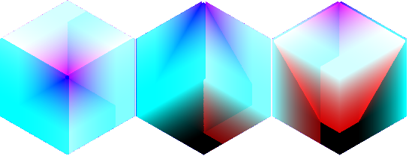

|  |  |  |  |
| --- | --- | --- | --- |
| Figure | Figure | Figure | Figure |
| 1ST figure shows rgb image. 2nd figure shows red channel. 3rd figure shows green channel and 4th figure shows blue channel.  HSVL_1RANGE | | | |
| Figure | Figure | Figure | Figure |
| 1ST figure shows rgb image. 2nd figure shows red channel. 3rd figure shows green channel and 4th figure shows blue channel.  HSVL_2RANGE | | | |
| Figure | Figure | Figure | Figure |
| 1ST figure shows rgb image. 2nd figure shows red channel. 3rd figure shows green channel and 4th figure shows blue channel.  HSVL_3RANGE | | | |
| Figure | Figure | Figure | Figure |
| 1ST figure shows rgb image. 2nd figure shows red channel. 3rd figure shows green channel and 4th figure shows blue channel. | | | |
| HSVL_4RANGE   | | | |
| A large ship in the water  Description automatically generated with medium confidence  Figure | Figure | A large ship in the water  Description automatically generated with medium confidence  Figure | A large ship in the water  Description automatically generated with medium confidence  Figure |
| 1ST figure shows rgb image. 2nd figure shows red channel. 3rd figure shows green channel and 4th figure shows blue channel. | | | |

CMYK COLOR SPACE

The implemented cmyk to rgb color space in video color processing module uses cmyk to rgb conversion algorithm for FPGA devices, and it has been designed with a standard Xilinx AXI4 streaming interface, so that it can be inserted as module ip within any image processing pipeline.

This module takes a stream of camera data in pixel pipeline format. This stream must be presented to the inputs iRgb.red, iRgb.red, iRgb.red, iRgb.valid, iRgb.eol, iRgb.eof and iRgb.sof. The result of this module steam cmyk color space in output oRgb channel.

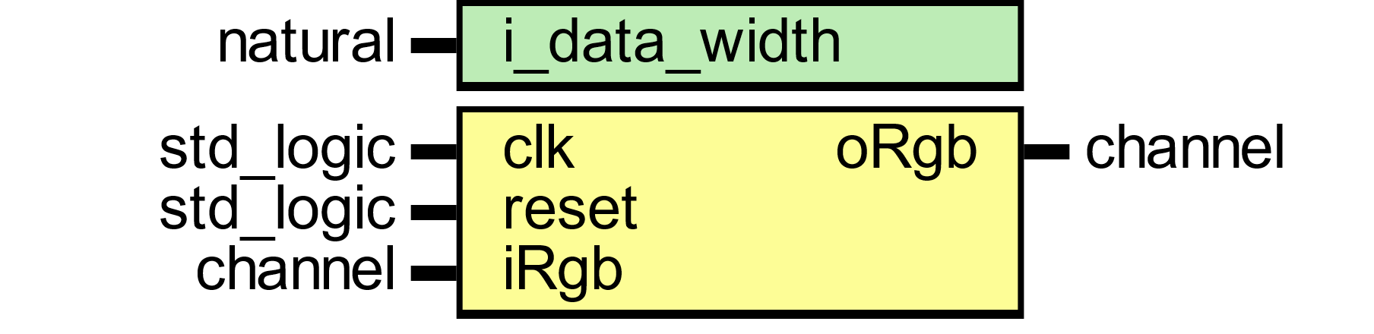

CMYK (Cyan, Magenta, Yellow, Key/Black) is the color space for printed materials.

|  |  |
| --- | --- |
| A picture containing shape  Description automatically generated  Figure | Shape  Description automatically generated  Figure |
| A picture containing colorful, pallette, several  Description automatically generated  Figure | A picture containing pallette  Description automatically generated  Figure |
| A picture containing indoor  Description automatically generated  Figure | Figure |

From these values, the value of colors can be calculated from the following equations:

$$K=1-MAX\left(R,G,B\right)$$

$$C =(1-R-K)(1-K)$$ $M=(1-G-K)(1-K)$ $$Y =(1-B-K)(1-K)$$

CMYK color space has four dimensions, and it is used for printing color images. The color printer makes use of subtractive(secondary) color scheme. The minimum requirement for color printer is equipped with three primary colors: cyan(C), magenta (M), and yellow (Y). The secondary colors Yellow, Cyan and Magenta are generated by adding primary colors Red, Green and Blue. Above figures shows, a 500 x 500 color image in RGB and CYM formats. The pinkish color in RGB transformed into greenish, as the red and blue component intensities are high compared to green. The black color is generated by combining all the colors whereas white is set with no colors.

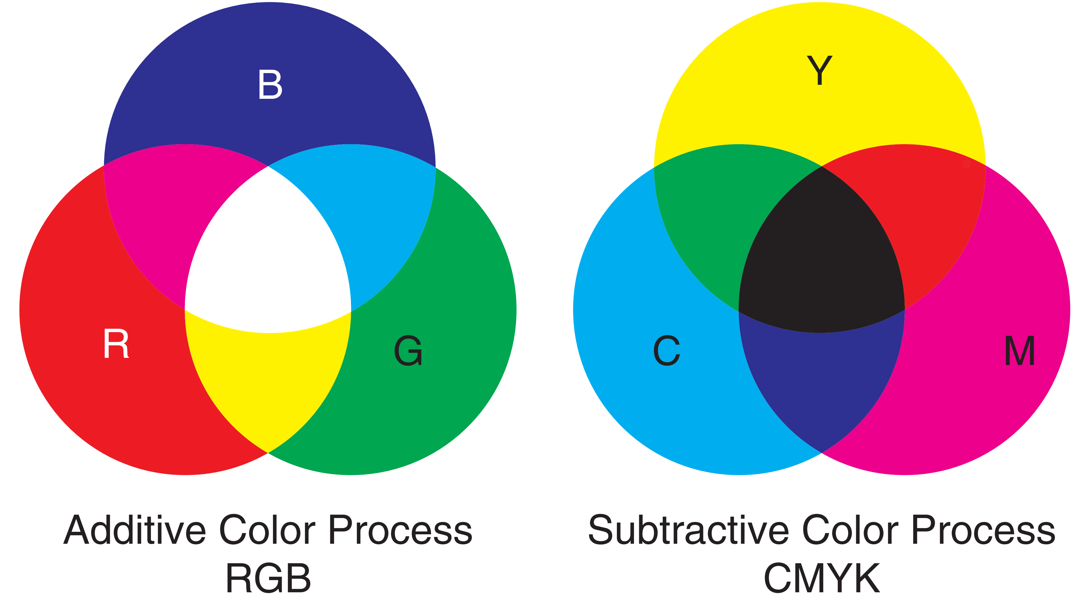 

YDBDR COLOR SPACE

This module takes a stream of camera data in pixel pipeline format. This stream must be presented to the inputs iRgb.red, iRgb.red, iRgb.red, iRgb.valid, iRgb.eol, iRgb.eof and iRgb.sof. The result of this module steam YDRDB color space in output oRgb channel.



|  |  |
| --- | --- |
| Figure RGB Image | Shape  Description automatically generated  Figure YDBDR Image |
| A picture containing indoor  Description automatically generated  Figure RGB Image | Figure YDBDR Image |

In this color space, Figure 95 image represent by three components, namely, Y, DB, and DR.

The R, G, B tristimulus values converted to Y, DB, DR tristimulus values as follows:

$$\left[\begin{matrix}Y \\ D_{R} \\ D_{B}\end{matrix}\right]=\left[\begin{matrix}0.299 & 0.587 & 0.114 \\ -0.450 & -0.883 & 1.333 \\ -1.333 & -1.160 & 0.217\end{matrix}\right]\left[\begin{matrix}R \\ G \\ B\end{matrix}\right]$$

Above figures illustrates the result of convert color image space in RGB domain to image with YDRDB components.

CIEXYZ COLOR SPACE

This module takes a stream of camera data in pixel pipeline format. This stream must be presented to the inputs iRgb.red, iRgb.red, iRgb.red, iRgb.valid, iRgb.eol, iRgb.eof and iRgb.sof. The result of this module steam CIE-XYZ color space in output oRgb channel.



|  |  |
| --- | --- |
| A picture containing shape  Description automatically generated  Figure | Figure |
| A picture containing indoor  Description automatically generated  Figure | Figure |

Above figures illustrates the result of convert color image space in RGB domain to image with XYZ components.

The R, G, B tristimulus values converted to X, Y, Z tristimulus values. The relationship between RGB and the XYZ values expressed by a 3x3 matrix as shown in equation below.

$$\left[\begin{matrix}X \\ Y \\ Z\end{matrix}\right]=\left[\begin{matrix}0.412 & 0.357 & 0.180 \\ 0.212 & 0.715 & 0.072 \\ 0.019 & 0.119 & 0.950\end{matrix}\right]\left[\begin{matrix}R \\ G \\ B\end{matrix}\right]$$

The coefficients values in 3x3 matrix are multiplied to input RGB components and the sum of the result values as per XYZ channel.

CIEYUV COLOR SPACE

This module takes a stream of camera data in pixel pipeline format. This stream must be presented to the inputs iRgb.red, iRgb.red, iRgb.red, iRgb.valid, iRgb.eol, iRgb.eof and iRgb.sof. The result of this module steam CIE-YUV color space in output oRgb channel.



|  |  |
| --- | --- |
| A picture containing shape  Description automatically generated  Figure | Figure |
| A picture containing indoor  Description automatically generated  Figure | Figure |

The R, G, B tristimulus values converted to Y, U, V tristimulus values as follows:

$$\left[\begin{matrix}Y \\ U \\ V\end{matrix}\right]=\left[\begin{matrix}0.299 & 0.587 & 0.114 \\ -0.147 & -0.289 & 0.436 \\ 0.615 & -0.515 & -0.100\end{matrix}\right]\left[\begin{matrix}R \\ G \\ B\end{matrix}\right]$$

YIQ COLOR SPACE

This module takes a stream of camera data in pixel pipeline format. This stream must be presented to the inputs iRgb.red, iRgb.red, iRgb.red, iRgb.valid, iRgb.eol, iRgb.eof and iRgb.sof. The result of this module steam YIQ color space in output oRgb channel.



|  |  |
| --- | --- |
| A picture containing shape  Description automatically generated  Figure | Figure |
| A picture containing indoor  Description automatically generated  Figure | Figure |

In this color space, Figure 107 image represent by three components, namely, Y, I, and Q. The Y-channel (this corresponds roughly with intensity) is the luminance component, and I(In-Phase)/Q(Quadrature) represent chrominance (color information: chroma, jointly describe the hue and saturation). This color space separate intensity information from color details.

The R, G, B tristimulus values converted to Y, I, Q tristimulus values as follows:

$$\left[\begin{matrix}Y \\ I \\ Q\end{matrix}\right]=\left[\begin{matrix}0.299 & 0.587 & 0.114 \\ 0.595 & -0.274 & -0.321 \\ 0.211 & -0.522 & -0.311\end{matrix}\right]\left[\begin{matrix}R \\ G \\ B\end{matrix}\right]$$

Figure 106 shows RGB converted to YIQ color space Figure 106 using the transformation of above equation. Note the elements of 1st row in the conversion matrix sum to 1 and 2nd and 3rd rows sum to zero. IQ components are transmitted with slower amplitude variations with limited image details whereas Y component contain more gray level image details of information.

YPBPR COLOR SPACE

This module takes a stream of camera data in pixel pipeline format. This stream must be presented to the inputs iRgb.red, iRgb.red, iRgb.red, iRgb.valid, iRgb.eol, iRgb.eof and iRgb.sof. The result of this module steam YPBPR color space in output oRgb channel.



|  |  |
| --- | --- |
| A picture containing shape  Description automatically generated  Figure | Figure |
| Figure | Figure |

In this color space, Figure 111 image represent by three components, namely, Y, PB, and PR. The Y-channel corresponds to luminance component, PB channel corresponds to difference between blue and luma and whereas PR channel corresponds to difference between red and luma.

The R, G, B tristimulus values converted to Y, PR, PB tristimulus values as follows:

$$\left[\begin{matrix}Y \\ P_{R} \\ P_{B}\end{matrix}\right]=\left[\begin{matrix}0.213 & 0.715 & 0.072 \\ -0.115 & -0.385 & 0.500 \\ 0.500 & -0.454 & -0.046\end{matrix}\right]\left[\begin{matrix}R \\ G \\ B\end{matrix}\right]$$

I1I2I3 OHTA COLOR INTENSITIES

This module takes a stream of camera data in pixel pipeline format. This stream must be presented to the inputs iRgb.red, iRgb.red, iRgb.red, iRgb.valid, iRgb.eol, iRgb.eof and iRgb.sof. The result of this module steam I1I2I3 color space in output oRgb channel.



Figure

|  |  |
| --- | --- |
| A picture containing shape  Description automatically generated  Figure | A picture containing shape  Description automatically generated  Figure |
| Figure | Figure |

LMS COLOR SPACE

This module takes a stream of camera data in pixel pipeline format. This stream must be presented to the inputs iRgb.red, iRgb.red, iRgb.red, iRgb.valid, iRgb.eol, iRgb.eof and iRgb.sof. The result of this module steam LMS color space in output oRgb channel.



Figure

|  |  |
| --- | --- |
| A picture containing shape  Description automatically generated  Figure | A picture containing shape  Description automatically generated  Figure |
| A picture containing indoor  Description automatically generated  Figure | Figure |

The R, G, B tristimulus values converted to L, M, S tristimulus values as follows:

$$\left[\begin{matrix}L \\ M \\ S\end{matrix}\right]=\left[\begin{matrix}0.400 & 0.707 & -0.080 \\ -0.228 & 1.150 & 0.061 \\ 0.000 & 0.000 & 0.918\end{matrix}\right]\left[\begin{matrix}R \\ G \\ B\end{matrix}\right]$$

ICTCP COLOR SPACE

This module takes a stream of camera data in pixel pipeline format. This stream must be presented to the inputs iRgb.red, iRgb.red, iRgb.red, iRgb.valid, iRgb.eol, iRgb.eof and iRgb.sof. The result of this module steam ICTCP color space in output oRgb channel.



Figure

|  |  |
| --- | --- |
| A picture containing shape  Description automatically generated  Figure | A picture containing shape  Description automatically generated  Figure |
| A picture containing indoor  Description automatically generated  Figure | Figure |

The R, G, B tristimulus values converted to I, CT, CP tristimulus values as follows:

$$\left[\begin{matrix}I \\ C_{T} \\ C_{P}\end{matrix}\right]=\left[\begin{matrix}0.400 & 0.400 & 0.200 \\ 4.455 & -4.851 & 3.960 \\ 8.056 & 3.572 & -1.162\end{matrix}\right]\left[\begin{matrix}R \\ G \\ B\end{matrix}\right]$$

HED COLOR SPACE

This module takes a stream of camera data in pixel pipeline format. This stream must be presented to the inputs iRgb.red, iRgb.red, iRgb.red, iRgb.valid, iRgb.eol, iRgb.eof and iRgb.sof. The result of this module steam HED color space in output oRgb channel.



Figure

|  |  |
| --- | --- |
| A picture containing shape  Description automatically generated  Figure | Figure |
| A picture containing indoor  Description automatically generated  Figure | Figure |

The R, G, B tristimulus values converted to H, E, D tristimulus values as follows:

$$\left[\begin{matrix}H \\ E \\ D\end{matrix}\right]=\left[\begin{matrix}1.800 & -0.070 & -0.600 \\ -1.020 & -1.130 & -0.480 \\ -0.550 & -0.130 & 1.570\end{matrix}\right]\left[\begin{matrix}R \\ G \\ B\end{matrix}\right]$$

YC1C2 COLOR SPACE

This module takes a stream of camera data in pixel pipeline format. This stream must be presented to the inputs iRgb.red, iRgb.red, iRgb.red, iRgb.valid, iRgb.eol, iRgb.eof and iRgb.sof. The result of this module steam YC1C2 color space in output oRgb channel.



Figure

|  |  |
| --- | --- |
| A picture containing shape  Description automatically generated  Figure | Figure |
| A picture containing indoor  Description automatically generated  Figure | Figure |

The R, G, B tristimulus values converted to Y, C1, C2 tristimulus values as follows:

$$\left[\begin{matrix}Y \\ P_{R} \\ P_{B}\end{matrix}\right]=\left[\begin{matrix}0.213 & 0.715 & 0.072 \\ -0.115 & -0.385 & 0.500 \\ 0.500 & -0.454 & -0.046\end{matrix}\right]\left[\begin{matrix}R \\ G \\ B\end{matrix}\right]$$

|  |
| --- |
|  |

SHARP FILTER

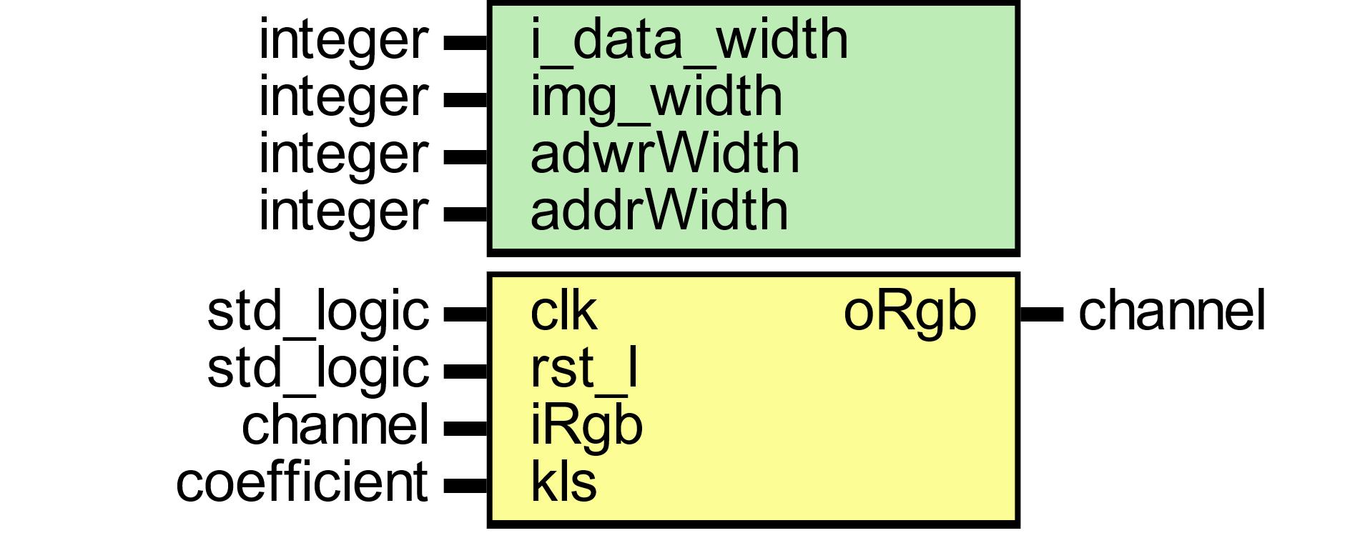

Figure

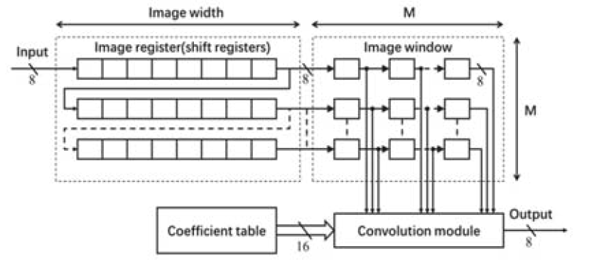

The sharp filter has been implemented and tested for an image size of 1024 × 1024 as shown figure below.

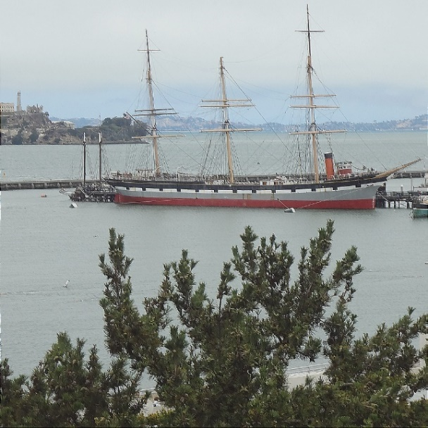

BLUR FILTER

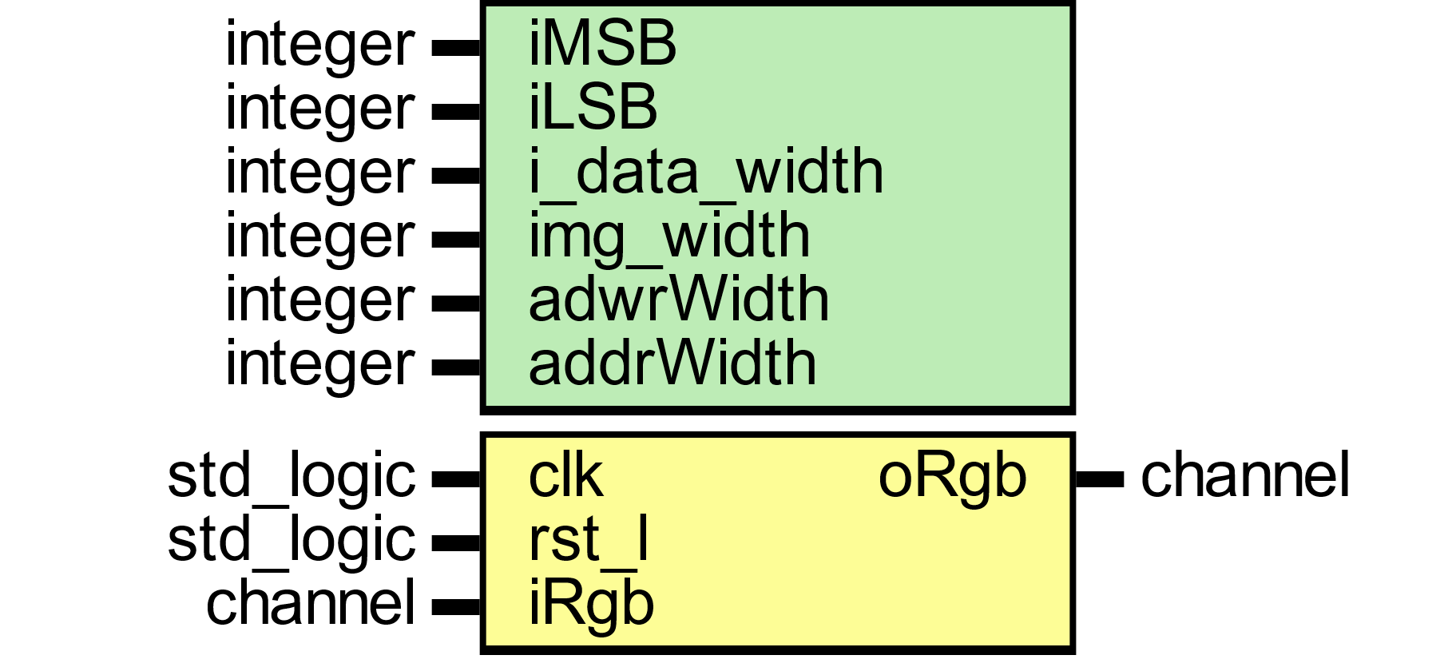

Figure



|  |  |  |  |
| --- | --- | --- | --- |
| Gray Level Colors | | | |
| 0.400 | 0.350 | 0.200 | 0.950 |
| 0.200 | 0.700 | 0.100 | 1.00 |
| 0.05 | 0.100 | 0.900 | 1.05 |
| 0.605 | 1.15 | 1.20 | ∑ |

EMBOSS FILTER



An emboss filter will take video frame and convert into an embossed image.

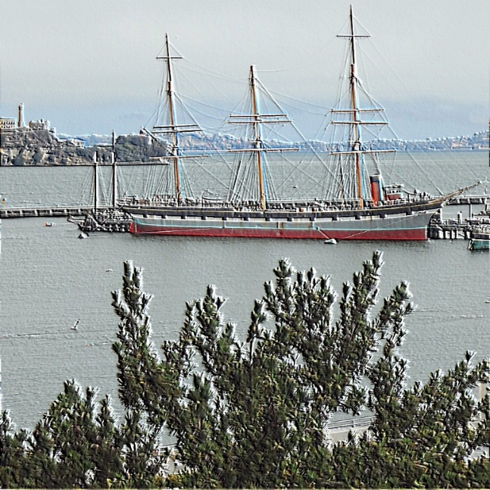

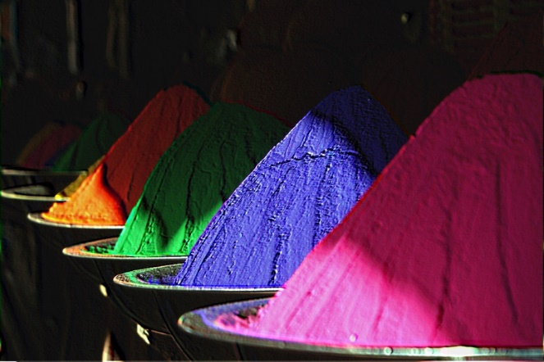

SOBEL FILTER

For Sobel edge detection, monochrome RGB pixel are used of 8 bits which are stored in row-by-row memory of successive pixels. Two Sobel filters are used for edge detection. There are two distinct filters, one which computes vertical edge left and one for horizontal edge right. The filters are convolved with the entire input 3-line buffer which holds the pixel information. The vertical edge component is calculated with vertical filter Ky into input the first tap1 of 8 bits and then tap2 and tap3 sum to 3 Ky taps (3 elements of 1st rows of filter). The Same calculation is applied to horizontal filter 3 columns Kx gives the output of sum 3 Kx taps(3 elements of 1st column of filter). The resulted sum 3 Ky taps gives us the final sum of Vertical Kvy1,2,3 and 3 sum for horizontal Kvx1,2,3. Final output of vertical and horizontal is given by Rxy which is the square root of sum Kvy and Kvx. √ . The Figure below illustrates the concept of Sobel Filter for Video Edge detection.

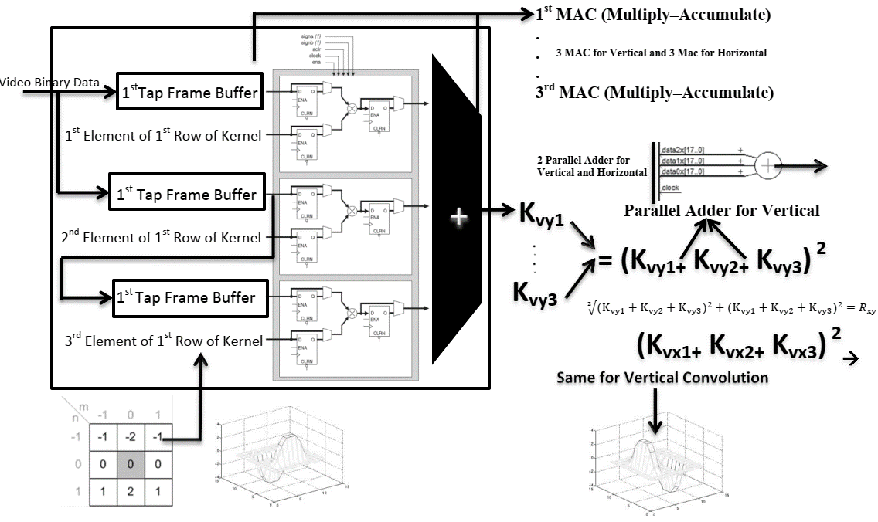

Three lines video buffer have used for a filter with 3x3 kernel for both vertical and horizontal edge detection. Then the video buffer enters the filter in a parallel form. Each 3 t-taps module takes the data taps from the line buffer with a rate faster than system clock rate by 3 times and multiply them by the 3 filter coefficients. The output from each multiplications process is accumulated in the accumulator. Then finally sum all three 3-Tap filter from the accumulator fed into parallel adder which form one processed pixel. Once the Rxy is calculated the value is compared with threshold which is the user input from the switches (12 to 1). If the pixel output from Rxy is greater than the threshold, the pixel is detected as the edge otherwise no output to the RGB channel.

A Sobel filter will take video frame and convert into an Sobel image.

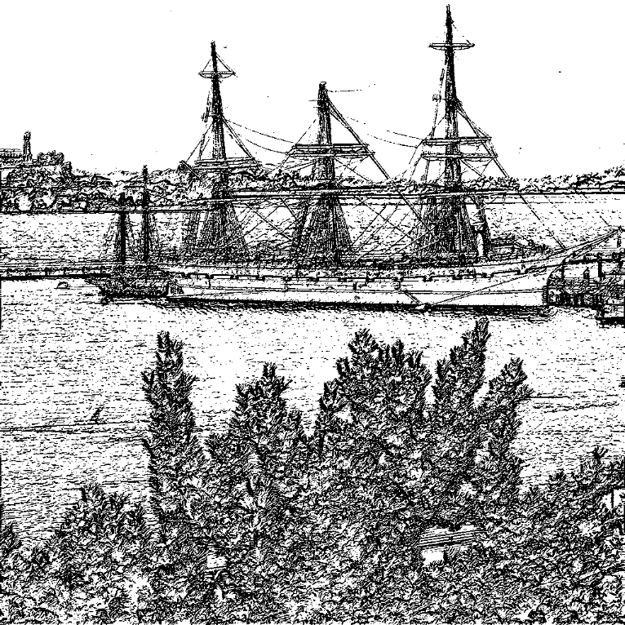

Figure

YCBCR COLOR SPACE

This module takes a stream of camera data in pixel pipeline format. This stream must be presented to the inputs iRgb.red, iRgb.red, iRgb.red, iRgb.valid, iRgb.eol, iRgb.eof and iRgb.sof. The result of this module steam CIE-XYZ color space in output oRgb channel.



Figure

Cb refers to the blue-difference chroma component, and Cr refers to the red-difference chroma component.

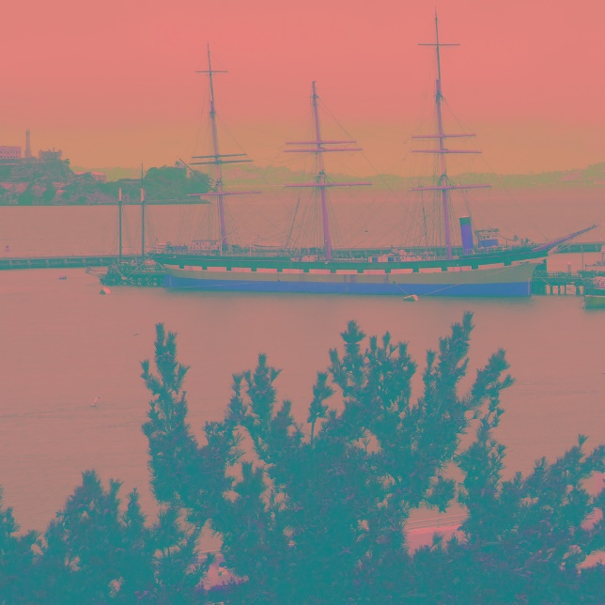

Figure

COLOR ADJUST MATRIX

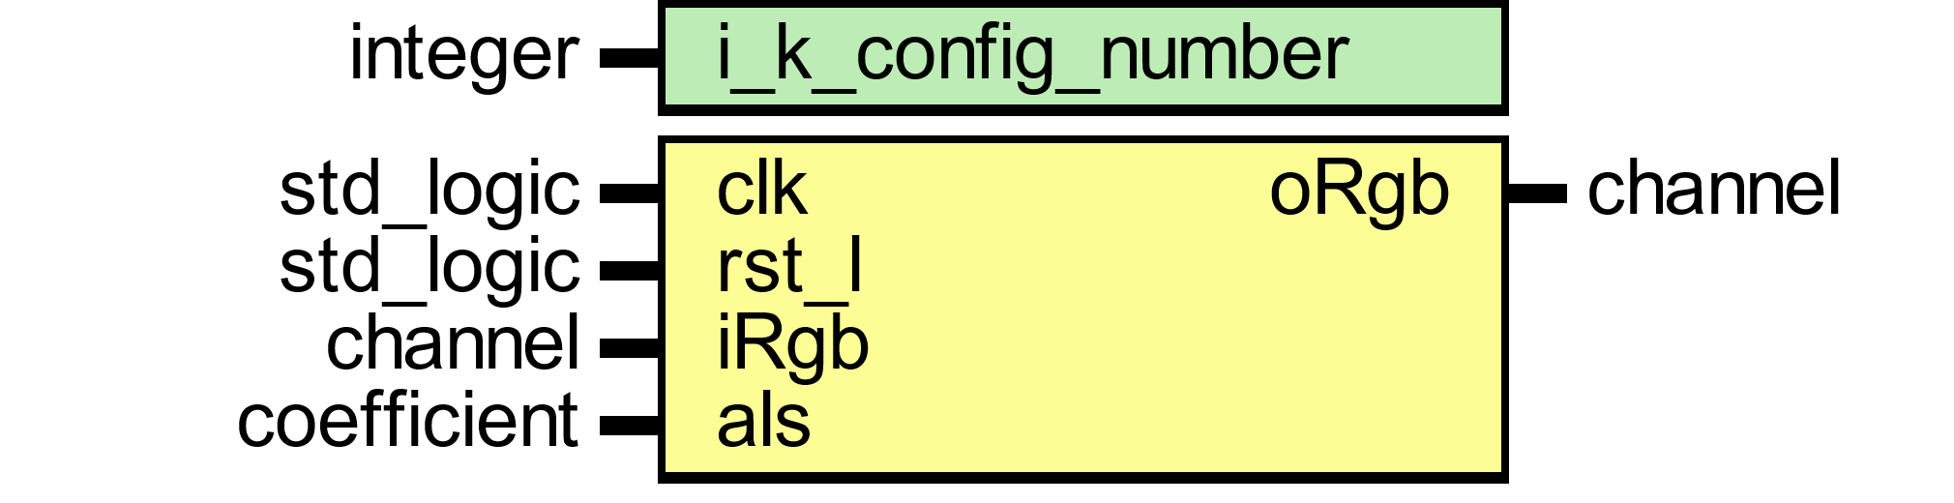

Figure

The objective of the color adjust matrix is to transform each pixel red, green and blue channel into improve suitable agreement in display and light sources sensitivity. The color adjust matrix can eb expressed as a 3x3 matrix as in equation below. The ‘CAM’ is used to denote the color adjust matrix rgb values.

$$\left[\begin{matrix}R_{CAM} \\ G_{CAM} \\ B_{CAM}\end{matrix}\right]=\left[\begin{matrix}K1 & K2 & K3 \\ K4 & K5 & K6 \\ K7 & K8 & K9\end{matrix}\right]\left[\begin{matrix}R \\ G \\ B\end{matrix}\right]$$

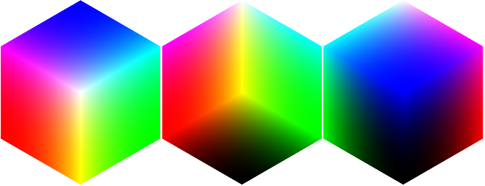

The color transformations defined in this section are for each color in pixel changed into unique color as multicolor colors range changed into single color.

COLOR MANIPULATION INDEX # 01

|  |  |  |  |  |
| --- | --- | --- | --- | --- |
| Color Adjust Matrix | | | | |
| CAM-1 | 5.000 | -3. 313 | -1. 687 | 0.00 |
| -1. 687 | 5.000 | -3. 313 | 0.00 |
| -3. 313 | -1. 687 | 5.000 | 0.00 |
| 0.00 | 0.00 | 0.00 |  |
| CAM-2 | 1.200 | -0.435 | -0.165 | 0.600 |
| -0.165 | 1.200 | -0.435 | 0.600 |
| -0.435 | -0.165 | 1.200 | 0.600 |
| 0.600 | 0.600 | 0.600 |  |
| CAM-3 | 0.900 | 0.300 | 0.350 | 1.650 |
| 0.350 | 0.900 | 0.300 | 1.650 |
| 0.300 | 0.350 | 0.900 | 1.650 |
| 1.650 | 1.650 | 1.650 |  |

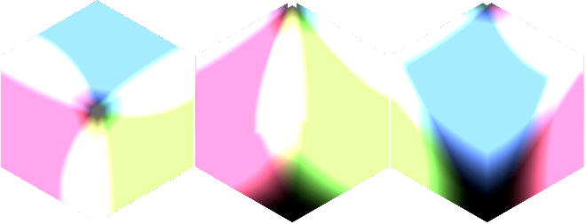

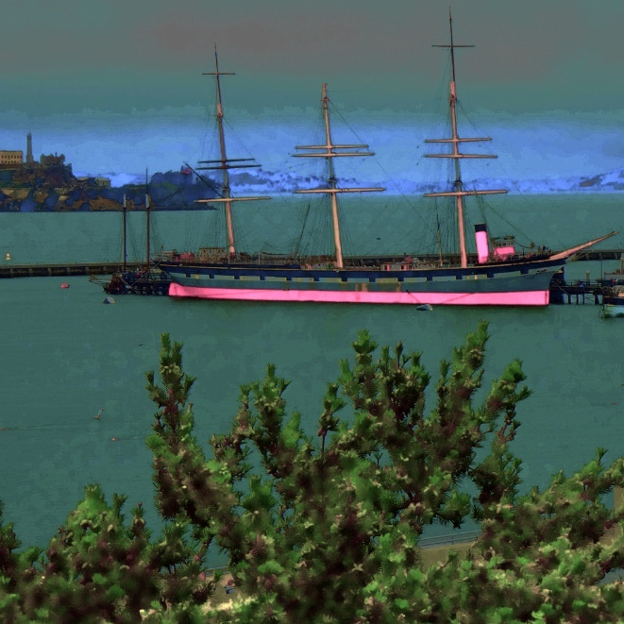

Color Manipulation Index # 02

|  |  |  |  |  |
| --- | --- | --- | --- | --- |
| Color Adjust Matrix | | | | |
| CAM-1 | 1.340 | -0.850 | -0.400 | 0.09 |
| -0.400 | 1.340 | -0.850 | 0.09 |
| -0.850 | -0.400 | 1.340 | 0.09 |
| 0.09 | 0.09 | 0.09 |  |
| CAM-2 | 2.000 | -0.200 | -0.100 | 1.70 |
| -0.100 | 2.000 | -0.200 | 1.70 |
| -0.200 | -0.100 | 2.000 | 1.70 |
| 1.70 | 1.70 | 1.70 |  |
| CAM-3 | 1.5 | 0.900 | 0.650 | 3.05 |
| 0.650 | 1.5 | 0.900 | 3.05 |
| 0.900 | 0.650 | 1.5 | 3.05 |
| 3.05 | 3.05 | 3.05 |  |

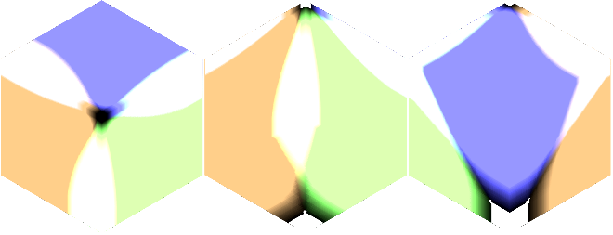

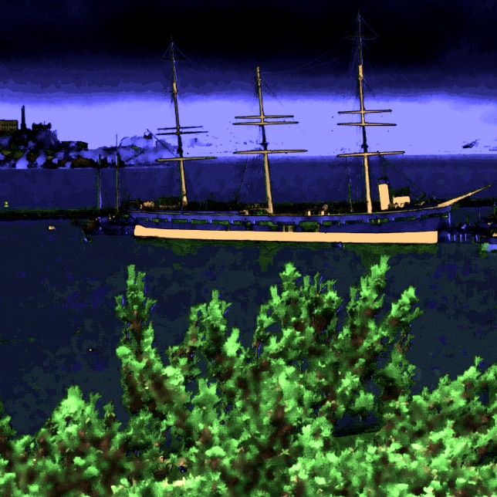

Color Manipulation Index # 03

|  |  |  |  |  |
| --- | --- | --- | --- | --- |
| Color Adjust Matrix | | | | |
| CAM-1 | 1.5 | -0.250 | -0.250 | 1.00 |
| -0.250 | 1.5 | -0.250 | 1.00 |
| -0.250 | -0.250 | 1.5 | 1.00 |
| 1.00 | 1.00 | 1.00 |  |
| CAM-2 | 1.5 | -0.250 | -0.250 | 1.00 |
| -0.250 | 1.5 | -0.250 | 1.00 |
| -0.250 | -0.250 | 1.5 | 1.00 |
| 1.00 | 1.00 | 1.00 |  |
| CAM-3 | 1.5 | -0.250 | -0.250 | 1.00 |
| -0.250 | 1.5 | -0.250 | 1.00 |
| -0.250 | -0.250 | 1.5 | 1.00 |
| 1.00 | 1.00 | 1.00 |  |

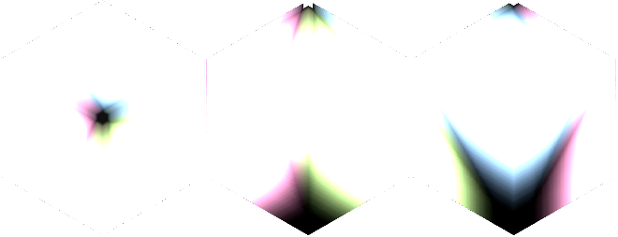

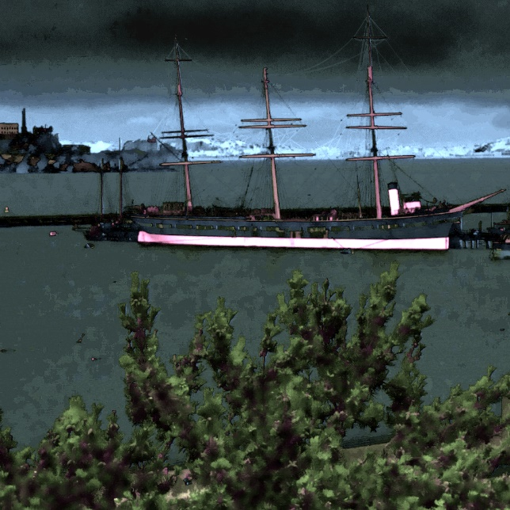

Color Manipulation Index # 04

|  |  |  |  |  |
| --- | --- | --- | --- | --- |
| Color Adjust Matrix | | | | |
| CAM-1 | 1.5 | -0.250 | -0.250 | 1.00 |
| -0.250 | 1.5 | -0.250 | 1.00 |
| -0.250 | -0.250 | 1.5 | 1.00 |
| 1.00 | 1.00 | 1.00 |  |
| CAM-2 | 1.5 | -0.250 | -0.250 | 1.00 |
| -0.250 | 1.5 | -0.250 | 1.00 |
| -0.250 | -0.250 | 1.5 | 1.00 |
| 1.00 | 1.00 | 1.00 |  |
| CAM-3 | 1.5 | -0.250 | -0.250 | 1.00 |
| -0.250 | 1.5 | -0.250 | 1.00 |
| -0.250 | -0.250 | 1.5 | 1.00 |
| 1.00 | 1.00 | 1.00 |  |

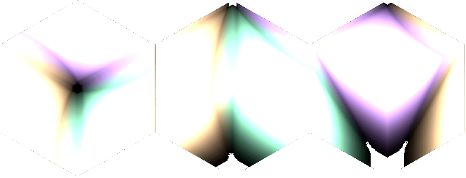

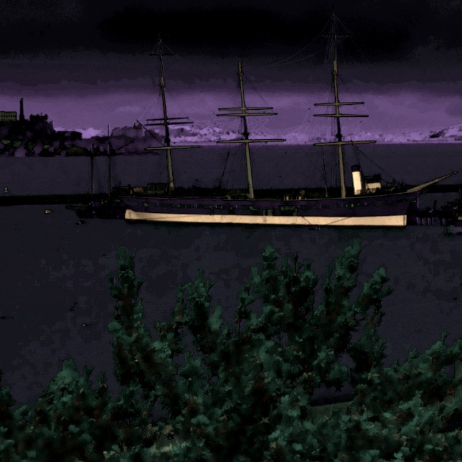

Color Manipulation Index # 05

|  |  |  |  |  |
| --- | --- | --- | --- | --- |
| Color Adjust Matrix | | | | |
| CAM-1 | 1.5 | -0.250 | -0.250 | 1.00 |
| -0.250 | 1.5 | -0.250 | 1.00 |
| -0.250 | -0.250 | 1.5 | 1.00 |
| 1.00 | 1.00 | 1.00 |  |
| CAM-2 | 1.5 | -0.250 | -0.250 | 1.00 |
| -0.250 | 1.5 | -0.250 | 1.00 |
| -0.250 | -0.250 | 1.5 | 1.00 |
| 1.00 | 1.00 | 1.00 |  |
| CAM-3 | 1.5 | -0.250 | -0.250 | 1.00 |
| -0.250 | 1.5 | -0.250 | 1.00 |
| -0.250 | -0.250 | 1.5 | 1.00 |
| 1.00 | 1.00 | 1.00 |  |

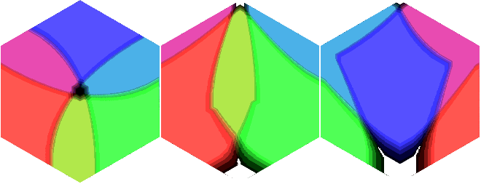

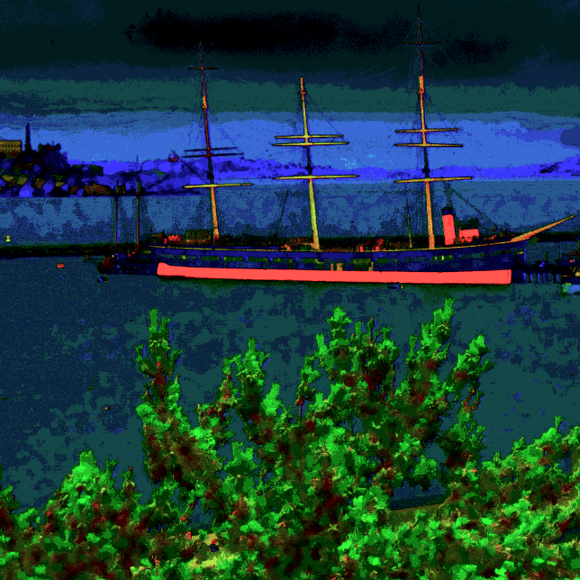

Color Manipulation Index # 06

|  |  |  |  |  |
| --- | --- | --- | --- | --- |
| Color Adjust Matrix | | | | |
| CAM-1 | 1.5 | -0.250 | -0.250 | 1.00 |
| -0.250 | 1.5 | -0.250 | 1.00 |
| -0.250 | -0.250 | 1.5 | 1.00 |
| 1.00 | 1.00 | 1.00 |  |
| CAM-2 | 1.5 | -0.250 | -0.250 | 1.00 |
| -0.250 | 1.5 | -0.250 | 1.00 |
| -0.250 | -0.250 | 1.5 | 1.00 |
| 1.00 | 1.00 | 1.00 |  |
| CAM-3 | 1.5 | -0.250 | -0.250 | 1.00 |
| -0.250 | 1.5 | -0.250 | 1.00 |
| -0.250 | -0.250 | 1.5 | 1.00 |
| 1.00 | 1.00 | 1.00 |  |

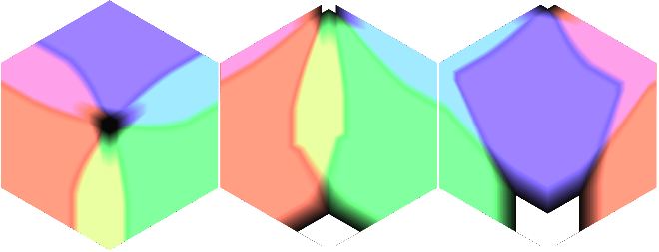

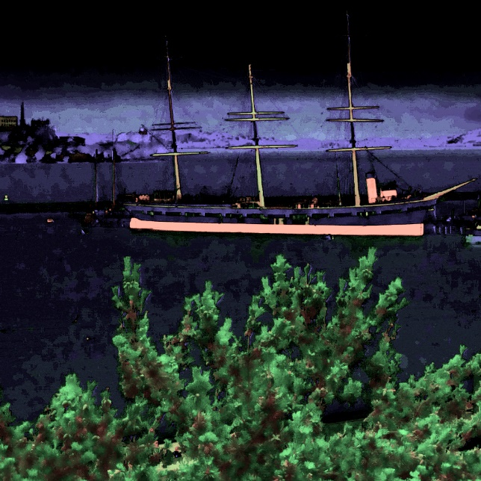

Color Manipulation Index # 07

|  |  |  |  |  |
| --- | --- | --- | --- | --- |
| Color Adjust Matrix | | | | |
| CAM-1 | 1.5 | -0.250 | -0.250 | 1.00 |
| -0.250 | 1.5 | -0.250 | 1.00 |
| -0.250 | -0.250 | 1.5 | 1.00 |
| 1.00 | 1.00 | 1.00 |  |
| CAM-2 | 1.5 | -0.250 | -0.250 | 1.00 |
| -0.250 | 1.5 | -0.250 | 1.00 |
| -0.250 | -0.250 | 1.5 | 1.00 |
| 1.00 | 1.00 | 1.00 |  |
| CAM-3 | 1.5 | -0.250 | -0.250 | 1.00 |
| -0.250 | 1.5 | -0.250 | 1.00 |
| -0.250 | -0.250 | 1.5 | 1.00 |
| 1.00 | 1.00 | 1.00 |  |



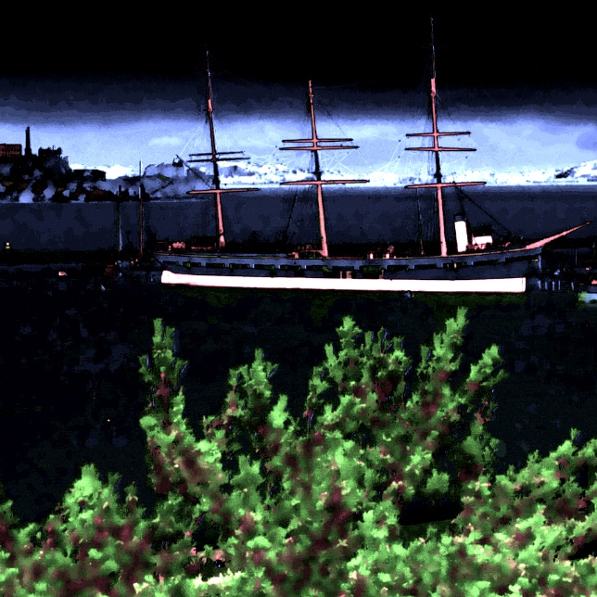

Color Manipulation Index # 08

|  |  |  |  |  |
| --- | --- | --- | --- | --- |
| Color Adjust Matrix | | | | |
| CAM-1 | 1.250 | -0.850 | -0.400 | 0.00 |
| -0.400 | 1.250 | -0.850 | 0.00 |
| -0.850 | -0.400 | 1.250 | 0.00 |
| 0.00 | 0.00 | 0.00 |  |
| CAM-2 | 1.00 | -0.600 | -0.400 | 0.00 |
| -0.400 | 1.00 | -0.600 | 0.00 |
| -0.600 | -0.400 | 1.00 | 0.00 |
| 0.00 | 0.00 | 0.00 |  |
| CAM-3 | 1.5 | 1.200 | 0.500 | 3.20 |
| 0.500 | 1.5 | 1.200 | 3.20 |
| 1.200 | 0.500 | 1.5 | 3.20 |
| 3.20 | 3.20 | 3.20 |  |

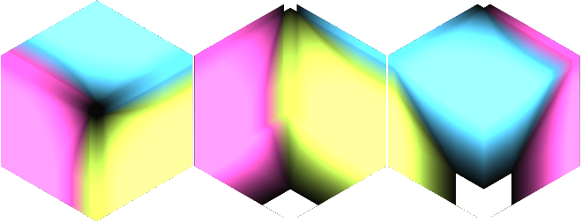



Color Manipulation Index # 09

|  |  |  |  |  |
| --- | --- | --- | --- | --- |
| Color Adjust Matrix | | | | |
| CAM-1 | 1.250 | -0.850 | -0.400 | 0.00 |
| -0.400 | 1.250 | -0.850 | 0.00 |
| -0.850 | -0.400 | 1.250 | 0.00 |
| 0.00 | 0.00 | 0.00 |  |
| CAM-2 | 1.00 | -0.600 | -0.400 | 0.00 |
| -0.400 | 1.00 | -0.600 | 0.00 |
| -0.600 | -0.400 | 1.00 | 0.00 |
| 0.00 | 0.00 | 0.00 |  |
| CAM-3 | 1.5 | 1.200 | 0.500 | 3.20 |
| 0.500 | 1.5 | 1.200 | 3.20 |
| 1.200 | 0.500 | 1.5 | 3.20 |
| 3.20 | 3.20 | 3.20 |  |

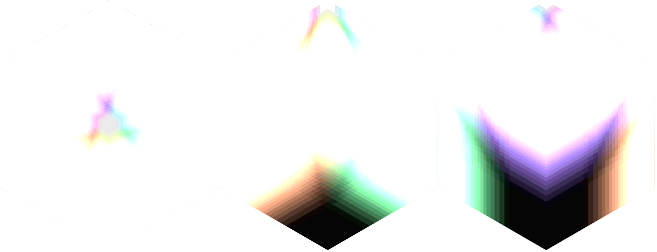

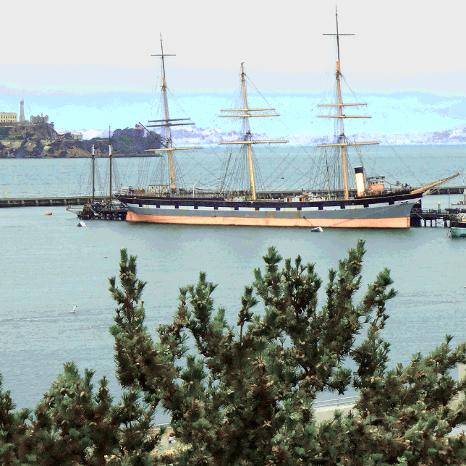

Color Manipulation Index # 10

|  |  |  |  |  |
| --- | --- | --- | --- | --- |
| Color Adjust Matrix | | | | |
| CAM-1 | 1.250 | -0.850 | -0.400 | 0.00 |
| -0.400 | 1.250 | -0.850 | 0.00 |
| -0.850 | -0.400 | 1.250 | 0.00 |
| 0.00 | 0.00 | 0.00 |  |
| CAM-2 | 1.00 | -0.600 | -0.400 | 0.00 |
| -0.400 | 1.00 | -0.600 | 0.00 |
| -0.600 | -0.400 | 1.00 | 0.00 |
| 0.00 | 0.00 | 0.00 |  |
| CAM-3 | 1.5 | 1.200 | 0.500 | 3.20 |
| 0.500 | 1.5 | 1.200 | 3.20 |
| 1.200 | 0.500 | 1.5 | 3.20 |
| 3.20 | 3.20 | 3.20 |  |

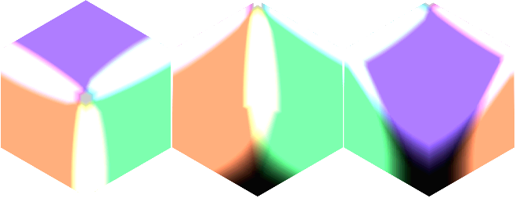

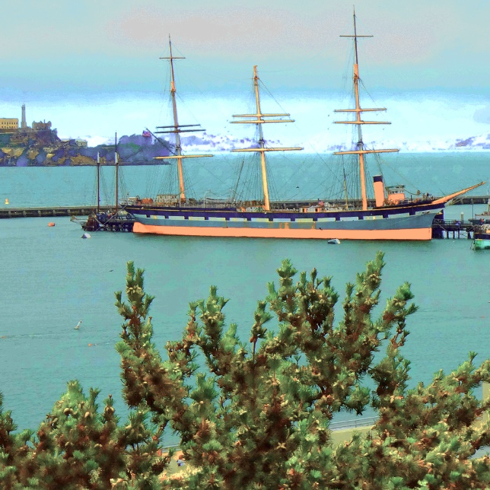

Color Manipulation Index # 11

|  |  |  |  |  |
| --- | --- | --- | --- | --- |
| Color Adjust Matrix | | | | |
| CAM-1 | 1.250 | -0.850 | -0.400 | 0.00 |
| -0.400 | 1.250 | -0.850 | 0.00 |
| -0.850 | -0.400 | 1.250 | 0.00 |
| 0.00 | 0.00 | 0.00 |  |
| CAM-2 | 1.00 | -0.600 | -0.400 | 0.00 |
| -0.400 | 1.00 | -0.600 | 0.00 |
| -0.600 | -0.400 | 1.00 | 0.00 |
| 0.00 | 0.00 | 0.00 |  |
| CAM-3 | 1.5 | 1.200 | 0.500 | 3.20 |
| 0.500 | 1.5 | 1.200 | 3.20 |
| 1.200 | 0.500 | 1.5 | 3.20 |
| 3.20 | 3.20 | 3.20 |  |

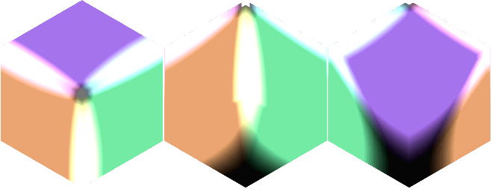

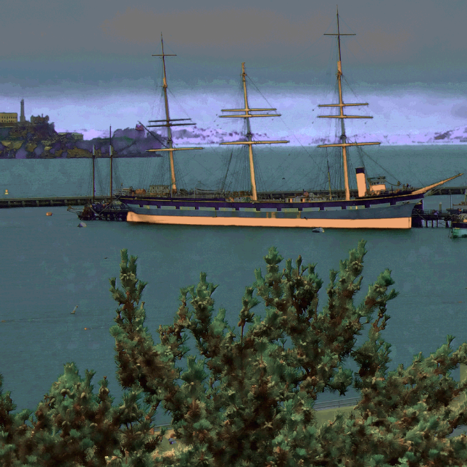

Color Manipulation Index # 12

|  |  |  |  |  |
| --- | --- | --- | --- | --- |
| Color Adjust Matrix | | | | |
| CAM-1 | 1.250 | -0.850 | -0.400 | 0.00 |
| -0.400 | 1.250 | -0.850 | 0.00 |
| -0.850 | -0.400 | 1.250 | 0.00 |
| 0.00 | 0.00 | 0.00 |  |
| CAM-2 | 1.00 | -0.600 | -0.400 | 0.00 |
| -0.400 | 1.00 | -0.600 | 0.00 |
| -0.600 | -0.400 | 1.00 | 0.00 |
| 0.00 | 0.00 | 0.00 |  |
| CAM-3 | 1.5 | 1.200 | 0.500 | 3.20 |
| 0.500 | 1.5 | 1.200 | 3.20 |
| 1.200 | 0.500 | 1.5 | 3.20 |
| 3.20 | 3.20 | 3.20 |  |

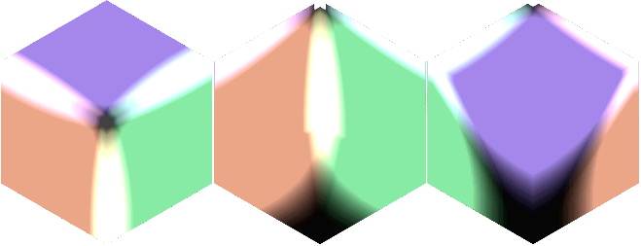

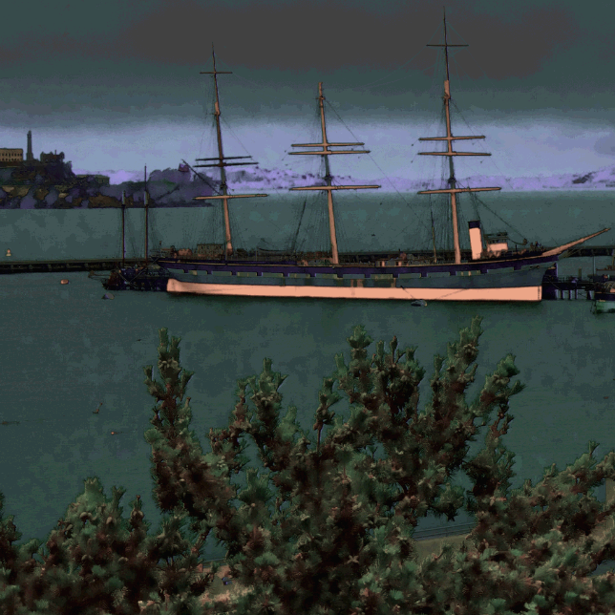

Color Manipulation Index # 13

|  |  |  |  |  |
| --- | --- | --- | --- | --- |
| Color Adjust Matrix | | | | |
| CAM-1 | 1.250 | -0.850 | -0.400 | 0.00 |
| -0.400 | 1.250 | -0.850 | 0.00 |
| -0.850 | -0.400 | 1.250 | 0.00 |
| 0.00 | 0.00 | 0.00 |  |
| CAM-2 | 1.00 | -0.600 | -0.400 | 0.00 |
| -0.400 | 1.00 | -0.600 | 0.00 |
| -0.600 | -0.400 | 1.00 | 0.00 |
| 0.00 | 0.00 | 0.00 |  |
| CAM-3 | 1.5 | 1.200 | 0.500 | 3.20 |
| 0.500 | 1.5 | 1.200 | 3.20 |
| 1.200 | 0.500 | 1.5 | 3.20 |
| 3.20 | 3.20 | 3.20 |  |

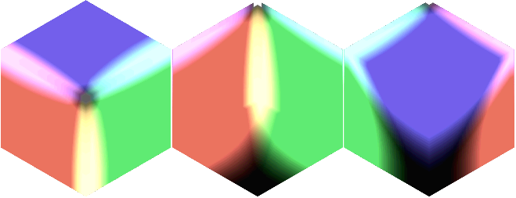

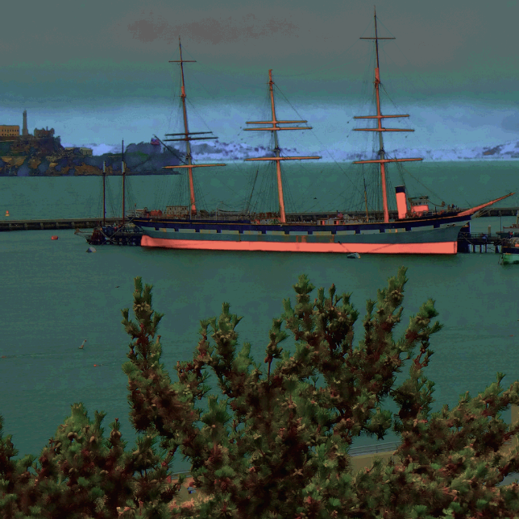

Color Manipulation Index # 14

|  |  |  |  |  |
| --- | --- | --- | --- | --- |
| Color Adjust Matrix | | | | |
| CAM-1 | 1.250 | -0.850 | -0.400 | 0.00 |
| -0.400 | 1.250 | -0.850 | 0.00 |
| -0.850 | -0.400 | 1.250 | 0.00 |
| 0.00 | 0.00 | 0.00 |  |
| CAM-2 | 1.00 | -0.600 | -0.400 | 0.00 |
| -0.400 | 1.00 | -0.600 | 0.00 |
| -0.600 | -0.400 | 1.00 | 0.00 |
| 0.00 | 0.00 | 0.00 |  |
| CAM-3 | 1.5 | 1.200 | 0.500 | 3.20 |
| 0.500 | 1.5 | 1.200 | 3.20 |
| 1.200 | 0.500 | 1.5 | 3.20 |
| 3.20 | 3.20 | 3.20 |  |

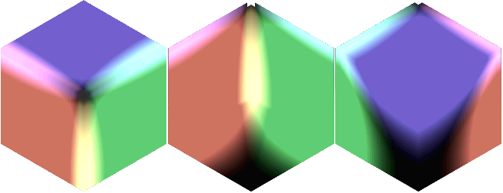

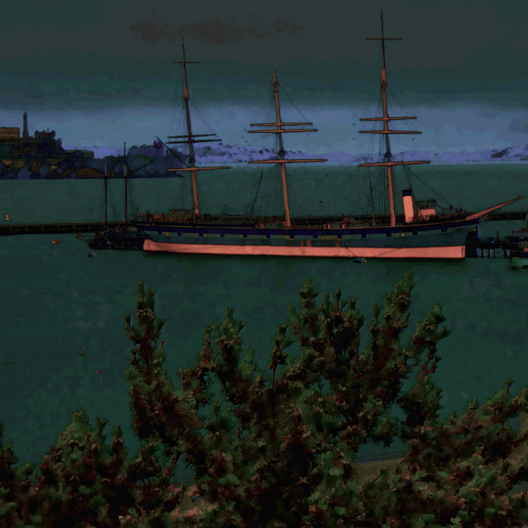

Color Manipulation Index # 15

|  |  |  |  |  |
| --- | --- | --- | --- | --- |
| Color Adjust Matrix | | | | |
| CAM-1 | 1.250 | -0.850 | -0.400 | 0.00 |
| -0.400 | 1.250 | -0.850 | 0.00 |
| -0.850 | -0.400 | 1.250 | 0.00 |
| 0.00 | 0.00 | 0.00 |  |
| CAM-2 | 1.00 | -0.600 | -0.400 | 0.00 |
| -0.400 | 1.00 | -0.600 | 0.00 |
| -0.600 | -0.400 | 1.00 | 0.00 |
| 0.00 | 0.00 | 0.00 |  |
| CAM-3 | 1.5 | 1.200 | 0.500 | 3.20 |
| 0.500 | 1.5 | 1.200 | 3.20 |
| 1.200 | 0.500 | 1.5 | 3.20 |
| 3.20 | 3.20 | 3.20 |  |

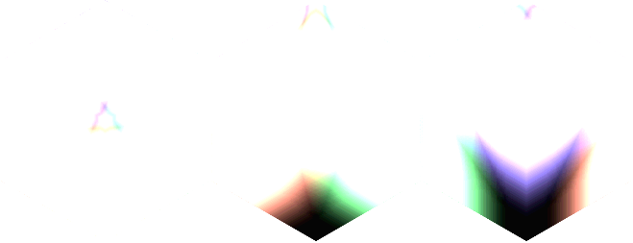

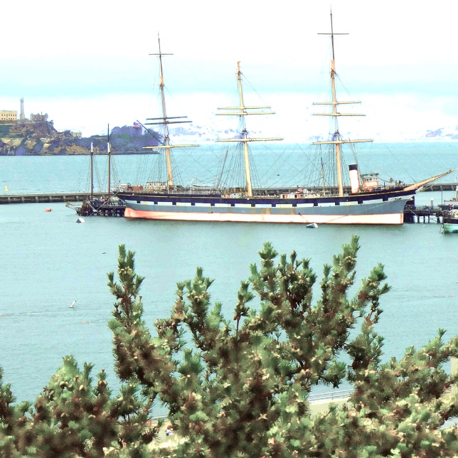

Color Manipulation Index # 16

|  |  |  |  |  |
| --- | --- | --- | --- | --- |
| Color Adjust Matrix | | | | |
| CAM-1 | 1.250 | -0.850 | -0.400 | 0.00 |
| -0.400 | 1.250 | -0.850 | 0.00 |
| -0.850 | -0.400 | 1.250 | 0.00 |
| 0.00 | 0.00 | 0.00 |  |
| CAM-2 | 1.00 | -0.600 | -0.400 | 0.00 |
| -0.400 | 1.00 | -0.600 | 0.00 |
| -0.600 | -0.400 | 1.00 | 0.00 |
| 0.00 | 0.00 | 0.00 |  |
| CAM-3 | 1.5 | 1.200 | 0.500 | 3.20 |
| 0.500 | 1.5 | 1.200 | 3.20 |
| 1.200 | 0.500 | 1.5 | 3.20 |
| 3.20 | 3.20 | 3.20 |  |

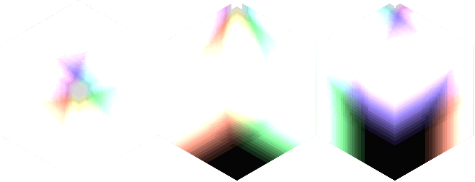

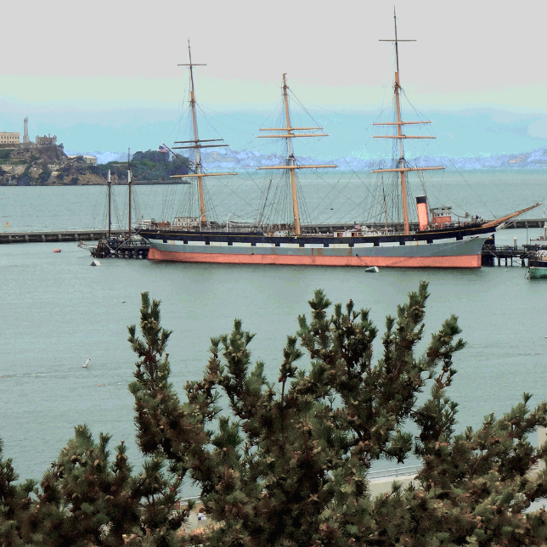

AN FPGA IMPLEMENTATION OF K-MEANS CLUSTERING

This section of the document describes computing the k-mean rgb clustering of rgb video stream.

The implemented image segment uses K-Mean clustering algorithm for FPGA Devices, and it has been designed with a standard Xilinx AXI4 streaming interface, so that it can be inserted as module ip within any image processing pipeline.



Figure

This module takes a stream of camera data in pixel pipeline format. This stream must be presented to the inputs data (iRgb.red, iRgb.green, iRgb.blue) and control signals (iRgb.valid, iRgb.eol, iRgb.eof, iRgb.sof). The result of this module steam K-Mean rgb cluster color space in output oRgb channel.

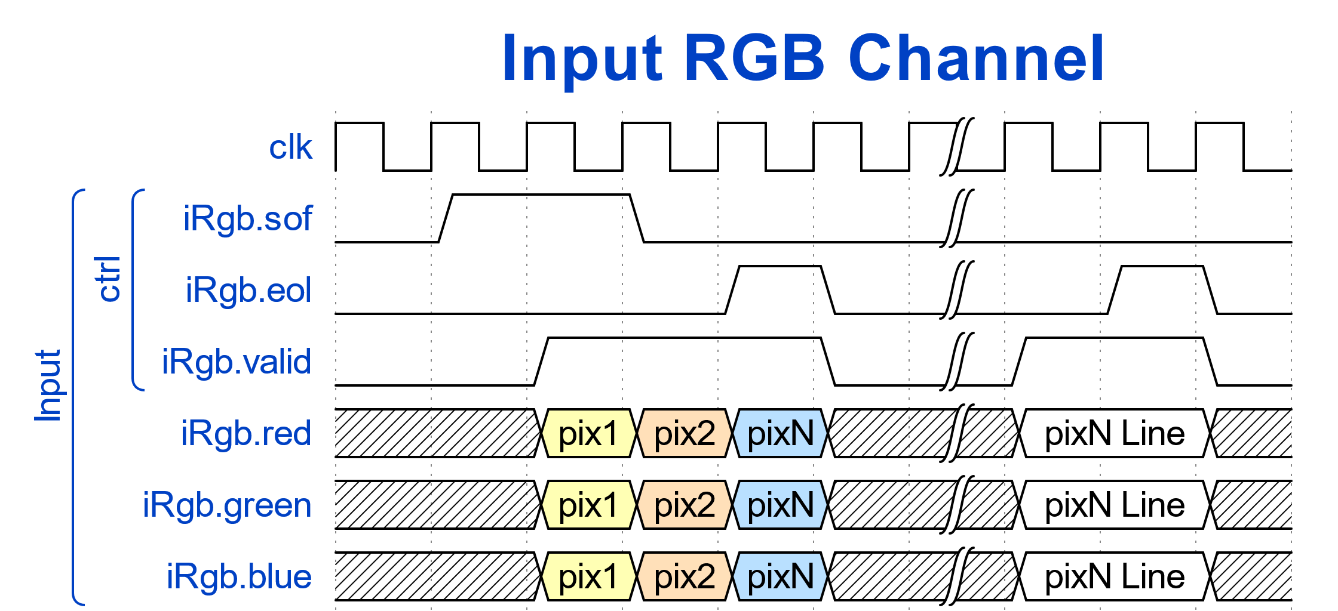

Figure

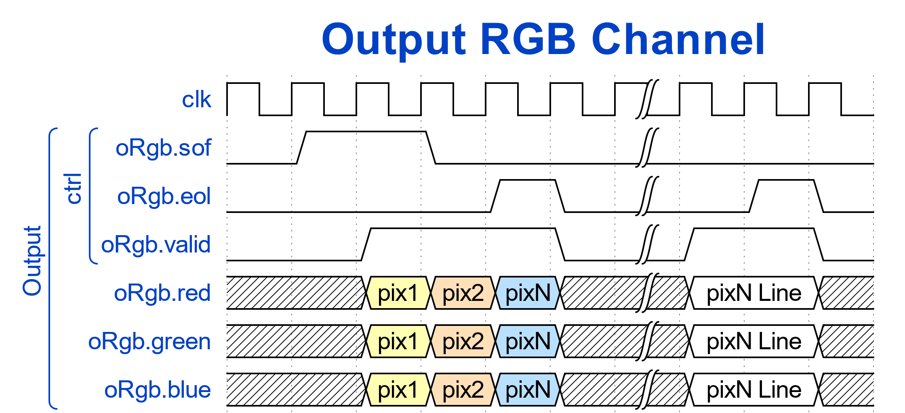

Figure

This module is synthesized and implemented using Vivado 2022.1 for KRIA KV260 board and verified using ModelSim 2020 edition simulator.

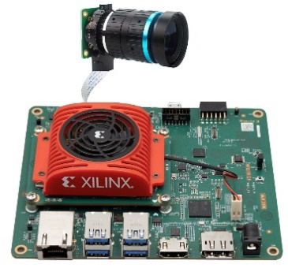

The Functional block diagram of the implemented rgb data path to n clustered conversion is shown in Figure below.



In this module, K mean-based color quantization algorithm is applied to rgb input stream pixels.

* Select rgb k color references for k points to decide number of clusters.
* Find the distance of each input pixels with selected rgb k points.
* Assign each new pixel value to closest selected rgb n values using Euclidean distance.
* Pixels which are nearest to the selected rgb values allocated to a cluster.

Euclidean distance is calculated between original image pixel Red1, Green1 and Blue1 and reference pixel color schemes.

$$D=\sqrt{{{(RED}_{2}{-RED}_{1})}^{2}+{{(GREEN}_{2}{-GREEN}_{1})}^{2}+{{(BLUE}_{2}{-BLUE}_{1})}^{2}}$$

Rgb Image of video frame consist of 0 to 255 values per rgb channel which gives 256*256*256 colors, and the goal is to use color k mean cluster to set number of clusters. Minimum distance is the final candidate for being closest to the source rgb color. If an RGB image color depth of 24 bits which is 16 million of colors, after K-mean clustering with value n, then image is converted to a version of n colors.

The codebook created for K-Means is called the color palette or reference color scheme.

K-mean cluster module convert 16 million of rgb colors into n color version. The module has clock and reset ports. Port iRGB and oRGB consist of red, green, and blue rgb channels with valid signal.

|  |  |
| --- | --- |
| Ports | Description |
| clk | Reference clock for input and output data stream. |
| reset | Specifies module asynchronous active low reset. |
| iRgb.red | 8-bit input data. Red value. |
| iRgb.green | 8-bit input data. Green value. |
| iRgb.blue | 8-bit input data. Blue value. |
| iRgb.valid | Input data valid. Specifies whether the next data point has arrived for processing. |
| oRgb.red | 8-bit output data. N clustered red value. |
| oRgb.green | 8-bit output data. N clustered green value. |
| oRgb.blue | 8-bit output data. N clustered blue value. |
| oRgb.valid | Output data valid. Control signal to indicate the validity of each pixel. |

**K EQUALTO 6 REFERENCE COLOR SCHEMES**

Generated image below is the result of k-mean clustering using 6 colors references of palette schemes.

|  |  |  |  |
| --- | --- | --- | --- |
| # | Red | Green | Blue |
| 1 | 230 | 170 | 120 |
| 2 | 70 | 40 | 35 |
| 3 | 150 | 200 | 130 |
| 4 | 20 | 25 | 10 |
| 5 | 75 | 150 | 180 |
| 6 | 15 | 30 | 60 |



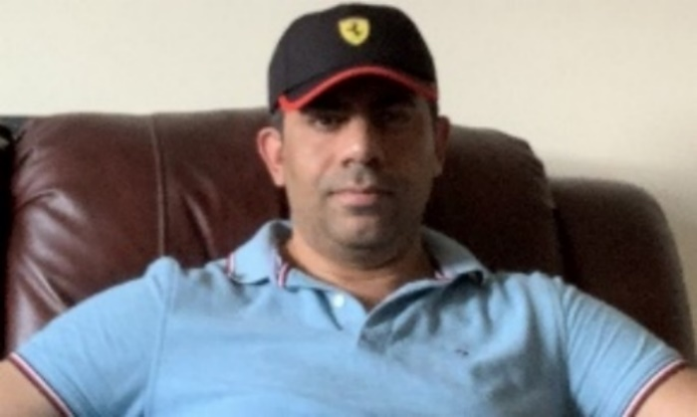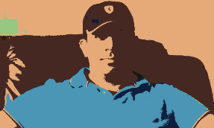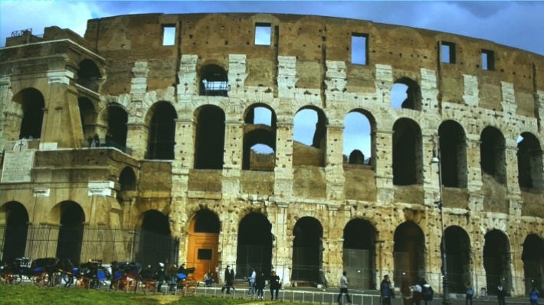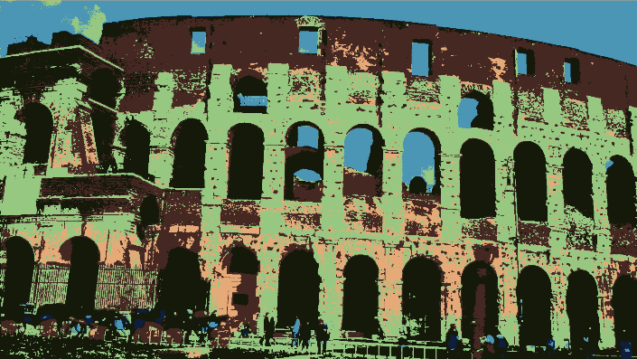

**K EQUALTO 9 REFERENCE COLOR SCHEMES**

In this reference, k parameter set to k = 9, where k is the number of clusters. K-mean color quantization quantizes input image to number of colors into 9 clusters from 9 refences of color schemes.

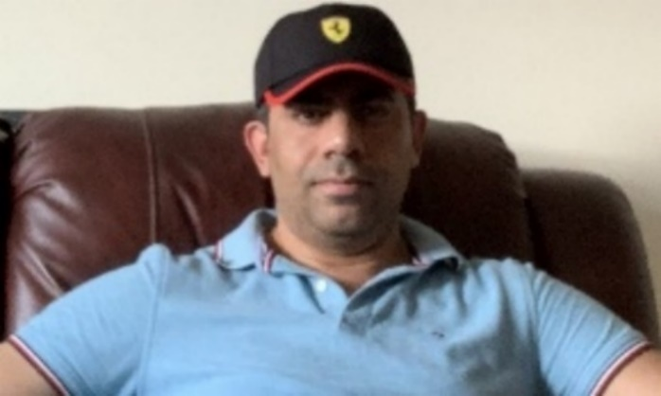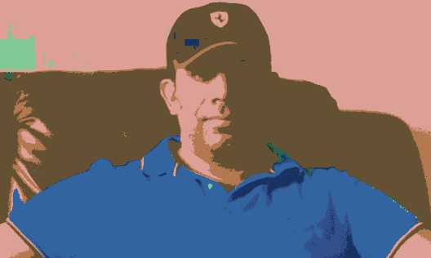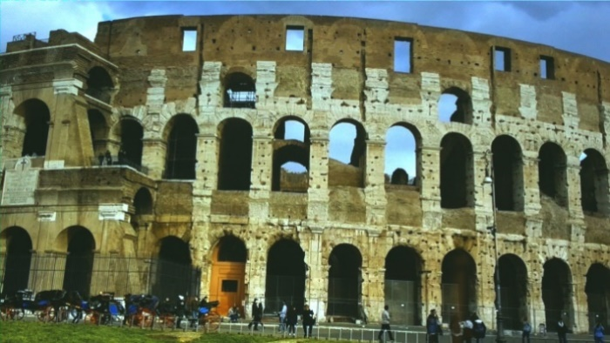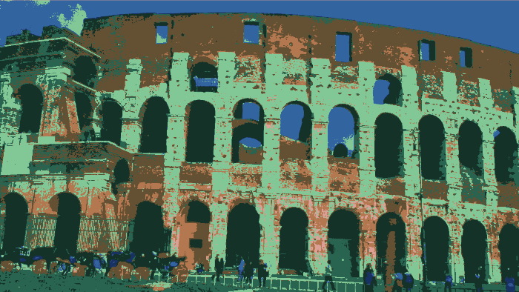

**K EQUALTO 24 REFERENCE COLOR SCHEMES**

In this reference, k parameter set to k = 24, where k is the number of clusters. K-mean color quantization quantizes input image to number of colors into 24 clusters from 24 refences of color schemes.

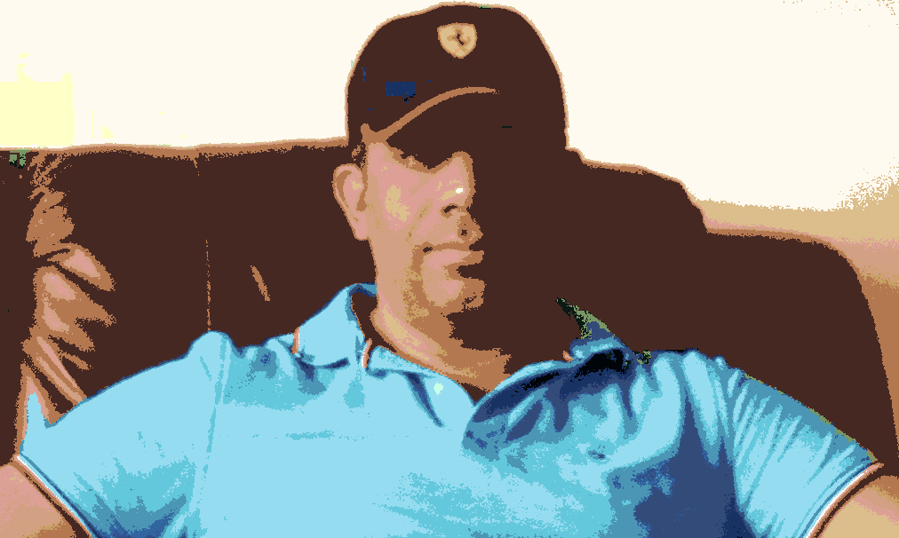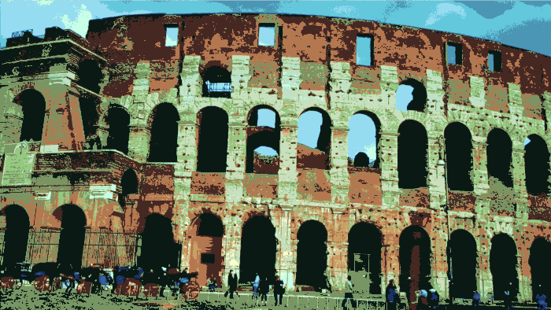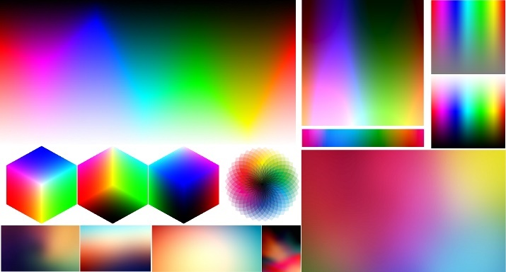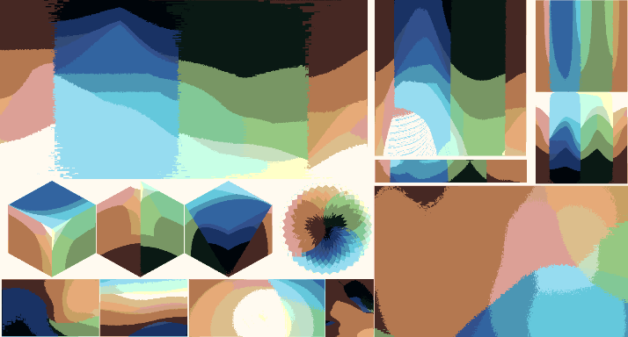

**K EQUALTO 51 REFERENCE COLOR SCHEMES**

In this reference, k parameter set to k = 51, where k is the number of clusters. K-mean color quantization quantizes input image to number of colors into 51 clusters from 51 refences of color schemes.

Image below is generated using 51 reference color schemes.

|  |  |  |  |  |  |  |  |  |  |  |  |  |  |  |  |  |  |  |  |  |  |  |  |  |  |  |  |  |  |  |  |  |  |  |  |  |  |  |  |  |  |  |  |  |  |  |  |  |  |  |  |  |  |  |  |  |  |  |  |  |  |  |  |  |  |  |  |  |  |  |  |  |  |  |  |  |  |  |  |  |  |  |  |  |  |  |  |  |  |  |  |  |  |  |  |  |  |  |  |  |  |  |  |  |  |  |  |  |  |  |  |  |  |  |  |  |  |  |  |  |  |  |  |  |  |  |  |  |  |  |  |  |  |  |  |  |  |  |  |  |  |  |  |  |  |  |  |  |  |  |  |  |  |  |  |  |  |  |  |  |  |  |  |  |  |  |  |  |  |  |  |  |  |  |  |  |  |  |  |  |  |  |  |  |  |  |  |  |  |  |  |  |  |  |  |  |  |  |  |  |  |  |  |  |  |  |  |  |  |  |  |  |  |  |  |  |  |  |  |  |  |  |  |  |  |  |  |  |
| --- | --- | --- | --- | --- | --- | --- | --- | --- | --- | --- | --- | --- | --- | --- | --- | --- | --- | --- | --- | --- | --- | --- | --- | --- | --- | --- | --- | --- | --- | --- | --- | --- | --- | --- | --- | --- | --- | --- | --- | --- | --- | --- | --- | --- | --- | --- | --- | --- | --- | --- | --- | --- | --- | --- | --- | --- | --- | --- | --- | --- | --- | --- | --- | --- | --- | --- | --- | --- | --- | --- | --- | --- | --- | --- | --- | --- | --- | --- | --- | --- | --- | --- | --- | --- | --- | --- | --- | --- | --- | --- | --- | --- | --- | --- | --- | --- | --- | --- | --- | --- | --- | --- | --- | --- | --- | --- | --- | --- | --- | --- | --- | --- | --- | --- | --- | --- | --- | --- | --- | --- | --- | --- | --- | --- | --- | --- | --- | --- | --- | --- | --- | --- | --- | --- | --- | --- | --- | --- | --- | --- | --- | --- | --- | --- | --- | --- | --- | --- | --- | --- | --- | --- | --- | --- | --- | --- | --- | --- | --- | --- | --- | --- | --- | --- | --- | --- | --- | --- | --- | --- | --- | --- | --- | --- | --- | --- | --- | --- | --- | --- | --- | --- | --- | --- | --- | --- | --- | --- | --- | --- | --- | --- | --- | --- | --- | --- | --- | --- | --- | --- | --- | --- | --- | --- | --- | --- | --- | --- | --- | --- | --- | --- | --- | --- | --- | --- | --- | --- | --- | --- | --- | --- | --- | --- | --- | --- | --- | --- |
| |  |  |  |  | | --- | --- | --- | --- | | # | RED | GREEN | BLUE | | 1 | 255 | 250 | 240 | | 2 | 230 | 200 | 150 | | 3 | 220 | 190 | 140 | | 4 | 240 | 180 | 120 | | 5 | 230 | 170 | 120 | | 6 | 220 | 160 | 150 | | 7 | 210 | 160 | 130 | | 8 | 200 | 160 | 100 | | 9 | 180 | 120 | 80 | | 10 | 160 | 100 | 70 | | |  |  |  |  | | --- | --- | --- | --- | | # | RED | GREEN | BLUE | | 11 | 150 | 80 | 60 | | 12 | 140 | 80 | 60 | | 13 | 120 | 80 | 55 | | 14 | 100 | 80 | 50 | | 15 | 80 | 60 | 40 | | 16 | 70 | 40 | 35 | | 17 | 60 | 40 | 30 | | 18 | 50 | 30 | 20 | | 19 | 40 | 20 | 15 | | 20 | 25 | 15 | 10 | | |  |  |  |  | | --- | --- | --- | --- | | # | RED | GREEN | BLUE | | 21 | 255 | 255 | 200 | | 22 | 200 | 255 | 230 | | 23 | 200 | 224 | 190 | | 24 | 190 | 224 | 200 | | 25 | 150 | 200 | 130 | | 26 | 130 | 200 | 150 | | 27 | 120 | 150 | 100 | | 28 | 100 | 150 | 120 | | 29 | 80 | 100 | 40 | | 30 | 40 | 100 | 80 | | |  |  |  |  | | --- | --- | --- | --- | | # | RED | GREEN | BLUE | | 31 | 50 | 75 | 30 | | 32 | 30 | 75 | 50 | | 33 | 40 | 50 | 20 | | 34 | 20 | 50 | 40 | | 35 | 10 | 25 | 20 | | 36 | 20 | 25 | 10 | | 37 | 15 | 10 | 0 | | 38 | 0 | 10 | 5 | | 39 | 220 | 240 | 55 | | 40 | 150 | 220 | 40 | | |  |  |  |  | | --- | --- | --- | --- | | # | RED | GREEN | BLUE | | 41 | 100 | 200 | 20 | | 42 | 90 | 180 | 0 | | 43 | 75 | 150 | 80 | | 44 | 50 | 100 | 60 | | 45 | 50 | 80 | 40 | | 46 | 50 | 75 | 20 | | 47 | 25 | 50 | 0 | | 48 | 20 | 40 | 80 | | 49 | 15 | 30 | 60 | | 50 | 5 | 10 | 20 | | 51 | 0 | 5 | 10 | |

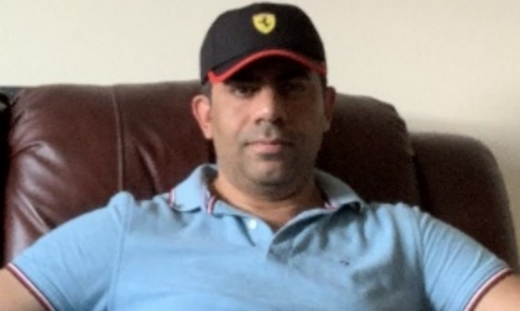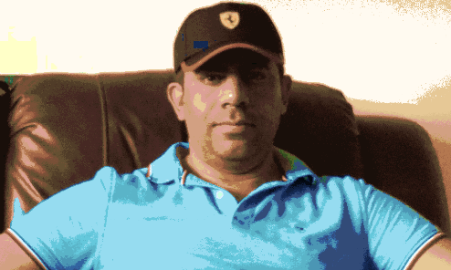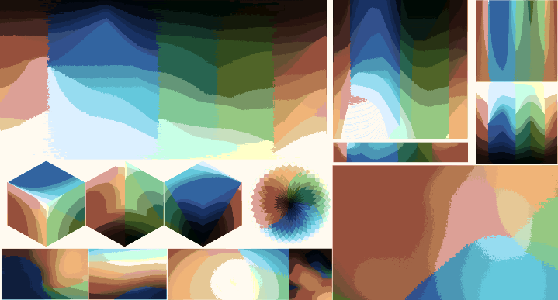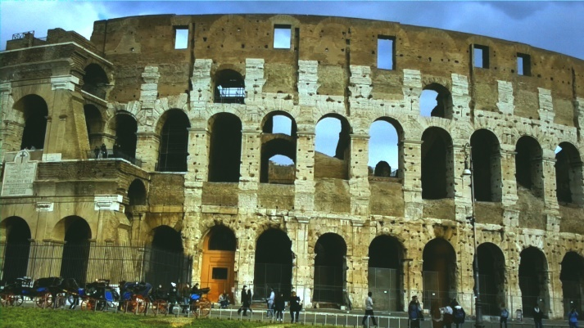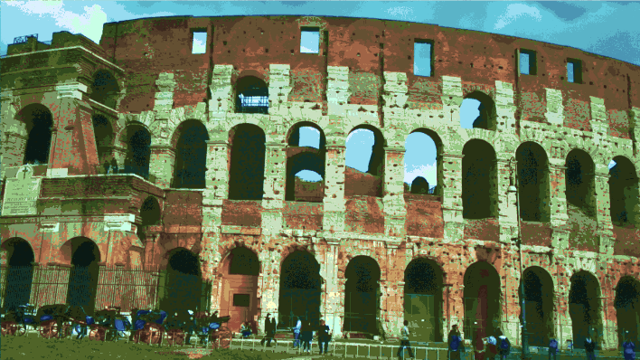

**IMX477 CAMERA: K EQUALTO 90 REFERENCE COLOR SCHEMES**

In this reference, k parameter set to k = 90, where k is the number of clusters. K-mean color quantization quantizes input image to number of colors into 90 clusters from 90 refences of color schemes.

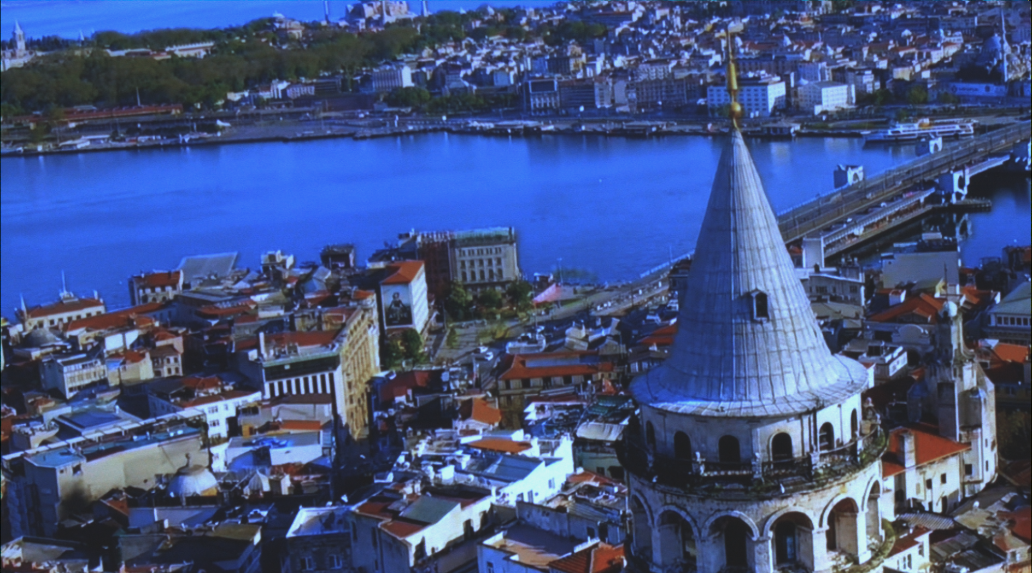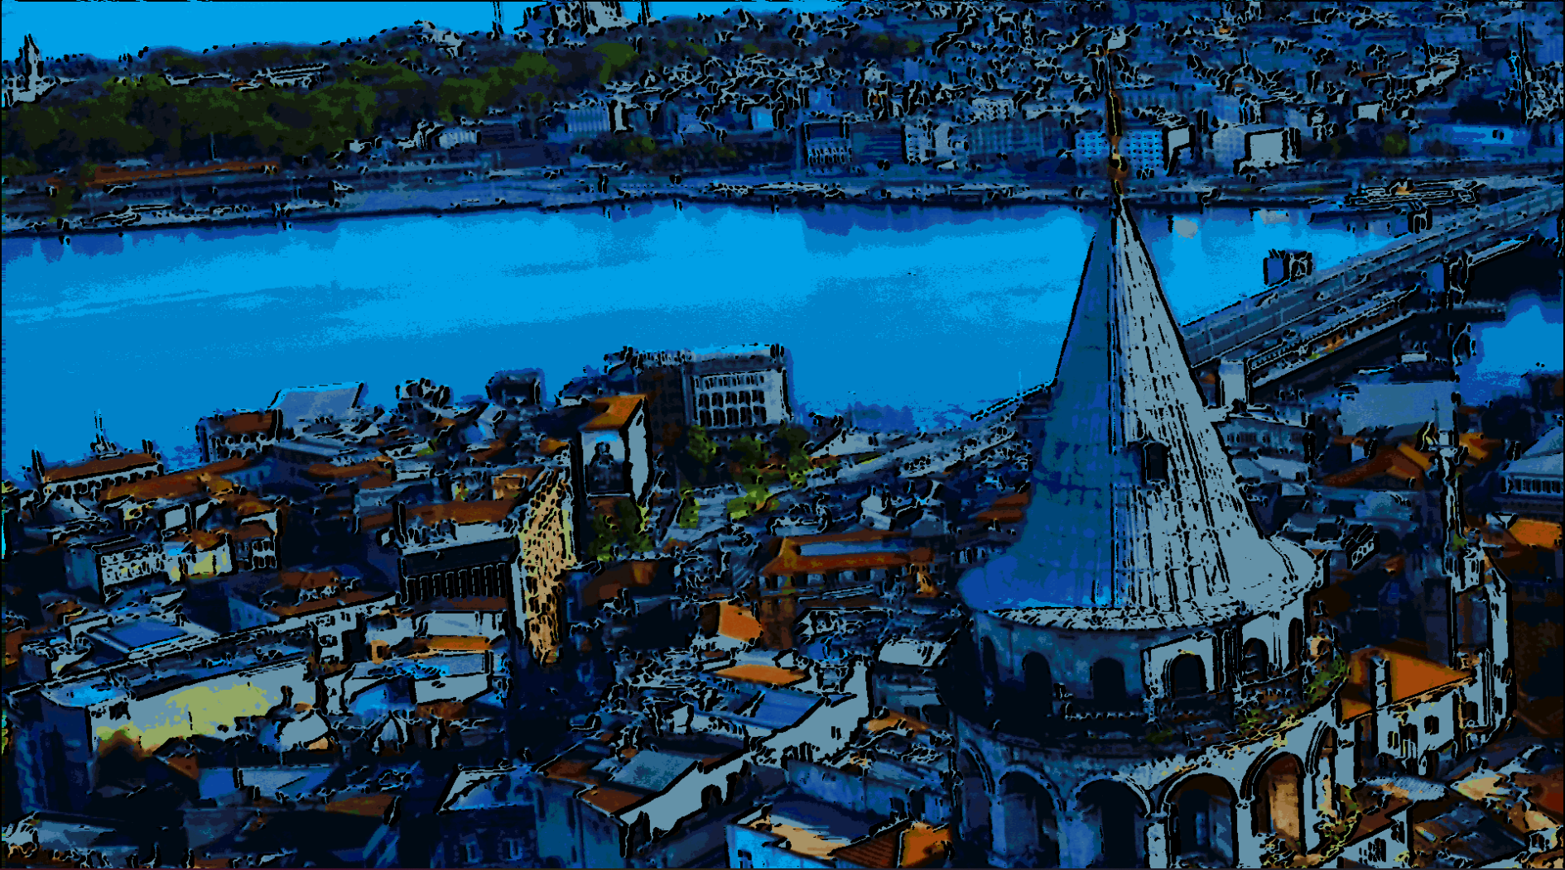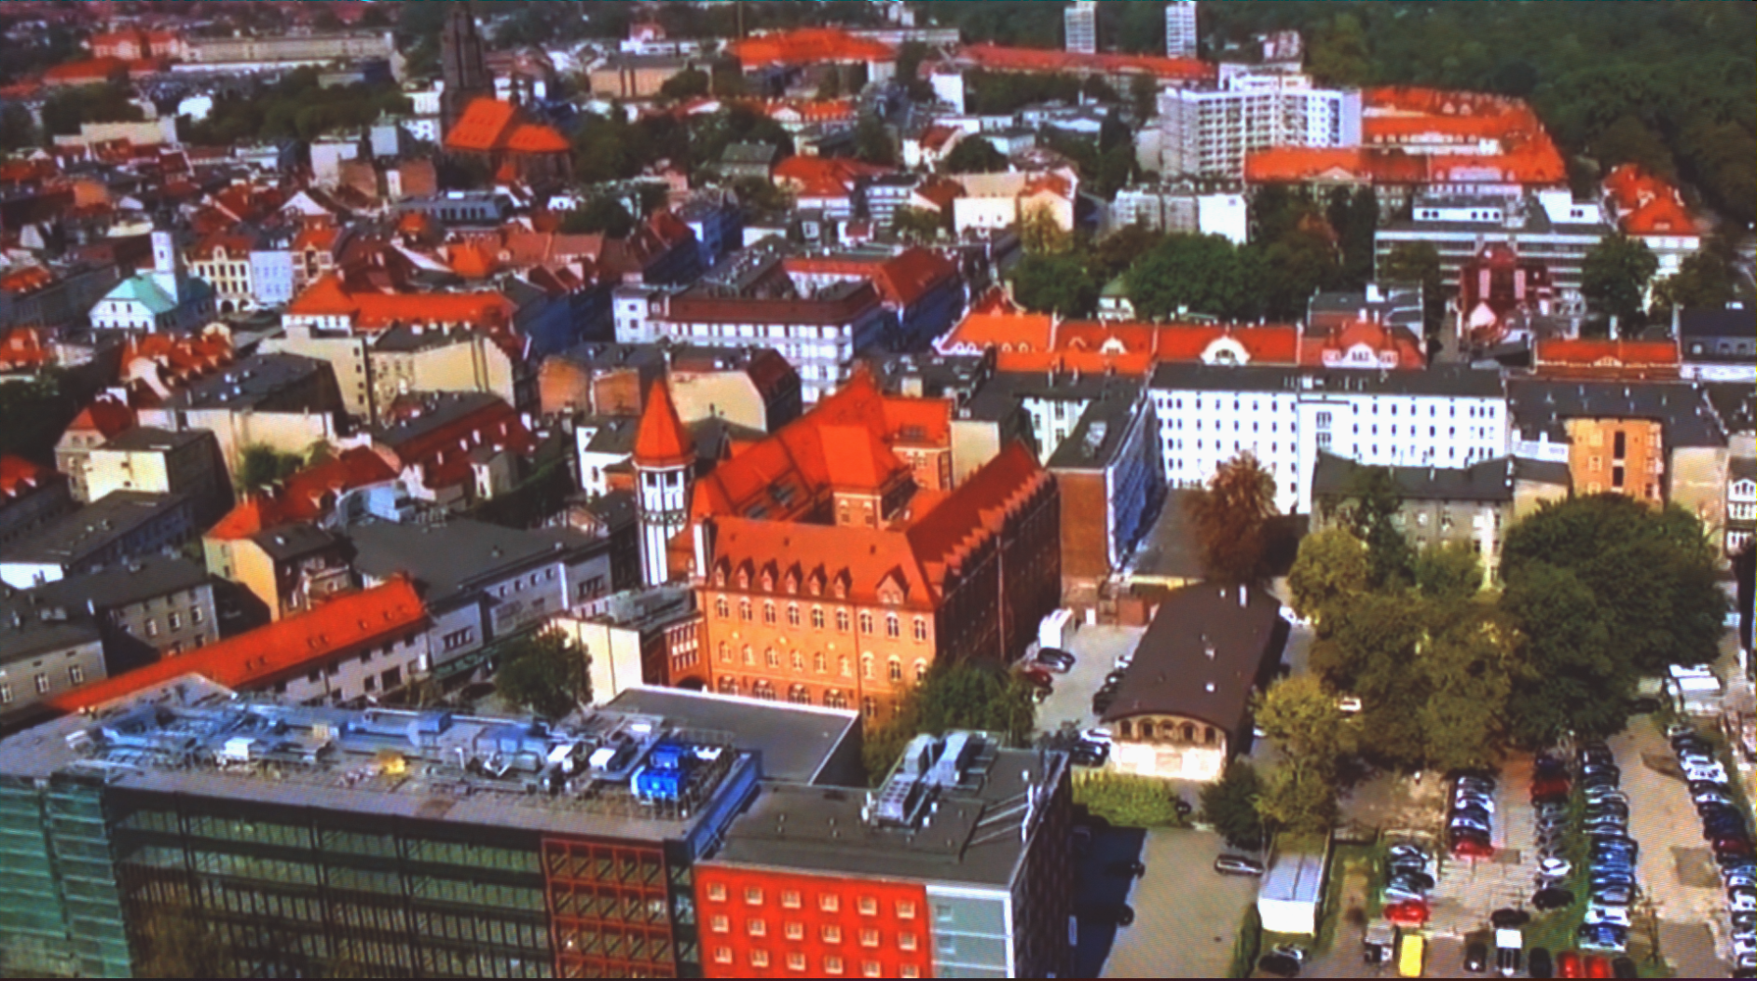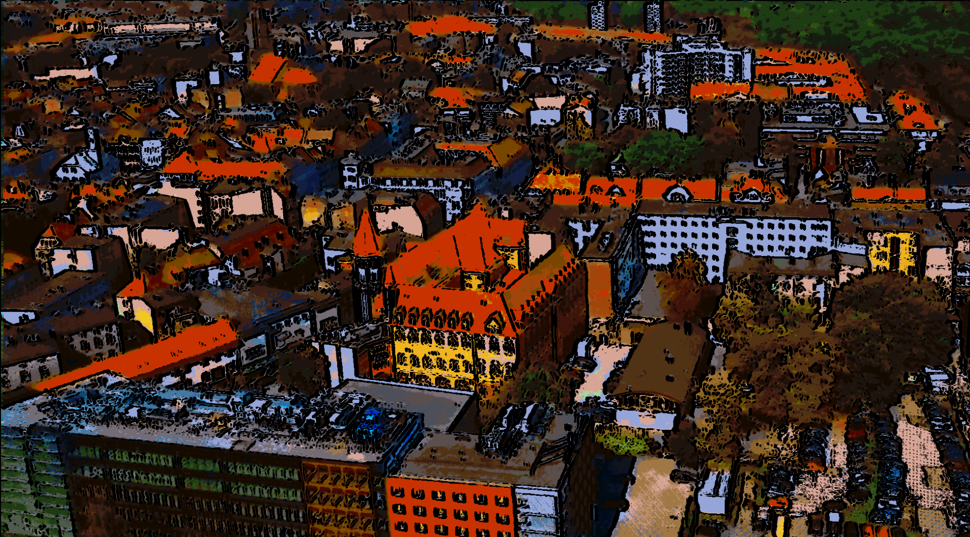 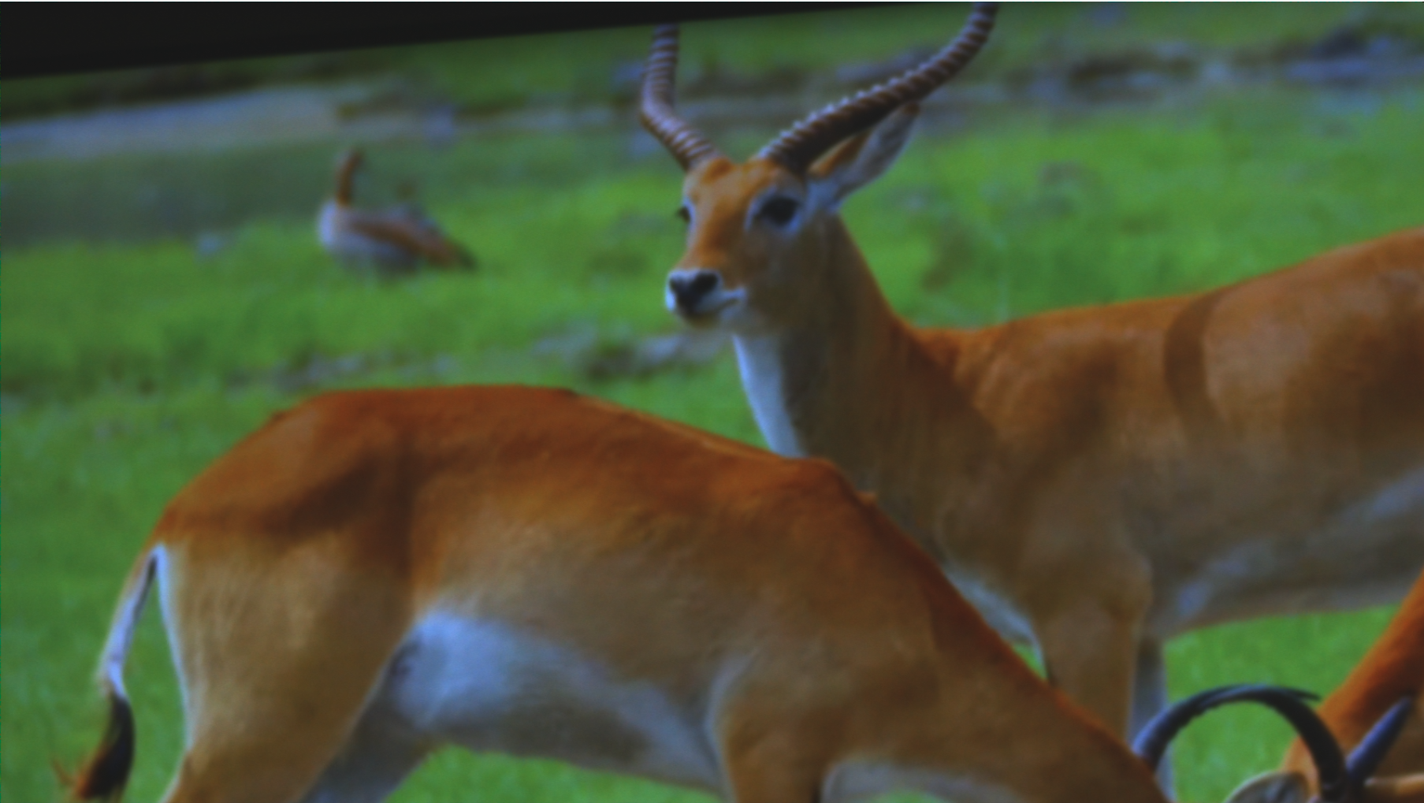 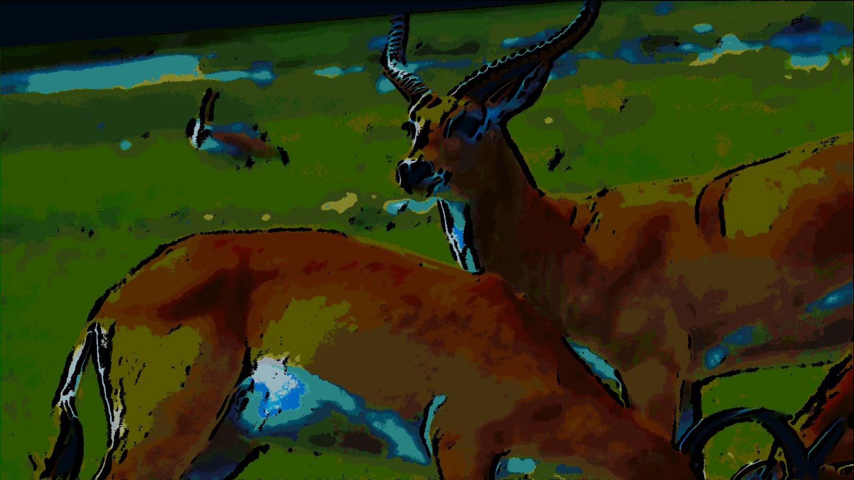 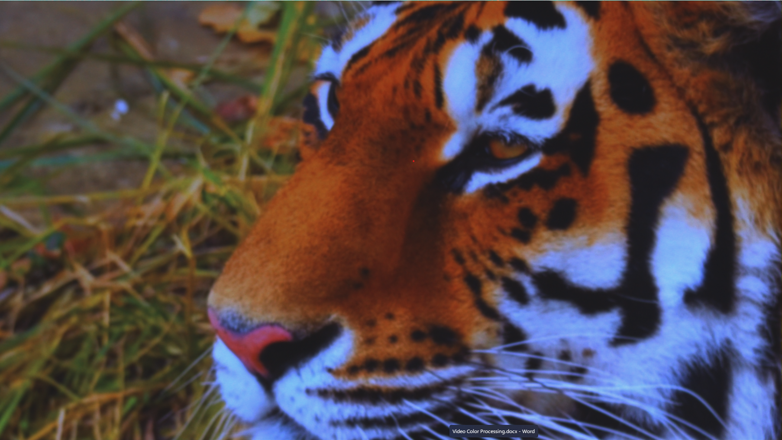 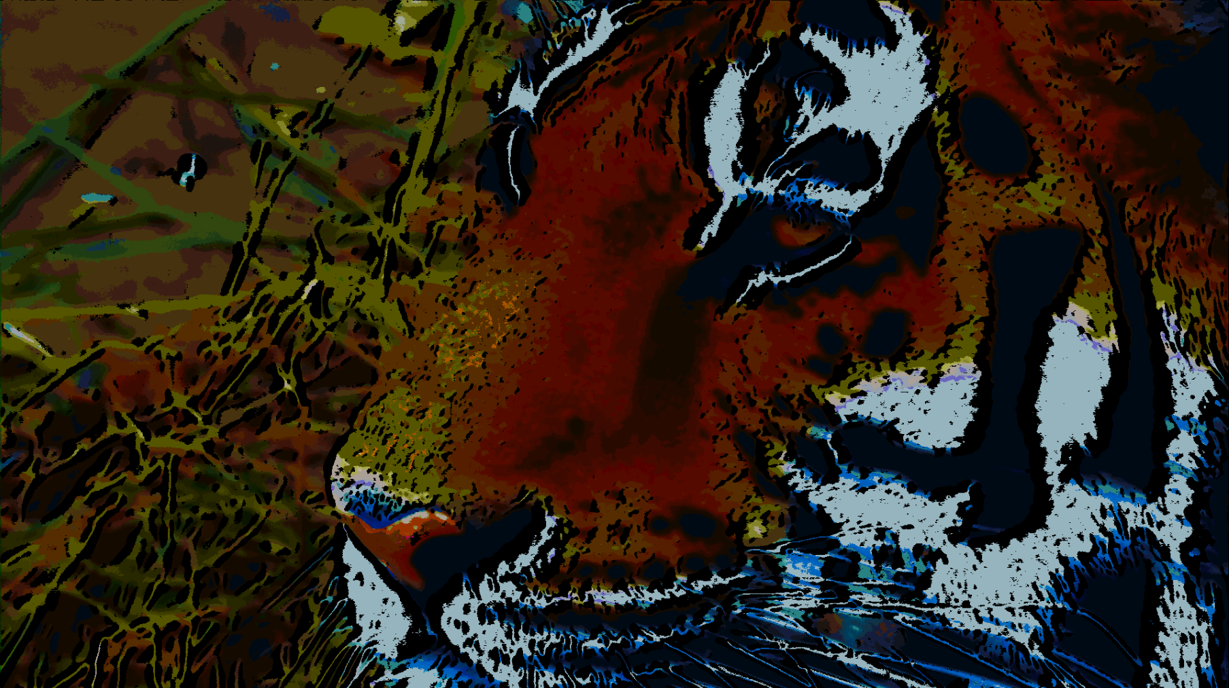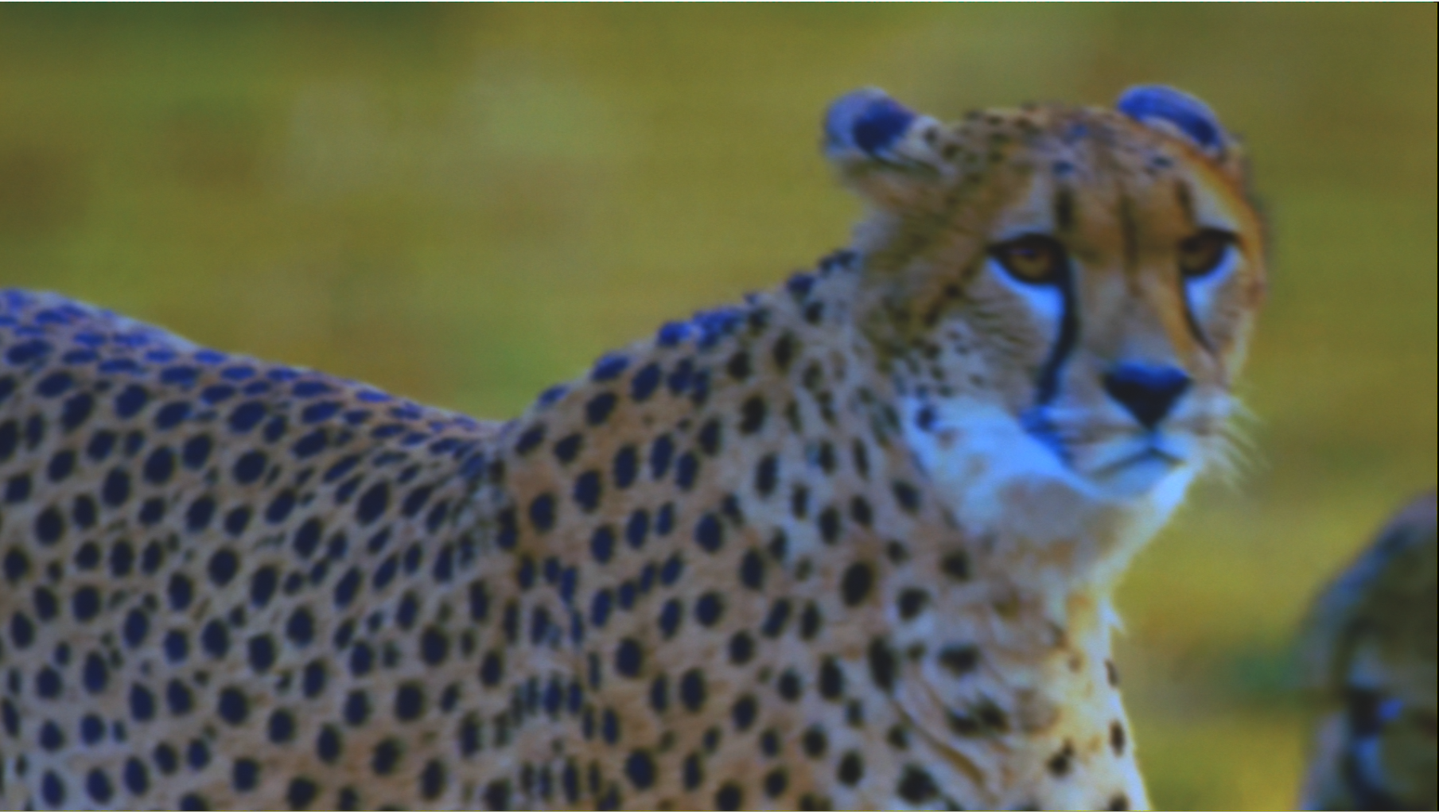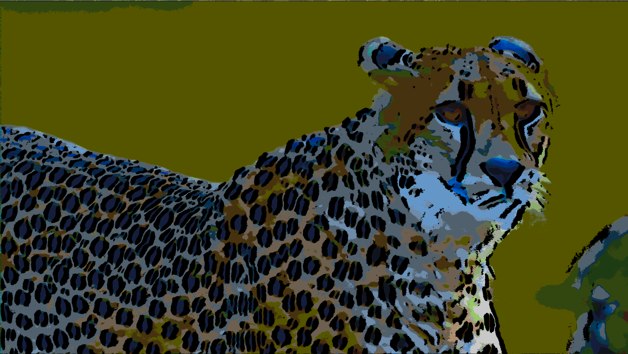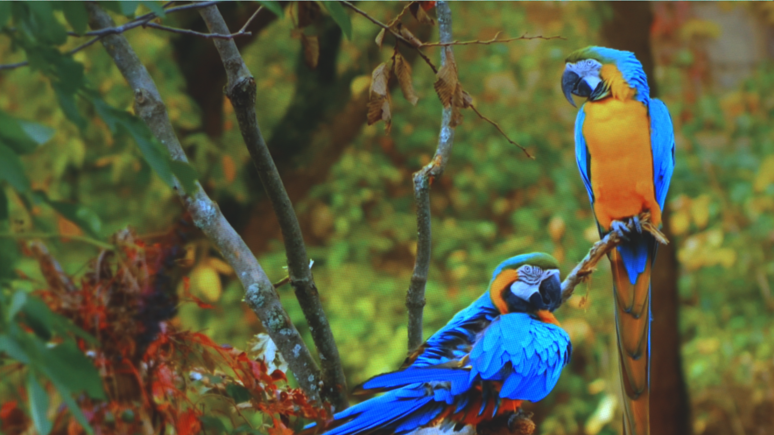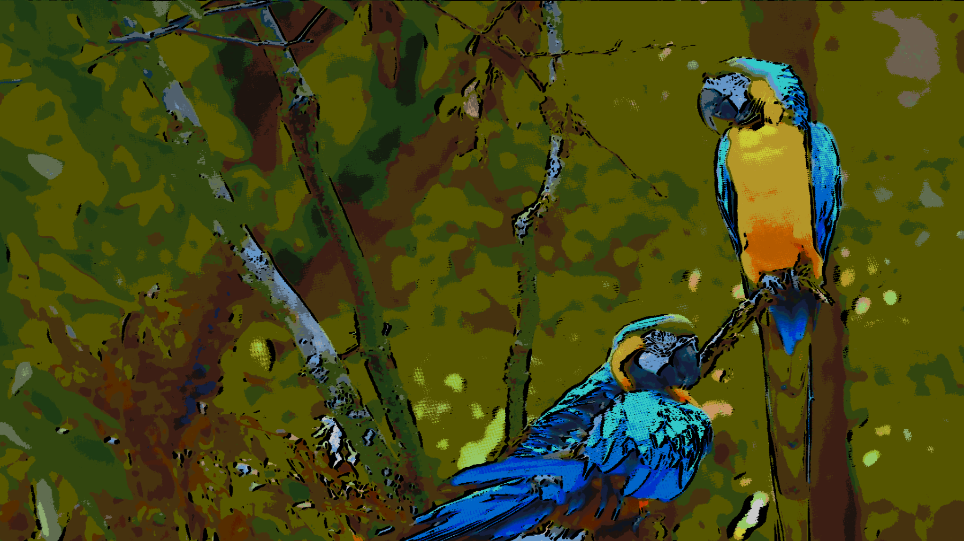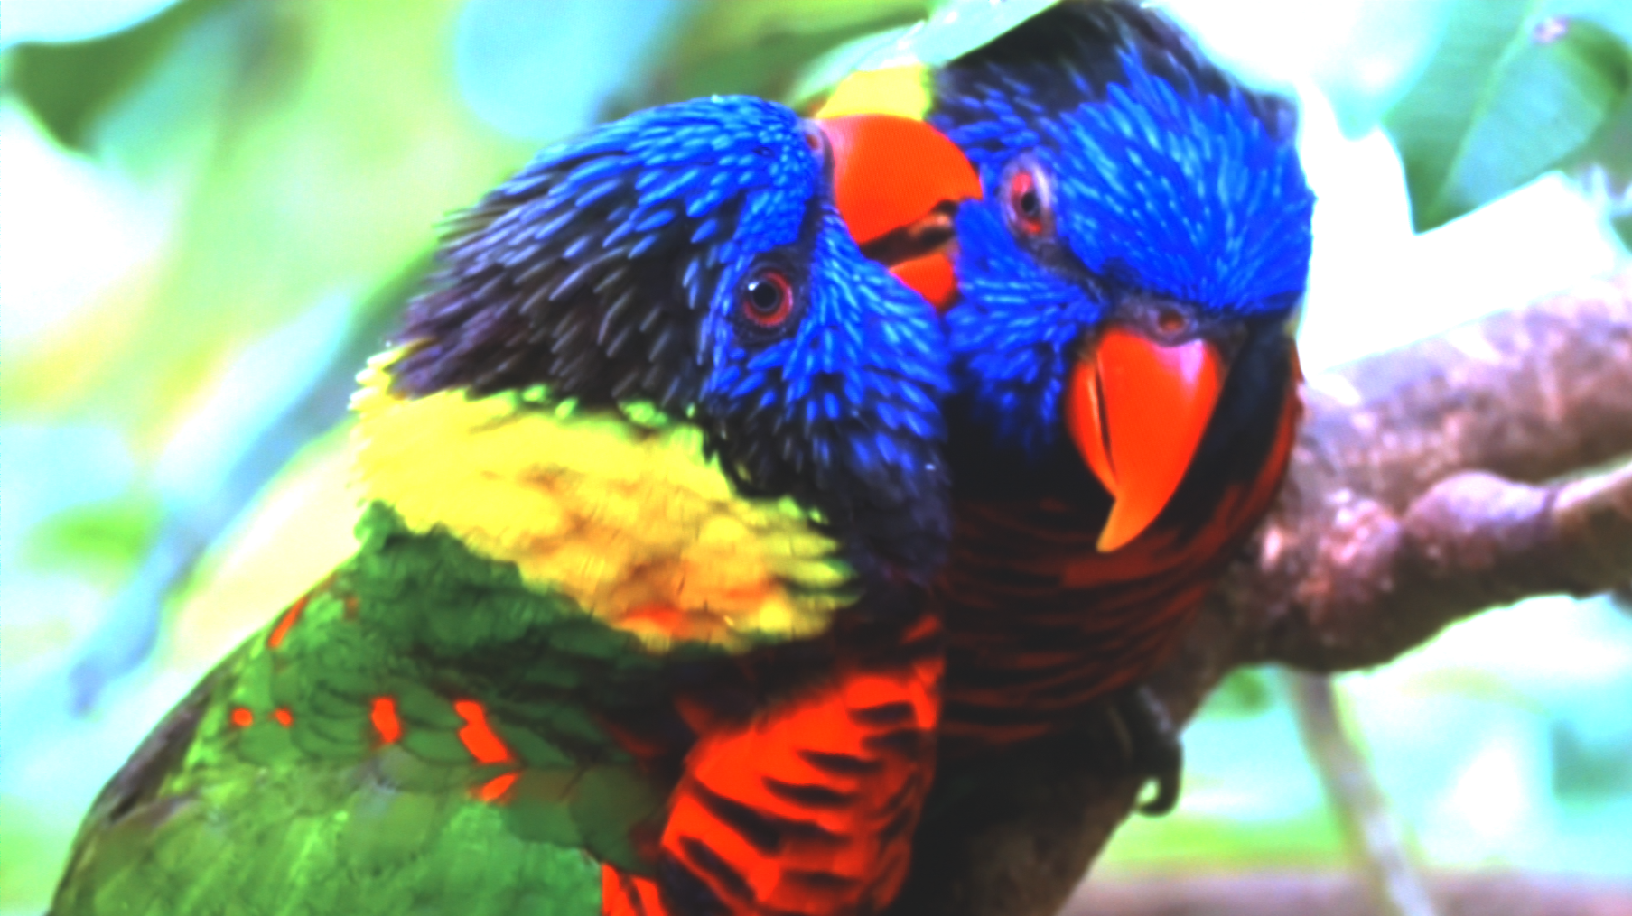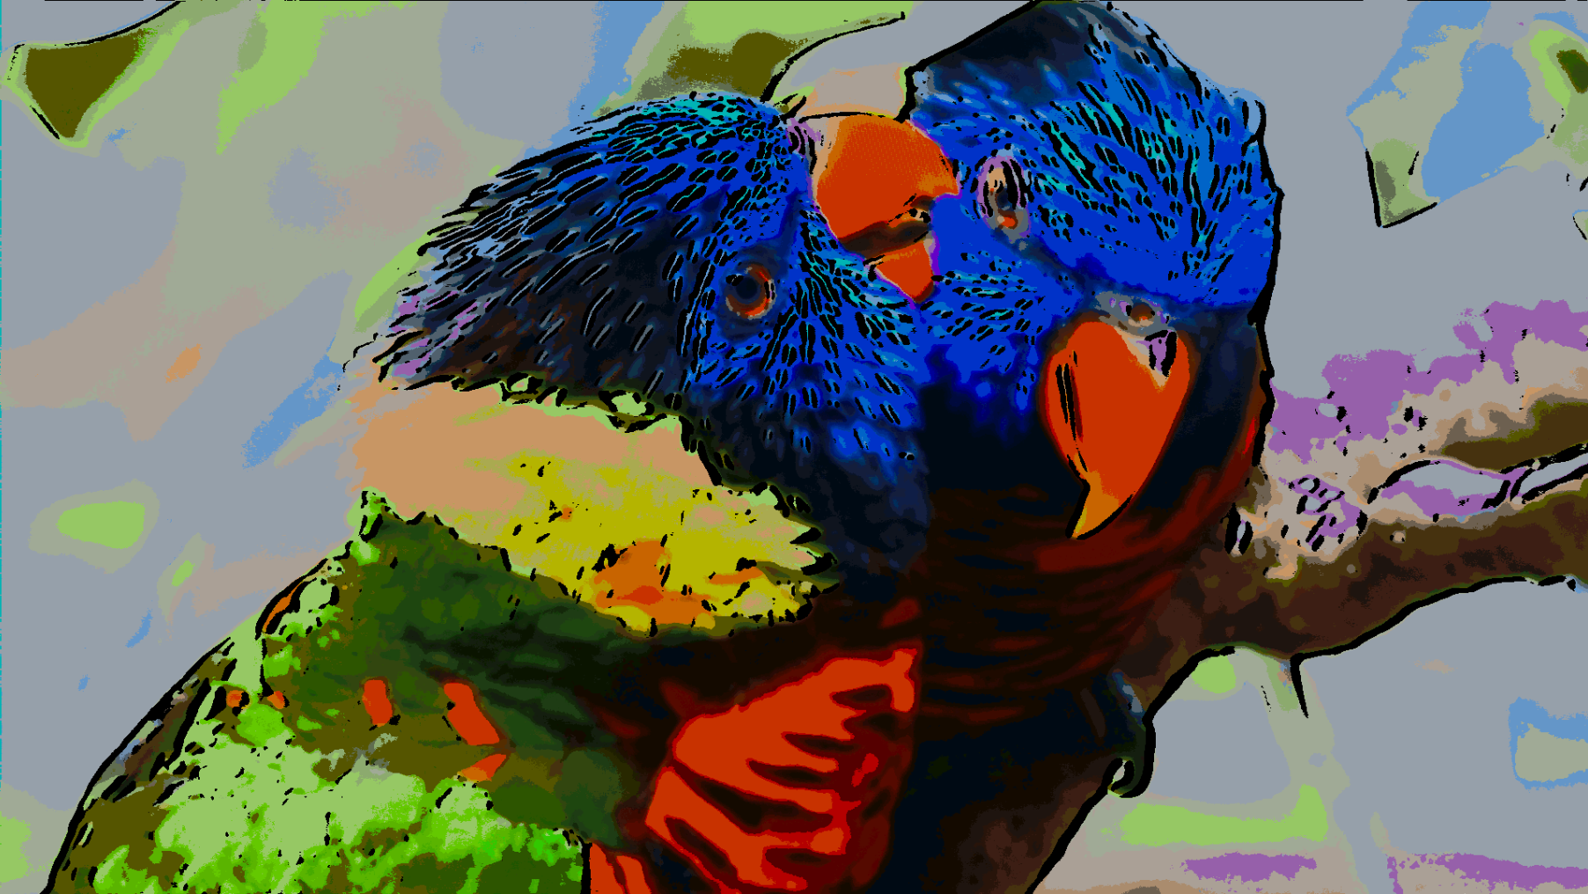

Figure 29. (Left) Original image; (Right) results obtained using the K-Mean Clustering.

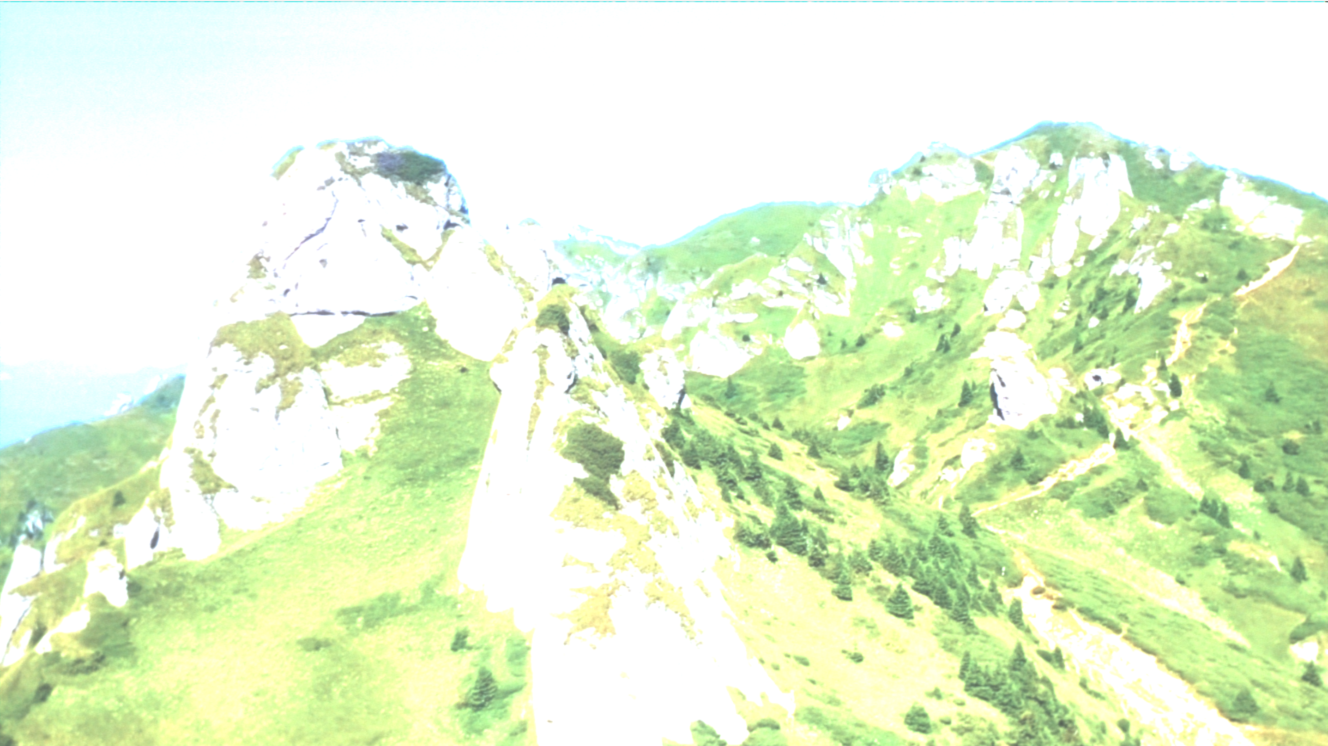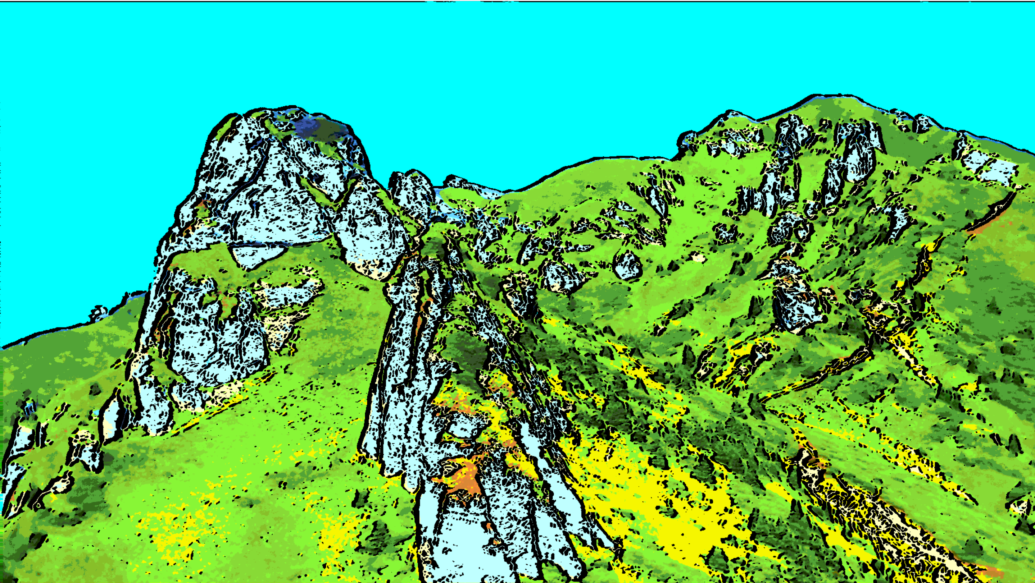

**90 REFERENCE PROGRAMABLE COLOR SCHEMES**

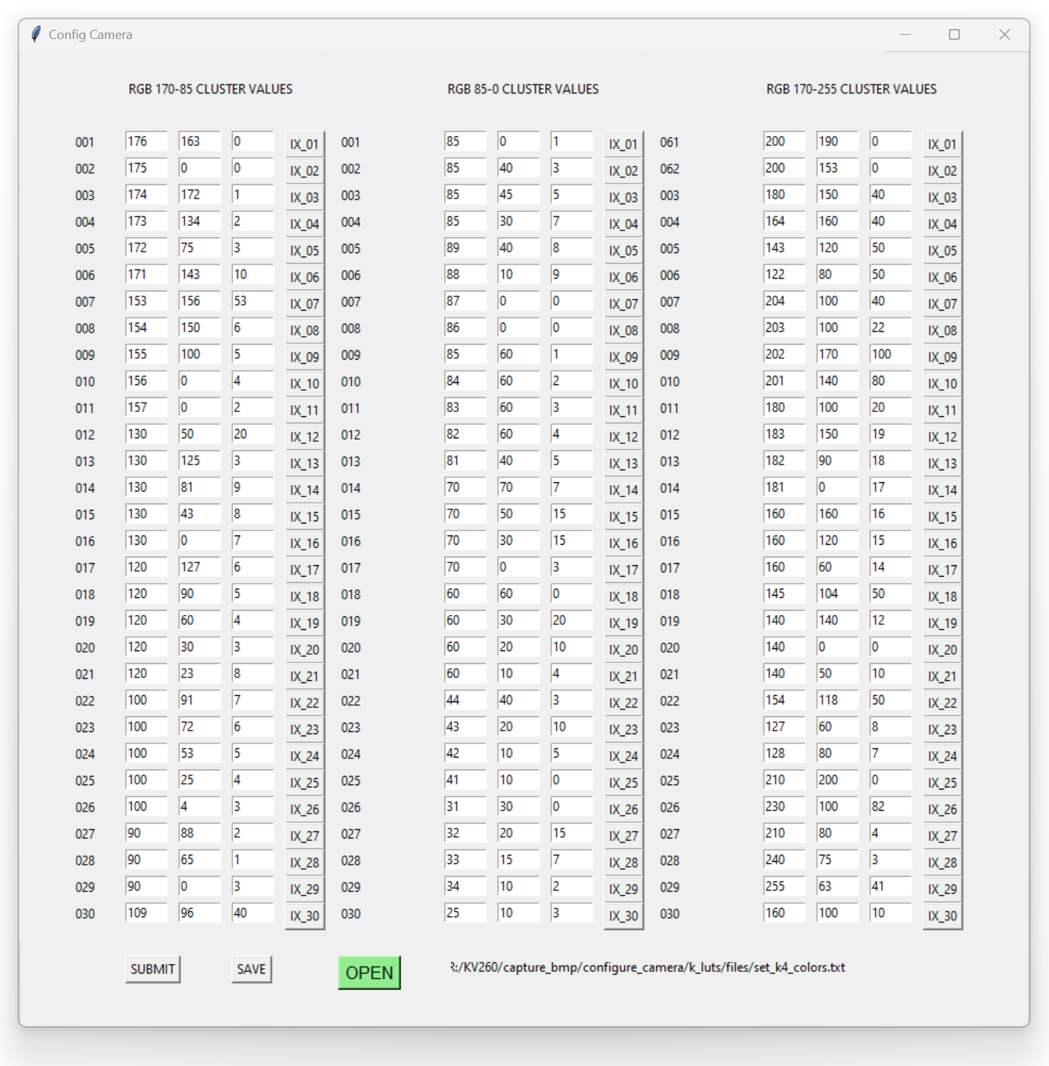

# VIDEO CONTROLLER INTERFACE

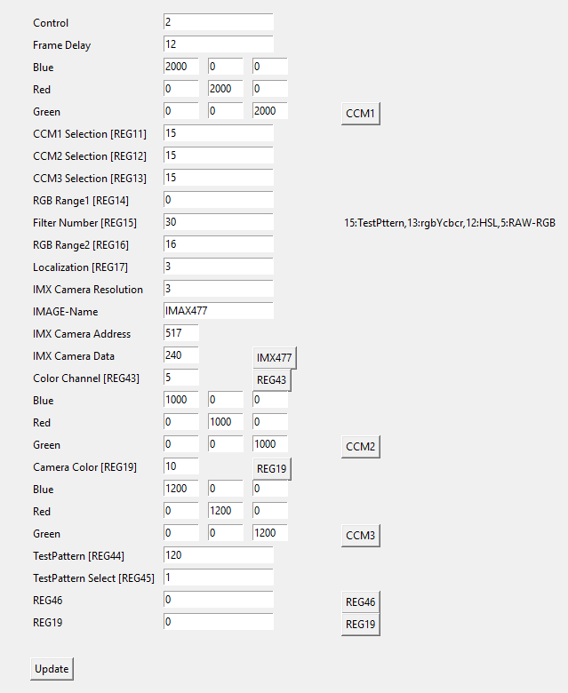

# LOCAL DYNAMIC THRESHOLD SEGMENTATION

This module takes the pixel as the center and check its neighboring pixels and compared with one by one. If the difference level is within the threshold limits than average, it and the new pixel value will be compared with each neighborhood pixels. The produced new region is uniform and difference in region would be small.

The aim is to average pixel by thresholding. Typically, in the design for this module, threshold of value 10 is selected with the pixel values in a 0-255 range. Pixel with values less than the threshold will map to average, whilst those with values greater than or equal to the threshold will map to original pixel values. Average pixel values are close to current and next values are averaged within the threshold; this mapping gives local clustering of image pixel.

Not implemented Yet: For given selected region of area below the define threshold such that there would exist a maximum value before averaging. Such those max value does not need to be part of average values. This would better result for averaging the pixels within the threshold. If all values are same than there is no max, in other words all value are constant in that region. Such implementation would be valid for at-least 3 pixels or greater.

The module rgb pixel data is available on when valid data is asserted high by the module.



IMAGE CONTRAST AND BRIGHTNESS

CAMERA RAW DATA

This module read 12-bit RGB data from Demosaic Xilinx IP. External Pixel clock is from camera used to sample 1 pixel which equal to 1 pll generated master external clock. Host camera data is than stored into buffer line by line which is ready to be fetch at system clock rate. Input line and frame valid signals are used to start reading stored buffer data. Valid read is enabled when both frame and line valid signal are asserted high. Buffer size set to be the size of frame width. The read controller side reads whole frame width from the buffer. Values written to buffer run at pixel clock rate whereas buffer read side run at faster rate than pixel clock.

Buffersize is auto size supported which is controlled by input line valid from host camera and maximum is set to default value of 3071. A base configuration consisting of a single 24-bits pipeline, capable of processing 1080p HD video at 30 frames per second.

Input data from camera is color filtered which is arranged in a bayer patten. Input data is read with line-by-line transfer rate of pixel clock which later synchronize into system clock.

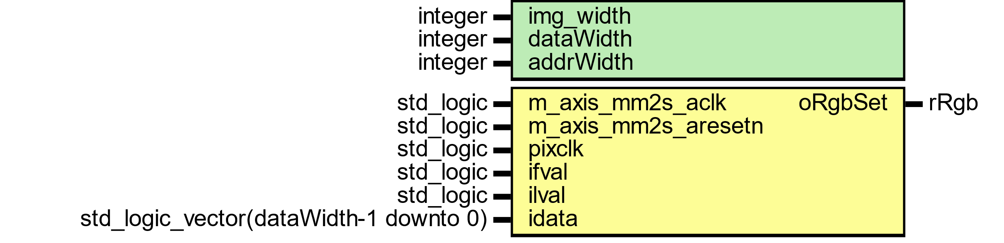

Figure : camera raw data module

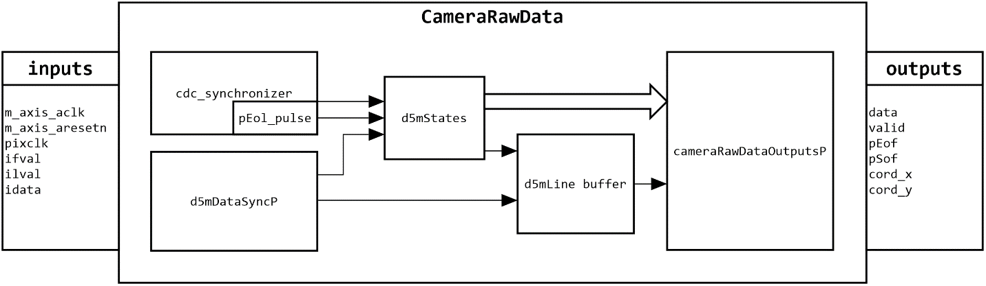

Figure : General view of camera raw data flow

Host camera interface uses 12 bits parallel input data with line and frame valid control signals.

THREE TAPS DATA



Figure

FOUR TAPS DATA



Figure

PIXEL COORDINATES



Figure





Figure



Figure

CAMERA RAW DATA

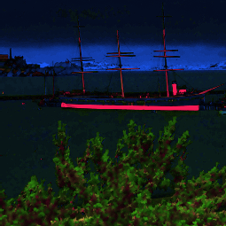

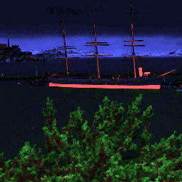

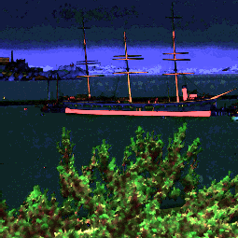

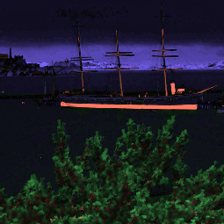

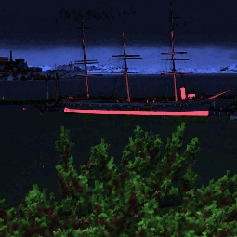

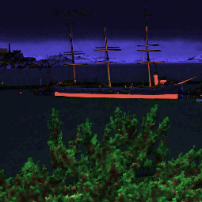

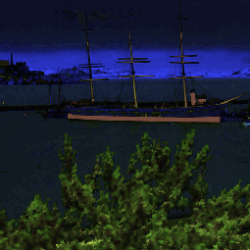

HISTOGRAM

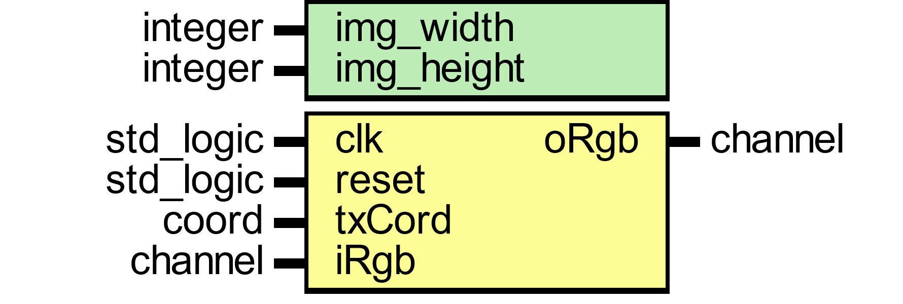

Figure

This module assigns memory location as rgb red channel input integer between 0 to 255 which equally 8 bits to express 256 levels address. Every input value would accumulate to its location to show how many hits per level.



Figure

Histogram Equation

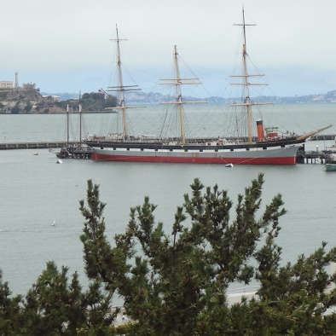

|  |  |  |  |
| --- | --- | --- | --- |
|  |  |  |  |
| 1ST figure shows rgb image. 2nd figure shows red channel. 3rd figure shows green channel and 4th figure shows blue channel. | | | |

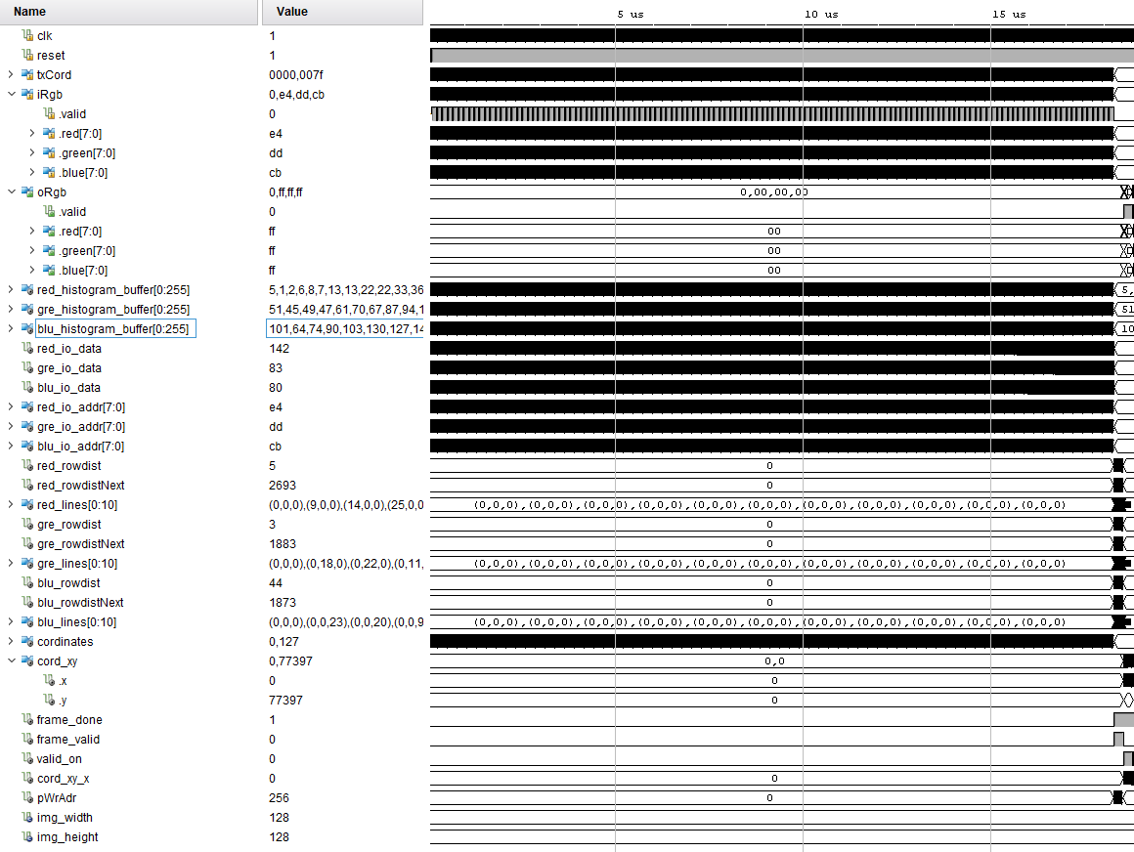

Figure

ETHERNET UDP VIDEO STREAMING

To successfully run the real-time network UDP (User Datagram Protocol) video streaming, this reference design uses the KRIA KV260 development board developed by Xilinx.

The design is composed of two platforms: the transmitter platform and the receiver platform. The receiver platform which receives input video stream from imx477 camera implements PL logic design of device. The transmitter platform which is PS Side of device implements a UDP/IP hardware protocol stack that enables high speed communication over a LAN or a point-to-point connection.

UDP/IP video streaming is implemented by using LWIP (**L**ight**W**eight **I**nternet **P**rotocol) which is open-source networking stacked design for embedded system. The main purpose usage of lwip in this design is portability, as well as small code and data size, making it especially suited for network video transmission.

LWIP supports both TCP and UDP at transport layer and application-level protocols. To get better performance, UDP protocol is used as a transport layer protocol. UDP is a connectionless protocol and faster than TCP since there is no error checking for packets. UDP protocol is used as transport layer in this design since it is suitable for video transmission that require fast transportation.

**CONFIGURATION**

KRIA KV260 board connect directly to the host PC and not running a DHCP server and host PC need to configure to an IP address of 192.168.0.42 and subnet mask of 255.255.255.0. Default IP address for FPGA development board is configured to “192.168.0.10”.

**NETWORK**

At startup LWIP fetch an IP address from DHCP server. If there no DHCP server than DHCP server request will timeout and the board will default to preset default to an IP address of 192.168.0.10.

The FFMPEG application on the host PC will connect with the video transmitter application on board and video data transmission will commence. When the video images are received, the FFMPEG invoke ffplay.exe which decode first 54 bytes source video type. Below figure shows 54 bytes of video header format.

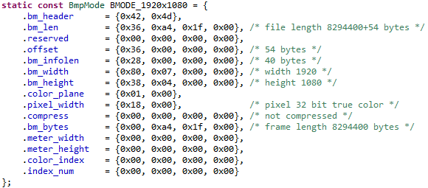

The BSP required to run the lwip application and it includes many settings that impact ethernet performance. Below figure shows lwip BSP settings.

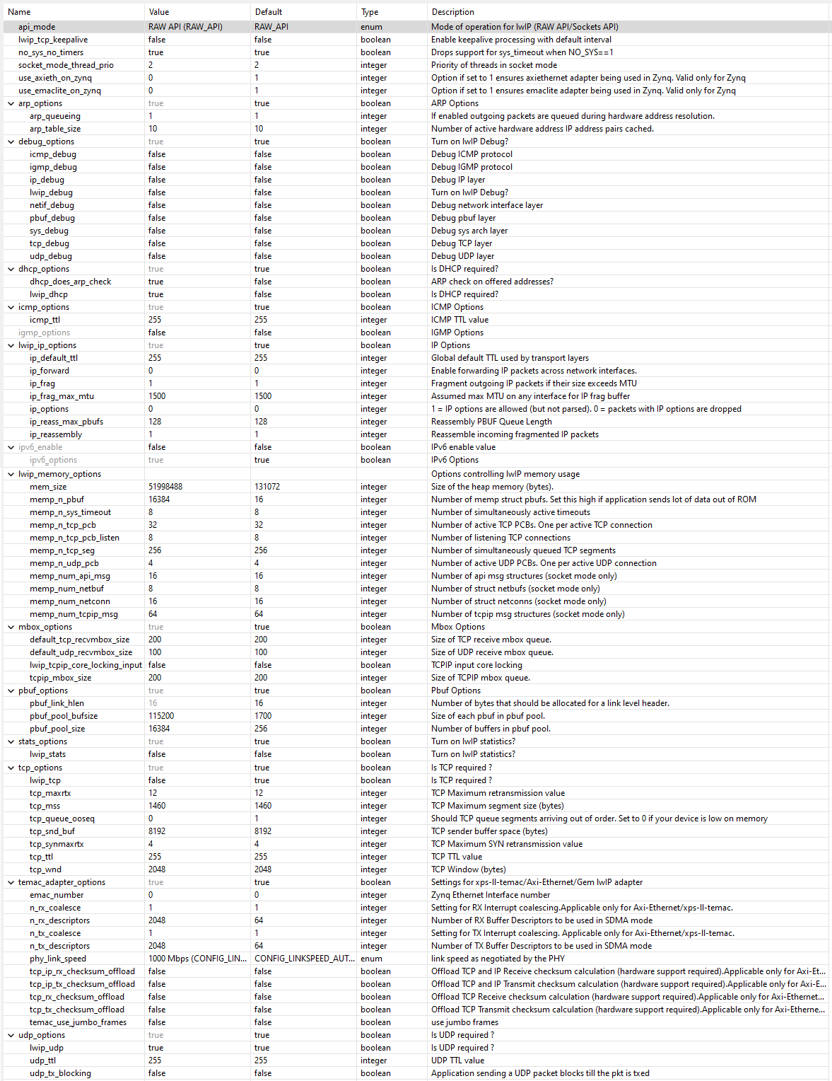

VIDEO STREAM DATA AND FORMAT

The GUI design on the remote computer provide the following features:

* Send the commands to the remote FPGA development board IP address “192.168.0.10”.
* Receive the image data from the development board.
* FFMPEG “ffplay.exe” decode the received bmp images to video stream at specified frame rate.

SONY IMX477/IMX682/IMX519/IMX219 AND ONSEMI AR1335 CAMERAS VIDEO STREAMING

Sony Cameras are used on Raspberry Pi interface the Kria KV260 Development Board.

LWIP ETHERNET INTERFACE

The KRIA KV260 development board has 1 Gigabit Ethernet which is connected through the RGMII interface.

5MP OV5640 SENSOR INTERFACE

The image sensor in the PCAM 5C Module is a CMOS type digital sensor model OV5640 which is 5 Megapixel (MP) color image sensor.

Image pixels data is transferred over dual -lane MIPI CSI-2 interface which is connected to KRIA KV260 development via 15-pin flat flexible cable.

5MP OV5647 SENSOR INTERFACE

The image sensor in the PCAM 5C Module is a CMOS type digital sensor model OV5640 which is 5 Megapixel (MP) color image sensor.

Image pixels data is transferred over dual -lane MIPI CSI-2 interface which is connected to KRIA KV260 development via 15-pin flat flexible cable.

8MP IMX219 SENSOR INTERFACE

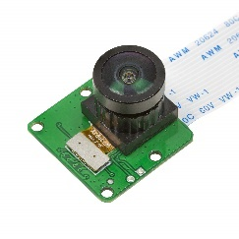

The image sensor in the SONY IMX219 Module is a CMOS type digital sensor which is 8 Megapixel (MP) color image sensor. It’s support 1080p30,720p60 and 640x480p90 video resolutions and still image of max resolution of 3280x2464 pixels.

Image pixels data is transferred over dual -lane MIPI CSI-2 interface which is connected to KRIA KV260 development via 15-pin flat flexible cable.

SPECIFICATIONS

|  |  |
| --- | --- |
| Sensor | Sony IMX219 |
| Optical Format | Type 1/4(Diagonal 4.60mm) |
| Pixel | 8MP |
| Pixel Size | 1.12μm×1.12μm |
| Active Pixels | 3280 (H) × 2464 (V) |
| CSI-2 Data Output | 2-lane mode |
| Data Format | Raw Bayer 10bit |
| Frame Rates | 1080p30, 720p60 and VGA90 video modes |
| Shutter Type | Rolling Shutter |
| FOV (Field of View) | 75°(H) |
| Camera Board Size | 24mm x 25mm |

SONY 12.5MP IMX477 SENSOR

IMX477-MIPI-CS is a high-resolution digital camera. It incorporates a Sony 1/2.3" CMOS digital image sensor with an active imaging pixel array of 4056H x3040V.

# SPECIFICATIONS

|  |  |
| --- | --- |
| Sensor | Sony IMX477 |
| Optical Format | Type 1/4(Diagonal 4.60mm) |
| Pixel | 12.5MP |
| Pixel Size | 1.55μm×1.55μm |
| Active Pixels | 4056 (H) × 3040 (V) approx. 12.33 M pixels |
| CSI-2 Data Output | 2/4-lane mode |
| Data Format | Raw Bayer 10/12 bits |
| Frame Rates | 4K2Kp60, 1080p240 and VGA90 video modes |
| Shutter Type | Rolling Shutter |
| Camera Board Size | 24mm x 25mm |

# DRIVE MODE

|  |  |  |  |  |
| --- | --- | --- | --- | --- |
| **Drive Mode** | **Number of active pixels** | **Maximum frame rate [frames/s]** | **Output Interface** | **ADC [bit]** |
| Full (4:3) [Normal] | 4056(H) × 3040(V) 12.3MP | 60 | CSI-2 | 10 |
| Full (4:3) [Normal] | 4056(H) × 3040(V) 12.3MP | 40 | CSI-2 | 12 |
| Full (4:3) [DOL-HDR] | 4056(H) × 3040(V) 12.3MP | 30/15 (DOL 2/DOL 3) | CSI-2 | 10 |
| Full (16:9) 4K2K [Normal] | 4056(H) × 2288(V) 9.3MP | 79 | CSI-2 | 10 |
| Full (16:9) 4K2K [DOL-HDR] | 4056(H) × 2288(V) 9.3MP | 39/19 (DOL 2/DOL 3) | CSI-2 | 10 |
| Full (4:3) Binning [Normal] | 2028(H) × 1520(V) 3.1MP | 179 | CSI-2 | 10 |
| Full (16:9) Binning 1080P [Normal] | 2028(H) × 1128(V) 2.3MP | 240 | CSI-2 | 10 |
| Full (16:9) Binning 720P [Normal] | 1348(H) × 750(V) 1MP | 240 | CSI-2 | 10 |
| Full (16:9) Scaling 1080P [Normal] | 2024(H) × 1142(V) 2.3MP | 79 | CSI-2 | 10 |
| Full (16:9) Scaling 720P [Normal] | 1348(H) × 762(V) 1MP | 79 | CSI-2 | 10 |

# FEATURES

* Back-illuminated and stacked CMOS image sensor Exmor RS
* Digital Overlap High Dynamic Range (DOL-HDR) mode with raw data output.
* High signal to noise ratio (SNR).
* Full resolution @60 frame/s (Normal), 4K2K @60 frame/s (Normal), 1080p @240 frame/s
* Full resolution @40 frame/s (12 bit Normal), Full resolution @30 frame/s (DOL-HDR, 2 frame)
* Output video format of RAW12/10/8, COMP8.
* Power Save Mode
* Pixel binning readout and V sub-sampling function.
* Independent flipping and mirroring.
* Input clock frequency 6 to 27 MHz
* CSI-2 serial data output (MIPI 2lane/4lane, Max. 2.1 Gbps/lane, D-PHY spec. ver. 1.2 compliant)
* 2-wire serial communication.
* Two PLLs for independent clock generation for pixel control and data output interface.
* Ambient Light Sensor (ALS)
* Fast mode transition.
* Dual sensor synchronization operation (Multi camera compatible)
* 7 K bit of OTP ROM for users.
* Built-in temperature sensor
* 10-bit/12-bit A/D conversion on chip
* 92-pin high-precision ceramic package

# INTERFACE

IMX477 Camera module and the KRIA KV260 development board are connected through the FPC flexible flat cable. Camera pixels data is transferred over dual -lane MIPI CSI-2 interface which is connected to development board via 15-pin flat flexible cable. Raspberry Pi camera module interface only support 2 MIPI lanes which directly connected directly to the Zynq UltraScale+ MPSoC HPA bank.

The interface is defined as follows:

|  |  |  |
| --- | --- | --- |
| **PIN** | **SIGNAL NAME** | **DESCRIPTION** |
| PIN 1 | Ground | Ground |
| PIN 2 | MIPI_LAN0_N | Camera CMOS LANE0 Data Negative Output |
| PIN 3 | MIPI_LAN0_P | Camera CMOS LANE0 Data Positive Output |
| PIN 4 | Ground | Ground |
| PIN 5 | MIPI_LAN1_N | Camera CMOS LANE1 Data Negative Output |
| PIN 6 | MIPI_LAN1_P | Camera CMOS LANE1 Data Positive Output |
| PIN 7 | Ground | Ground |
| PIN 8 | MIPI_CLK_N | Camera CMOS Clock Negative Output |
| PIN 9 | MIPI_CLK_P | Camera CMOS Clock Data Positive Output |
| PIN 10 | Ground | Ground |
| PIN 11 | CAM_PWUP | Camera CMOS Power-on Control Signal |
| PIN 12 | CAM_CLK | Camera CMOS Input Clock Signal |
| PIN 13 | CAM_SCL | Camera CMOS I2C Clock Signal |
| PIN 14 | CAM_SDA | Camera CMOS I2C Data Signal |
| PIN 15 | +3.3V | Power Supply 3.3V |

The Camera Serial Interface (CSI), a division from the MIPI Alliance which have formulated set of interface standards to standardize the interface of mobile devices such as camera and display. MIPI's full name is "Mobile Industry Processor Interface", MIPI DSI correspond to video display and MIPI CSI correspond to video input standards respectively. CSI interface is divided into physical layer (D-PHY) and protocol layer (CSI-2).



**CONFIGURATION**

For this design application, the IMX477 camera device is configured to output 1920x1080p video frames with RGB 30 bits pixel format, at 60 frames rate. Both the camera device and MIPI CSI-2 subsystem module is configured in advance.

**VIDEO INPUT SUBSYSTEMS**

The MIPI CSI-2 subsystem module is used to captures images from IMX477 camera sensor and outputs to axi4 stream video stream. Demosaic module is used to convert raw axi4 stream video data to rgb format video stream.

VDMA IP is used convert Demosaic video stream data to AXI4 memory map format and DDR fetching decoding and execution via AXI_HP interface.

VDMA (Video Direct Memory Access) is a general DMA, specially used for video and image applications. It has an AXI4 Memory Map interface for reading (writing channel) and writing (read channel) video to memory.

The display port controller in the PS is coupled to the STDP4320 demultiplexer on the carrier which consists of dual mode output ports configured as DP/HDMI.



**IMX477 CONFIGURATION REGISTERS**

|  |  |  |
| --- | --- | --- |
| **ADDRESS** | **REGISTER NAME** | **VALUE** |
| 0x0342 | LINE_LEN_MSB | 0X31 |
| 0x0343 | LINE_LEN_LSB | 0XC4 |
| 0x0344 | X_ADD_STA_MSB | 0X00 |
| 0x0345 | X_ADD_STA_LSB | 0X00 |
| 0x0348 | X_ADD_END_MSB | 0X0F |
| 0x0349 | X_ADD_END_LSB | 0XD7 |
| 0x0346 | Y_ADD_STA_MSB | 0X01 |
| 0x0347 | Y_ADD_STA_LSB | 0XB8 |
| 0x034A | Y_ADD_END_MSB | 0X0A |
| 0x034B | Y_ADD_END_LSB | 0X27 |
| 0x040C | DIG_CROP_WIDTH_MSB | 0X0F |
| 0x040D | DIG_CROP_WIDTH_LSB | 0XD7 |
| 0x040E | DIG_CROP_HEIGHT_MSB | 0X04 |
| 0x040F | DIG_CROP_HEIGHT_LSB | 0XB0 |
| 0x034C | X_OUT_SIZE_MSB | 0X08 |
| 0x034D | X_OUT_SIZE_LSB | 0X00 |
| 0x034E | Y_OUT_SIZE_MSB | 0X04 |
| 0x034F | Y_OUT_SIZE_LSB | 0XB0 |
| 0x0408 | DIG_CROP_X_OFFSET_MSB | 0X00 |
| 0x0409 | DIG_CROP_X_OFFSET_LSB | 0X00 |
| 0x040A | DIG_CROP_Y_OFFSET_MSB | 0X00 |
| 0x040B | DIG_CROP_Y_OFFSET_LSB | 0X00 |
| 0x0381 | X_ENV_INC_CONST | 0X01 |
| 0x0383 | X_ODD_INC_CONST | 0X01 |
| 0x0385 | Y_ENV_INC_CONST | 0X01 |
| 0x0387 | Y_ODD_INC | 0X01 |
| 0x0900 | BINNING_MODE | 0X01 |
| 0x0901 | BINNING_HV | 0X12 |
| 0x0902 | BINNING_WEIGHTING | 0X02 |
| 0x3F0D | ADC_BIT_SETTING | 0X0A |
| 0x0401 | SCALE_MODE | 0X01 |
| 0x0404 | SCALE_M_MSB | 0X00 |
| 0x0405 | SCALE_M_LSB | 0X20 |
| 0x0301 | IVTPXCK_DIV | 0X05 |
| 0x0303 | IVTSYCK_DIV | 0X02 |
| 0x0305 | IVT_PREPLLCK_DIV | 0X04 |
| 0x0306 | PLL_IVT_MPY_MSB | 0X01 |
| 0x0307 | PLL_IVT_MPY_LSB | 0X5E |
| 0x0309 | IOPPXCK_DIV | 0X0C |
| 0x030B | IOPSYCK_DIV | 0X02 |
| 0x030D | IOP_PREPLLCK_DIV | 0X02 |
| 0x030E | IOP_MPY_MSB | 0X00 |
| 0x030F | IOP_MPY_LSB | 0X96 |
| 0x0310 | PLL_MULTI_DRV | 0X01 |
| 0x0820 | REQ_LINK_BIT_RATE_MSB | 0X07 |
| 0x0821 | REQ_LINK_BIT_RATE_LMSB | 0X08 |
| 0x0822 | REQ_LINK_BIT_RATE_MLSB | 0X00 |
| 0x0823 | REQ_LINK_BIT_RATE_LSB | 0X00 |
| 0x080A | TCLK_POST_EX_MSB | 0X00 |
| 0x080B | TCLK_POST_EX_LSB | 0X7F |
| 0x080C | THS_PRE_EX_MSB | 0X00 |
| 0x080D | THS_PRE_EX_LSB | 0X4F |
| 0x080E | THS_ZERO_MIN_MSB | 0X00 |
| 0x080F | THS_ZERO_MIN_LSB | 0X77 |
| 0x0810 | THS_TRAIL_EX_MSB | 0X00 |
| 0x0811 | THS_TRAIL_EX_LSB | 0X5F |
| 0x0812 | TCLK_TRAIL_MIN_MSB | 0X00 |
| 0x0813 | TCLK_TRAIL_MIN_LSB | 0X57 |
| 0x0814 | TCLK_PREP_EX_MSB | 0X00 |
| 0x0815 | TCLK_PREP_EX_LSB | 0X4F |
| 0x0816 | TCLK_ZERO_EX_MSB | 0X01 |
| 0x0817 | TCLK_ZERO_EX_LSB | 0X27 |
| 0x0818 | TLPX_EX_MSB | 0X00 |
| 0x0819 | TLPX_EX_LSB | 0X3F |
| 0x3E37 | PDAF_CTRL1_0 | 0X00 |
| 0x3F50 | POWER_SAVE_ENABLE | 0X00 |
| 0x3F56 | LINE_LEN_INCLK_MSB | 0X01 |
| 0x3F57 | LINE_LEN_INCLK_LSB | 0X6C |
| 0x0204 | ANA_GLOBAL_GAIN_U | 0X03 |
| 0x0205 | ANA_GLOBAL_GAIN_L | 0X7F |
| 0x020E | DIG_GAIN_GR_U | 0X02 |
| 0x020F | DIG_GAIN_GR_L | 0X00 |
| 0x0210 | DIG_GAIN_R_U | 0X03 |
| 0x0211 | DIG_GAIN_R_L | 0X00 |
| 0x0212 | DIG_GAIN_B_U | 0X02 |
| 0x0213 | DIG_GAIN_B_L | 0X00 |
| 0x0214 | DIG_GAIN_GB_U | 0X02 |
| 0x0215 | DIG_GAIN_GB_L | 0X00 |
| 0x0202 | COARSE_INTEGRATION_TIME_MSB | 0X02 |
| 0x0203 | COARSE_INTEGRATION_TIME_LSB | 0X00 |
| 0x0100 | MODE_SEL | 0X01 |

16MP IMX519 SENSOR INTERFACE

The image sensor in the PCAM 5C Module is a CMOS type digital sensor model OV5640 which is 5 Megapixel (MP) color image sensor.

Image pixels data is transferred over dual -lane MIPI CSI-2 interface which is connected to KRIA KV260 development via 15-pin flat flexible cable.

64MP IMX682 SENSOR INTERFACE

The image sensor in the PCAM 5C Module is a CMOS type digital sensor model OV5640 which is 5 Megapixel (MP) color image sensor.

Image pixels data is transferred over dual -lane MIPI CSI-2 interface which is connected to KRIA KV260 development via 15-pin flat flexible cable.

**Vitis program development**

The program design is mainly divided into five parts, video initialization, configuration, control, and transmission. Below figure present the overall software structure of implemented application, which shows the program and data flow.



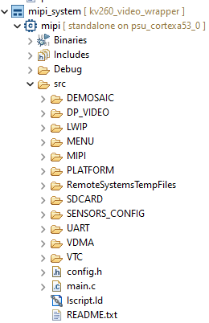

In the main function, the initialization of the 1 frame buffered is performed for VDMA1. The VIDEO1_MAX_FRAME macro definition is set to 1, the initial initialization of pFrame0 pointer, pFrame0 points to the cache of camera 1.

TESTBENCH

For filter modules verification vhdl testbench is being used to generate image. Approach used to generate stimulus and checking response by using single process testbench. Testbench include a process which read image file to apply rgb stimulus to design filter section and then wait until end of frame to generate valid output image bmp file.

TESTBENCH COMPONENTS/OBJECTS

D5M verification testbench is created through configuration, the factory and the phase build process which allows stimulus and randomization generation. The testbench describes image filters of design, where source of input stimuli, or test patterns are applied and monitor of output results inform of output generated images. Testbench requires the user to manually check filtered output image and check pass/fail test pattern testing.

UVM testbench build from classes. Test has environment, the environment has d5m agent.

Flow of testbench is to connect DUT and testbench, configure d5m agent, generate stimulus.

In the filter’s generic package, a common verification scenario for vfp tests is to initialize set of parameters by setting to define enable variable in frame enable package. This type of initialization can be done at terminal during compilation unit scope. In table shows available define variable with available size for image testing.

|  |  |  |
| --- | --- | --- |
| `define | size | description |
| rgb | **0**=64x64,  **1**=128x125,  **2**=255x255,  **3**=1920x1080 |  |
| sharp |  |
| blur |  |
| embross |  |
| hsl |  |
| hsv |  |
| cgain |  |
| sobel |  |

Set of parameters for image filter type and their size are assigned for current test values as shown in table 2 via defined macro in frame enable package according to table 1.

|  |  |  |
| --- | --- | --- |
| parameter | value | description |
| F_CGA | 1/0 | Enable ‘1’ Cgain color adjust for test. |
| F_SHP | 1/0 | Enable ‘1’ Sharp Filter for test. |
| F_BLU | 1/0 | Enable ‘1’ Blure Filter for test. |
| F_HSL | 1/0 | Enable ‘1’ HSL color space for test. |
| F_HSV | 1/0 | Enable ‘1’ HSV color space for test. |
| F_RGB | 1/0 | Enable ‘1’ RGB color space for test. |
| F_SOB | 1/0 | Enable ‘1’ Sobel filter for test. |
| F_EMB | 1/0 | Enable ‘1’ Embross Filter for test. |

For axi4-lite module registers in rtl, following parameters offset for base address are set for axi4 lite transections as shown table below.

|  |  |  |
| --- | --- | --- |
| Register Name | Offet | Description |
| initAddr | 8'h00 |  |
| oRgbOsharp | 8'h00 |  |
| oEdgeType | 8'h04 |  |
| filter_id | 8'h08 |  |
| aBusSelect | 8'h0C |  |
| threshold | 8'h10 |  |
| videoChannel | 8'h14 |  |
| dChannel | 8'h18 |  |
| cChannel | 8'h1C |  |
| kls_k1 | 8'h20 |  |
| kls_k2 | 8'h24 |  |
| kls_k3 | 8'h28 |  |
| kls_k4 | 8'h2C |  |
| kls_k5 | 8'h30 |  |
| kls_k6 | 8'h34 |  |
| kls_k7 | 8'h38 |  |
| kls_k8 | 8'h3C |  |
| kls_k9 | 8'h40 |  |
| kls_config | 8'h44 |  |
| als_k1 | 8'h54 |  |
| als_k2 | 8'h58 |  |
| als_k3 | 8'h5C |  |
| als_k4 | 8'h60 |  |
| als_k5 | 8'h64 |  |
| als_k6 | 8'h68 |  |
| als_k7 | 8'h6C |  |
| als_k8 | 8'h70 |  |
| als_k9 | 8'h74 |  |
| als_config | 8'h78 |  |
| pReg_pointInterest | 8'h7C |  |
| pReg_deltaConfig | 8'h80 |  |
| pReg_cpuAckGoAgain | 8'h84 |  |
| pReg_cpuWgridLock | 8'h88 |  |
| pReg_cpuAckoffFrame | 8'h8C |  |
| pReg_fifoReadAddress | 8'h90 |  |
| pReg_clearFifoData | 8'h94 |  |
| rgbCoord_rl | 8'hC8 |  |
| rgbCoord_rh | 8'hCC |  |
| rgbCoord_gl | 8'hD0 |  |
| rgbCoord_gh | 8'hD4 |  |
| rgbCoord_bl | 8'hD8 |  |
| rgbCoord_bh | 8'hDC |  |
| oLumTh | 8'hE0 |  |
| oHsvPerCh | 8'hE4 |  |
| oYccPerCh | 8'hE8 |  |

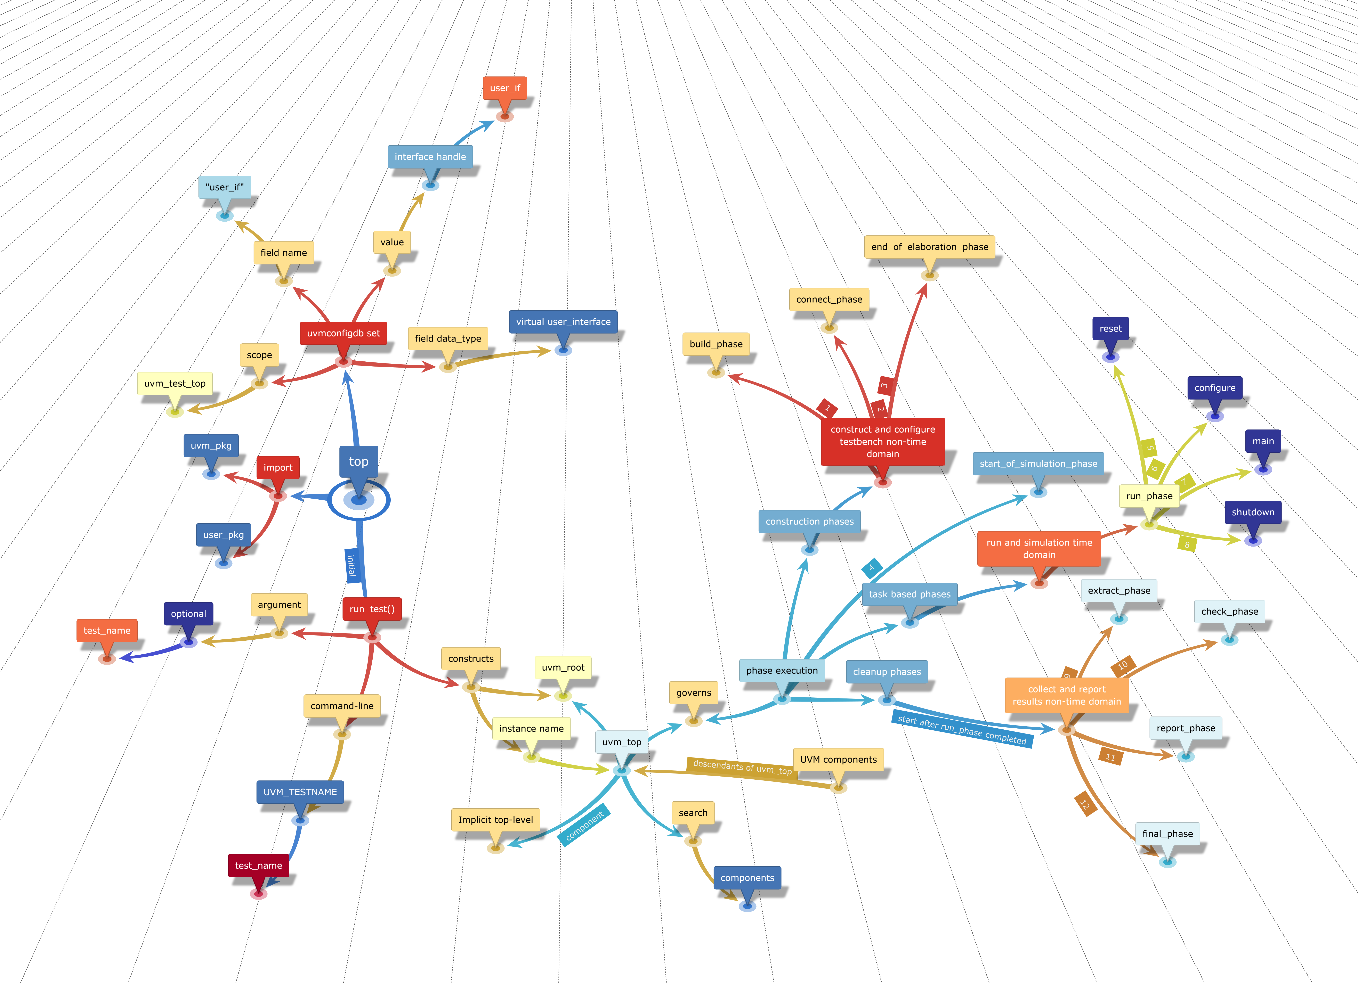

Figure

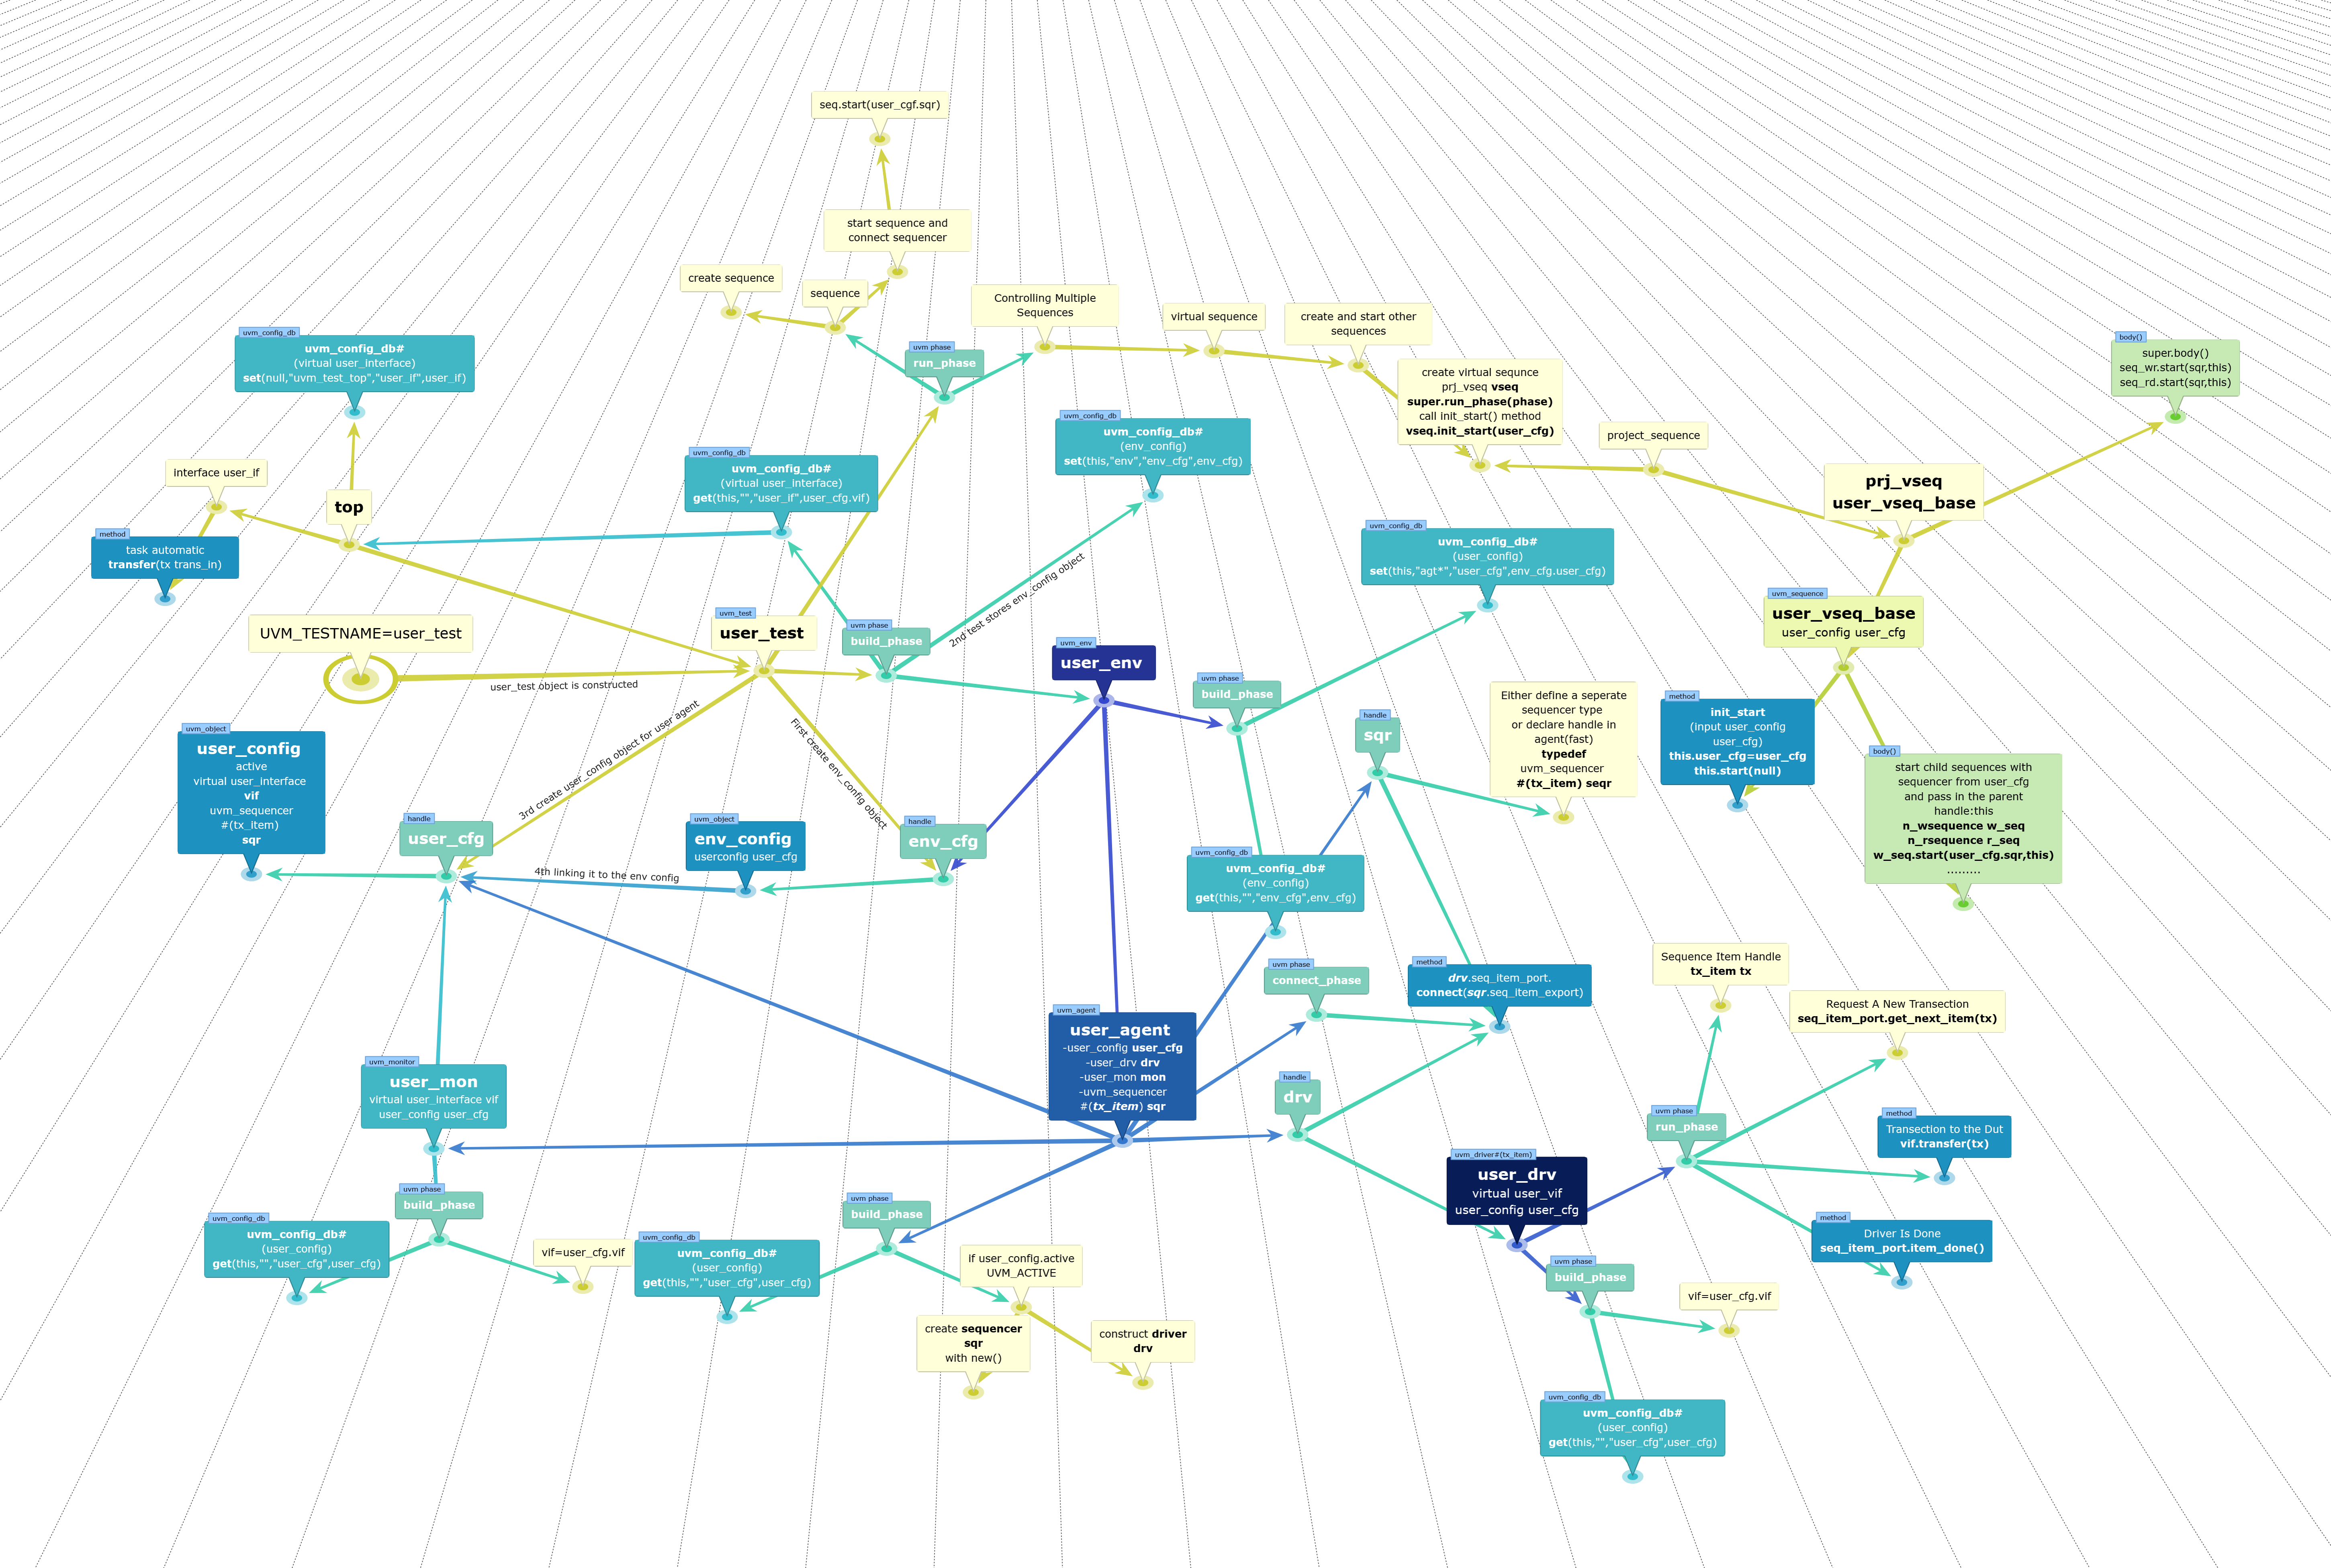

Figure

DUT CONNECTIONS

Input protocol interface

Output protocol interface

SEQUENCE ITEM

SEQUENCE

SEQUENCER

DRIVER

This class which extended from uvm driver pull data items generated by a sequencer and drive it to the DUT. In run phase, methods are used for reading and writing operation to dut through dut interface handle.

Axi4lite communication flow across 5 parallel channels. Read transection phases split into 2 phases. Request on read address channel and response on read data channel. Write transection split into 3 phases: address, data, and response with the status. Multiple read and write transaction are concurrent. Write address transfer can come before, during, or after the write data. Signal for read address channels start with AR* and read data signals start with R*. Write address signal start with AW*, write data signal name start with W* and write response start with B*. Axi4lite has flow control on each channel to control the rate the information is exchange such as address, data, and response. The source generates valid to indicate information is available. Destination generates ready signal to accept the information. The source assert valid first and wait for destination to be ready and then transfer the info. Or destination could go first, asserting ready to receive and wait for the source. When source is ready, it asserts valid and transfer the info. The transfer only occurs when both valid and ready are high.

Basic overview:

1. Declare the virtual interface.
2. Get the interface handle using get config_db.
3. Add the get config_db in the build_phase.
4. Add driving logic. get the seq_item and drive to dut signals.

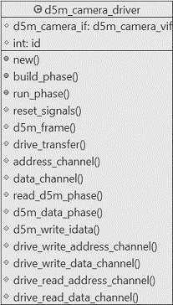

Figure

DECLARATION:

This uvm driver class is derived from uvm component.

|  |
| --- |
| class d5m_camera_driver extends uvm_driver #(d5m_trans); |

DATA MEMEBERS

|  |
| --- |
| protected virtual d5m_camera_if d5m_camera_vif;  protected int id; |

NEW CONSTRUCT

For Each component, the constructor must execute and complete to bring the component into existence. Therefore, new () must run before build() or any other subsequent phase can execute.

|  |
| --- |
| function new (string name, uvm_component parent);  super.new(name, parent);  endfunction: new |

BUILD_PHASE

Build method run top-down and the rest of the phases run bottom-up. In this phase, config the dut interface handle through get method. The uvm_config_db parameterized class provides a convenience interface on top of uvm_resource_db is used to for reading resource database. The uvm_config_db is derived from uvm_resource_db class. Get value of field_name “d5m_camera_vif”, using component cntxt ”this” as starting search point.

|  |
| --- |
| function void build_phase (uvm_phase phase);  super.build_phase(phase);  if (!uvm_config_db#(virtual d5m_camera_if)::get  (this, "", "d5m_camera_vif", d5m_camera_vif))  `uvm_fatal("NOVIF", {"virtual interface must be set for:  ",get_full_name(), ".d5m_camera_vif"});  endfunction: build_phase |

RUN_PHASE

In this method, fork join constructs are used to separate threads that drive each of the channels.

|  |
| --- |
| virtual task run_phase (uvm_phase phase);  fork  reset signals();  d5m_frame();  join  endtask: run_phase |

RESET SIGNALS

Reset the dut axi4 lite and d5m_cam_mod input signals when system reset is asserted from low to high.

|  |
| --- |
| virtual protected task reset_signals();  forever begin  @(posedge d5m_camera_vif.ARESETN);  d5m_camera_vif.axi4.AWADDR <= 8'h0;  d5m_camera_vif.axi4.AWPROT <= 3'h0;  d5m_camera_vif.axi4.AWVALID <= 1'b0;  d5m_camera_vif.axi4.WDATA <= 32'h0;  d5m_camera_vif.axi4.WSTRB <= 4'h0;  d5m_camera_vif.axi4.WVALID <= 1'b0;  d5m_camera_vif.axi4.BREADY <= 1'b0;  d5m_camera_vif.axi4.ARADDR <= 8'h0;  d5m_camera_vif.axi4.ARPROT <= 3'h0;  d5m_camera_vif.axi4.ARVALID <= 1'b0;  d5m_camera_vif.axi4.RREADY <= 1'b0;  d5m_camera_vif.d5p.iImageTypeTest <= 1'b0;  d5m_camera_vif.d5p.iReadyToRead <= 1'b0;  d5m_camera_vif.d5p.fvalid <= 1'b0;  d5m_camera_vif.d5p.lvalid <= 1'b0;  end  endtask: reset_signals |

D5M FRAME

In this method, drive the signals from defined seq in uvm_sequence.

|  |
| --- |
| virtual protected task d5m_frame();  forever begin  @(posedge d5m_camera_vif.clkmm);  seq_item_port.get_next_item(req);  drive_transfer(req);  seq_item_port.item_done();  end  endtask: d5m_frame |

DRIVE TRANSFER

This method which is master to dut axi4lite interface write/read data at given address using bus handshaking protocol. First valid address is transmitted and then wait for valid response in given time of 61 clock cycles in axi4_address method. Timeout accord on 62 clock cycle, if no response is asserted high on bvalid signal from dut and timeout is flagged using uvm_error macro. If valid response is asserted then axi4_data method write/read data depending on case statement. Once axi4 bus config the video process module in dut then write/read operation can be initiated by calling the d5m_pixel method.

|  |
| --- |
| virtual protected task drive_transfer (d5m_trans d5m_tx);  axi4_address(d5m_tx);  axi4_data(d5m_tx);  d5m_pixel(d5m_tx);  endtask: drive_transfer |

AXI4 ADDRESS CHANNEL

In this method, write/read axi4 address channel.

|  |
| --- |
| virtual protected task axi4_address (d5m_trans d5m_tx);  case (d5m_tx.d5m_txn)  AXI4_WRITE : axi4_write_address(d5m_tx);  AXI4_READ : axi4_wread_address(d5m_tx)  endcase  endtask: axi4_address |

AXI4 DATA CHANNEL

In this method, write/read axi4 data channel through axi4_write data and axi4_read_data methods on selected case.

|  |
| --- |
| virtual protected task axi4_data (d5m_trans d5m_tx);  bit[31:0] rw_data;  bit err;  rw_data = d5m_tx.axi4_lite.data;  case (d5m_tx.d5m_txn)  AXI4_WRITE : axi4_write_data(d5m_tx);  AXI4_READ : axi4_read_data(rw_data, err);  endcase  endtask: axi4_data |

D5M PIXEL

In this method, d5m read/write frame rgb pixel per transaction.

|  |
| --- |
| virtual protected task d5m_pixel (d5m_trans d5m_tx);  case (d5m_tx.d5m_txn)  D5M_WRITE : d5m_write_pixel_data(d5m_tx);  IMAGE_READ : d5m_read_pixel_data(d5m_tx);  endcase  endtask: d5m_pixel |

D5M WRITE PIXEL DATA

In this method, write data to d5m camera mod from d5m_trans sequence.

|  |
| --- |
| virtual protected task d5m_write_pixel_data (d5m_trans d5m_tx);  d5m_camera_vif.d5p.iReadyToRead <= 1'b0;  d5m_camera_vif.d5p.iImageTypeTest <= d5m_tx.d5p.iImageTypeTest;  d5m_camera_vif.d5p.rgb <= d5m_tx.d5p.rgb;  d5m_camera_vif.d5p.fvalid <= d5m_tx.d5p.fvalid;  d5m_camera_vif.d5p.lvalid <= d5m_tx.d5p.lvalid;  endtask: d5m_write_pixel_data |

D5M READ PIXEL DATA

In this method, config test type during read operation and wait for end of frame pulse.

|  |
| --- |
| virtual protected task d5m_read_pixel_data(d5m_trans d5m_tx);  @(posedge d5m_camera_vif.clkmm);  d5m_camera_vif.d5p.iImageTypeTest <= 1'b0;  d5m_camera_vif.d5p.iReadyToRead <= 1'b1;  forever begin  @(posedge d5m_camera_vif.clkmm);  if (d5m_camera_vif.d5m.eof) break;  end  endtask: d5m_read_pixel_data |

AXI4 WRITE ADDRESS

In this method, write address and assert write valid high and then wait for response from dut BVALID signal within 62 clock cycles.

|  |
| --- |
| virtual protected task axi4_write_address (d5m_trans d5m_tx);  int axi_lite_ctr;  d5m_camera_vif.axi4.AWADDR <= {8'h0, d5m_tx.axi4_lite.addr};  d5m_camera_vif.axi4.AWPROT <= 3'h0;  d5m_camera_vif.axi4.AWVALID <= 1'b1;  // wait for write response  for(axi_lite_ctr = 0; axi_lite_ctr <= 62; axi_lite_ctr ++) begin  @(posedge d5m_camera_vif.clkmm);  if (d5m_camera_vif.axi4.BVALID) break;  end  if (axi_lite_ctr == 62) begin  `uvm_error("axi_lite_master_driver","AWVALID timeout");  end  endtask: axi4_write_address |

AXI4 WRITE DATA

|  |
| --- |
| virtual protected task axi4_write_data (d5m_trans d5m_tx);  int axi_lite_ctr;  d5m_camera_vif.axi4.WDATA <= d5m_tx.axi4_lite.data;  d5m_camera_vif.axi4.WSTRB <= 4'hf;  d5m_camera_vif.axi4.WVALID <= 1'b1;  @(posedge d5m_camera_vif.clkmm);  for(axi_lite_ctr = 0; axi_lite_ctr <= 62; axi_lite_ctr ++) begin  @(posedge d5m_camera_vif.clkmm);  if (d5m_camera_vif.axi4.WREADY)  d5m_camera_vif.axi4.AWADDR <= 8'h0;  d5m_camera_vif.axi4.AWPROT <= 3'h0;  d5m_camera_vif.axi4.AWVALID <= 1'b0;  break;  end  if (axi_lite_ctr == 62) begin  `uvm_error("axi_lite_master_driver","AWVALID timeout");  end  @(posedge d5m_camera_vif.clkmm);  d5m_camera_vif.axi4.WDATA <= 32'h0;  d5m_camera_vif.axi4.WSTRB <= 4'h0;  d5m_camera_vif.axi4.WVALID <= 1'b0;  // wait for write response  for(axi_lite_ctr = 0; axi_lite_ctr <= 62; axi_lite_ctr ++) begin  @(posedge d5m_camera_vif.clkmm);  if (d5m_camera_vif.axi4.BVALID) break;  end  if (axi_lite_ctr == 62) begin  `uvm_error("axi_lite_master_driver","BVALID timeout");  end  else begin  if (d5m_camera_vif.axi4.BVALID == 1'b1 && d5m_camera_vif.axi4.BRESP != 2'h0)  `uvm_error("axi_lite_master_driver","Received ERROR Write Response");  d5m_camera_vif.axi4.BREADY <= d5m_camera_vif.axi4.BVALID;  @(posedge d5m_camera_vif.clkmm);  end  endtask: axi4_write_data |

AXI4 WREAD ADDRESS

|  |
| --- |
| virtual protected task axi4_wread_address (d5m_trans d5m_tx);  int axi_lite_ctr;  d5m_camera_vif.axi4.ARADDR <= {8'h0, d5m_tx.axi4_lite.addr};  d5m_camera_vif.axi4.ARPROT <= 3'h0;  d5m_camera_vif.axi4.ARVALID <= 1'b1;  for(axi_lite_ctr = 0; axi_lite_ctr <= 62; axi_lite_ctr ++) begin  @(posedge d5m_camera_vif.clkmm);  if (d5m_camera_vif.axi4.ARREADY) break;  end  if (axi_lite_ctr == 62) begin  `uvm_error("axi_lite_master_driver","ARVALID timeout");  end  @(posedge d5m_camera_vif.clkmm);  d5m_camera_vif.axi4.ARADDR <= 8'h0;  d5m_camera_vif.axi4.ARPROT <= 3'h0;  d5m_camera_vif.axi4.ARVALID <= 1'b0;  endtask: axi4_wread_address |

AXI4 READ DATA

In this method, axi4lite read data.

|  |
| --- |
| virtual protected task axi4_read_data (output bit [31:0] data, output bit error);  int axi_lite_ctr;  for(axi_lite_ctr = 0; axi_lite_ctr <= 62; axi_lite_ctr ++) begin  @(posedge d5m_camera_vif.clkmm);  if (d5m_camera_vif.axi4.RVALID) break;  end  data = d5m_camera_vif.axi4.RDATA;  if (axi_lite_ctr == 62) begin  `uvm_error("axi_lite_master_driver","RVALID timeout");  end  else begin  if (d5m_camera_vif.axi4.RVALID == 1'b1 && d5m_camera_vif.axi4.RRESP != 2'h0)  `uvm_error("axi_lite_master_driver","Received ERROR Read Response");  d5m_camera_vif.axi4.RREADY <= d5m_camera_vif.axi4.RVALID;  @(posedge d5m_camera_vif.clkmm);  end  endtask: axi4_read_data |

MONITOR

The monitor is a system is critical component in the verification environment. It obtains and collect events and data related activity in the DUT. The information collected by monitor from dut, or stimulus is for checkers, scoreboard, and coverage.

This class which extended from uvm_monitor.

**Basic overview:**

• Declare the virtual interface.

• Get the interface handle using get config_db.

**DECLARATION:**

This uvm_monitor class is derived from uvm component.

class d5m_mon_dut extends uvm_monitor;

**DATA MEMEBERS**

protected virtual d5m_camera_if d5m_camera_vif;

protected int id;

uvm_analysis_port #(d5m_trans) mon_d5m_dut;

**NEW CONSTRUCT**

For Each component, the constructor must execute and complete to bring the component into existence. Therefore, new () must run before build() or any other subsequent phase can execute.

function new (string name, uvm_component parent);

super.new(name, parent);

endfunction: new

**BUILD_PHASE**

In this phase, config the dut interface handle through get method. The uvm_config_db parameterized class provides a convenience interface on top of uvm_resource_db is used to for reading resource database. The uvm_config_db is derived from uvm_resource_db class. Get value of field_name “d5m_camera_vif”, using component cntxt ”this” as starting search point.

function void build_phase (uvm_phase phase);

super.build_phase(phase);

if(!uvm_config_db#(virtual d5m_camera_if)::get(this, "", "d5m_camera_vif", d5m_camera_vif))

`uvm_fatal("NOVIF",{"virtual interface must be set for: ",get_full_name(), ".d5m_camera_vif"});

mon_d5m_dut = new("mon_d5m_dut", this);

endfunction: build_phase

RUN_PHASE

In this method, call collection transection method.

COLLECT_TRANSACTIONS

virtual protected task collect_transactions();

d5m_trans rx_fdut;

rx_fdut = d5m_trans::type_id::create("rx_fdut");

forever begin

@(posedge d5m_camera_vif.clkmm)

rx_fdut.d5m.valid = d5m_camera_vif.d5m.valid;

rx_fdut.d5m.red = d5m_camera_vif.d5m.red;

rx_fdut.d5m.green = d5m_camera_vif.d5m.green;

rx_fdut.d5m.blue = d5m_camera_vif.d5m.blue;

rx_fdut.d5m.rgb = d5m_camera_vif.d5m.rgb;

rx_fdut.d5m.lvalid = d5m_camera_vif.d5m.lvalid;

rx_fdut.d5m.fvalid = d5m_camera_vif.d5m.fvalid;

rx_fdut.d5m.x = d5m_camera_vif.d5m.x;

rx_fdut.d5m.y = d5m_camera_vif.d5m.y;

rx_fdut.d5m.eof = d5m_camera_vif.d5m.eof;

mon_d5m_dut.write(rx_fdut);

end

endtask: collect_transactions

d5m_monitor extended from uvm monitor. Rx monitor watches transection from dut. It receives transection from dut through virtual interface. During build phase, the monitor gets the virtual interface from the configuration database. Tlm anaysis port is declared, first is mon_d5m_dut for sending input items in d5m_monitor_dut monitor and then d5m_mon_prd port for predicted values in d5m_monitor_predict monitor. Both ports are specialized are transection type. TLM connections are components and must be constructed in build phase. The TLM classes are never extended, just call new directly.

AGENT

D5M agent class is derived from uvm_agent which bundles together a sequencer, driver, monitor and coverage as a reusable verification component. In connect phase, agent connect analysis ports to the monitor’s port. Connection to the driver and sequencer is conditional connect to driver’s port and sequencer export of the agent which is configured active.

SCOREBOARD

The term scoreboard whose function is to answer does it work. The main purpose of scoreboard is to collect data about the operation of dut and compares it with expected values. D5M camera scoreboard class is derived from uvm component. It receives expected results transections and from a predictor and actual dut output transections from a monitor. It observes transactions to input of dut and computes the expected effects of those transaction and stores a representation in suitable format for later checking when corresponding transaction asserted from dut output.

ENVIRONMENT/ENV

D5M camera environment creates and configures agent to stimulate the dut and create scoreboard for the agent. Environment first register the class in the factory. Declare handles to components. Connect the agent to scoreboard.

TEST

Test class initiate and execute sequence on the specified sequencer in the run phase. First, simulator command line specifies the name of the test +UVM_TESTNAME=test to run. Then UVM factory creates a component of the test and starts its phase methods through run_test task which is called from the static part of test bench which is in initial block of the top-level test bench module.

When run_test method is called, it first creates the object of top test and then call all phases. It constructs the root component of the uvm environment in the top test which than trigger and initiate the uvm phasing component. Basically, calling run_test task causes the selected test to be constructed which first build uvm environment from top to downward and responsible for getting a reference to the uvm_root class instance from UVM core services. UVM infrastructure build phase start from selected test and continue to flow for next phasing until all uvm phases are completed which include connect and run sub phases. UVM calls $finish once all the phases are completed and return the control to top test bench module initial block. If no test and environment is created than fatal message will issued. However, test can be run in a uvm environment by specifying the test name as argument to run_test or call test name in command line argument. Once build, connect and end_of_elaboration phases are completed start_of_simulation phase gets initiated before time consuming run phase. This phase display banners and test bench topology and configuration information.

After start_of_simulation phase run phase gets initiated which is used for the stimulus generation and checking activities of the test bench and execution of all uvm_component in parallel. Each uvm_component run phase task run in parallel where main phase gets initiated, and stimulus of specified test case is generated and applied to the dut.

Most commonly in the user test, the uvm_phase object is used to raise and drop objection to void moving on the next phase, raise_objection() and drop_objection () are the methods to that. Both methods are used in the user test in the run phase and in between raise and drop objection sequence get started. When drop objection condition is met, action taken is to move to next phase of non-time-consuming cleanup phase and finally test ends.

Raise and drop objection mechanism allow hierarchical status communication among components and once all raised objections are dropped for run phase than phase end.

There are various types of image filters and color space implemented in rtl which need to be verified. Therefore, for each filter and color space tests has been created to verify rtl code. Each test is capable to configure various image dimension size and vfp configuration registers.

D5M TRANSECTION



This class which consists of d5m data items which are implemented as struct objects.

DECLARATION

This class is inherited from "uvm_sequence_item".

|  |
| --- |
| class d5m_trans extends uvm_sequence_item; |

DATA MEMEBERS

|  |
| --- |
| rand rgb_channel vfp;  rand rgb_channel d5m;  rand cof_channel cof;  rand axi4_lite_channel axi4_lite;  rand pattern_channel d5p;  vfp_axi4 axi4;  rand d5m_txn_e d5m_txn; |

In data member section d5m data items are listed. Data items vfp and d5m are rgb_channel type which consist of clock, valid, line valid, frame valid end of frame, start of frame, rgb channels x/y coordinates data members.

TESTBENCH_TOP

References: